Science curriculum area plan – secondary school example
Use this template to create a curriculum area plan for Science that considers:
- development and sequence of related teaching and learning units across the years
- focus and time allocation for coverage of the curriculum content
- curriculum coverage across the school year, to support learning progression based on the curriculum continuum and reduce repetition or gaps
- other school calendar considerations.
Hints:
- Use your completed curriculum area map to help populate this curriculum area plan with planned teaching and learning units.
- Delete any year levels that are not relevant to your school context.
- Use your completed curriculum area plan to help populate or update your teaching and learning units.

Using the Science strands in your planning:
This example curriculum area plan shows one way that a teacher or school could plan to implement the Victorian Curriculum F–10 Version 2.0 Science.
Teaching and learning from the 3 interrelated Science strands – Science Understanding, Science as a Human Endeavour and Science Inquiry – can intersect in many different ways, as shown in the diagram below. A teacher or school can design their teaching and learning units based on these different intersections.
For more information about how the Science strands meaningfully intersect, see Planning for teaching and learning across the Science strands in the Science Resources section of the Victorian Curriculum F–10 Version 2.0 website.
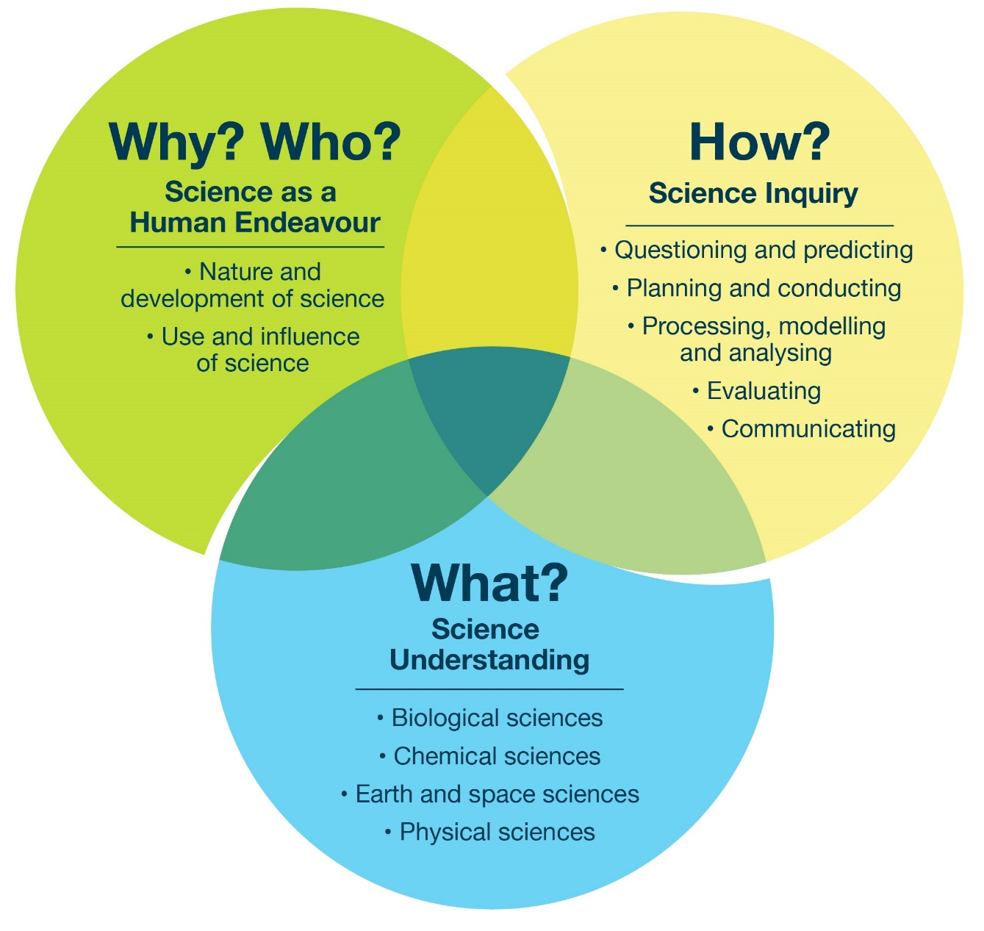

Key:
Unit number and framing question
Science as a Human Endeavour (H) – focus questions
Science Understanding (U) – focus questions
Science Inquiry (I) – focus questions
Other school calendar considerations

 | Week | 1 | 2 | 3 | 4 | 5 | 6 | 7 | 8 | 9 | 10 | 11 | 12 | 13 | 14 | 15 | 16 | 17 | 18
Year 7 | Semester 1 (Terms 1 and 2) | 7.1 Why is safety the first step in Science? |  | 7.2 How do we make sense of all living things? |  |  | 7.3 How can the particle model help us understand the way matter behaves? |  |  |  | 7.4 How do simple machines make life easier? |  |  | 7.5 How do cells work together to build life? |  |  | 7.6 How can we use Earth’s resources sustainably?
Year 7 | Semester 1 (Terms 1 and 2) | Not a focus. (H) |  | How have humans developed classification systems over time, and why do these change? (H) |  |  | How does knowledge of gas pressure and expansion help in designing rockets and airbags? Why must industries follow safety rules when storing or heating gases? (H) |  |  |  | How have simple machines been used throughout human history to solve human problems? In what ways do engineers and designers use the principles of simple machines in modern technologies? (H) |  |  | How have new technologies changed what humans know about cells? (H) |  |  | How can understanding the risks and benefits of resource use help individuals and communities make better decisions? How have advances in technology changed the way we extract and use resources? (H)
Year 7 | Semester 1 (Terms 1 and 2) | Not a focus. (U) |  | What features can be used to compare and contrast different organisms? How do similarities and differences within and between groups help humans classify living things? (U) |  |  | Why do solids keep their shape and gases fill their container? How can the particle model explain density and changes like expansion and contraction? (U) |  |  |  | What makes some machines better suited to lifting heavy loads than others? How can simple machines be combined to make complex machines? (U) |  |  | What are cells made of, and how do their parts work together? How are plant and animal cells similar and different? How do specialised cells help an organism survive? (U) |  |  | What is the difference between renewable and non-renewable resources? How do the properties of a resource affect how it can be used and reused? (U)
Year 7 | Semester 1 (Terms 1 and 2) | How can we identify and assess risks before starting an experiment? How should we set up, use and clean equipment? What are scientific drawings? (I) |  | How can we use dichotomous keys or other classification tools to identify organisms? How can we create models or diagrams to show the relationships between organisms? (I) |  |  | How can we design an investigation to compare the viscosity of different liquids? (I) |  |  |  | What happens when we change the length of a lever arm or the number of pulleys in a system?  How can we collect and record data to show the relationship between force, load and distance? (I) |  |  | What can we discover by comparing different types of cells under the microscope?  How can we model the parts of a cell to show how they work together? (I) |  |  | Not a focus. (I)
Year 7 | Semester 1 (Terms 1 and 2) |  |  |  | School camp |  |  | NAPLAN |  |  | Science Talent Search starts (competition) |  | University engineering (outreach program) |  |  |  |  |  | Science Talent Search finishes (expo)
Year 7 | Semester 2 (Terms 3 and 4) | 7.7 What’s in the mix and how can we get it out? |  |  | 7.8 How is energy transferred, transformed and used? |  |  |  | 7.9 How energy smart is my home? |  | 7.10 How do the Sun, Earth and Moon shape life on Earth? |  |  |  |  | 7.11 Why do ecosystems need balance?
Year 7 | Semester 2 (Terms 3 and 4) | Why is separating mixtures important in everyday life and industry? (H) |  |  | Not a focus. (H) |  |  |  | Not a focus. (H) |  | How have different cultures explained the patterns of the Sun, Earth and Moon over time? How has understanding of the Earth–Sun–Moon system changed with advances in astronomy and technology? (H) |  |  |  |  | How has understanding ecosystems guided environmental policies and conservation strategies? How do multidisciplinary teams of ecologists, biologists and policymakers work together to protect ecosystems? (H)
Year 7 | Semester 2 (Terms 3 and 4) | What is the difference between a pure substance and a mixture? How do different separation methods work? (U) |  |  | What are the different forms of energy? How is energy classified as kinetic or potential? How do conduction, convection and radiation transfer energy? (U) |  |  |  | What types of energy does my home use? What factors affect energy use? (U) |  | How do the tilt and orbit of Earth cause the seasons? How do the relative positions of the Earth, Sun and Moon cause eclipses? Why are tides predictable? (U) |  |  |  |  | How do matter and nutrients cycle through living and non-living parts of an ecosystem? Why are some ecosystems more stable than others? (U)
Year 7 | Semester 2 (Terms 3 and 4) | How do particle size, solubility and density affect our choice of separation method? How can we design a fair experiment to separate parts of a mixture? (I) |  |  | In what ways can we record energy transformations using diagrams or charts? Which energy transfers or transformations are the most efficient, and how can we compare them? (I) |  |  |  | How can I measure and record home energy use? Which appliance uses the most energy? How can I reduce energy use? (I) |  | How can we model the Earth–Sun–Moon system to explain eclipses, tides and seasons? (I) |  |  |  |  | Not a focus. (I)
Year 7 | Semester 2 (Terms 3 and 4) |  | Water treatment/ food processing  (excursion) | RACI crystal growing (competition) |  |  |  |  |  |  |  | Melbourne Planetarium / Observatory (excursion) |  |  |  | Marine and Freshwater Discovery Centre, Queenscliff (excursion)
 | Week | 1 | 2 | 3 | 4 | 5 | 6 | 7 | 8 | 9 | 10 | 11 | 12 | 13 | 14 | 15 | 16 | 17 | 18

 | Week | 1 | 2 | 3 | 4 | 5 | 6 | 7 | 8 | 9 | 10 | 11 | 12 | 13 | 14 | 15 | 16 | 17 | 18
Year 8 | Semester 1 (Terms 1 and 2) | 8.1 How does the particle world shape the world we see? |  |  | 8.2 How do systems in plants and animals work together to support their survival? |  |  |  |  |  | 8.3 How do balanced and unbalanced forces affect motion? |  |  |  |  | 8.4 What forces shape Earth’s mountains and trenches, trigger earthquakes and drive volcanic activity?
Year 8 | Semester 1 (Terms 1 and 2) | How has human understanding of particles influenced everyday products like food, medicine and industrial materials? (H) |  |  | How has knowledge of organ systems improved medical treatments and human health? (H) |  |  |  |  |  | Not a focus. (H) |  |  |  |  | How do scientists use knowledge of tectonic forces, earthquakes and volcanoes to improve building codes and disaster preparedness? How have advances in technology helped them monitor and predict earthquakes? (H)
Year 8 | Semester 1 (Terms 1 and 2) | How do the arrangement and motion of particles show the differences between solids, liquids and gases? How can particle theory explain material properties? (U) |  |  | How do cells and tissues work together to form organs with specialised roles? How do respiratory, circulatory and digestive systems work together in animals? How do plant transport systems move water and nutrients to support survival? How do the structures of different systems complement each other? (U) |  |  |  |  |  | What is the difference between balanced and unbalanced forces? How does the mass of an object influence its motion when forces are applied? How do gravitational, frictional and other forces affect the movement of objects? (U) |  |  |  |  | What are the types of forces at divergent, convergent and transform plate boundaries? How can tectonic plate models help explain the formation of mountains, trenches and volcanoes, and why earthquakes happen? (U)
Year 8 | Semester 1 (Terms 1 and 2) | How can we investigate particle behaviour? How can we model particle motion and interactions? How do temperature, mass and volume measurements explain changes in matter? (I) |  |  | How can we investigate how water moves through plant tissues? How can diagrams and models show the interconnections between systems? How can data from experiments support explanations about system interactions? (I) |  |  |  |  |  | How can the effect of different forces on an object’s motion be measured? How can forces acting on an object be represented using diagrams? (I) |  |  |  |  | Not a focus. (I)
Year 8 | Semester 1 (Terms 1 and 2) |  |  |  |  |  |  |  |  |  | Science Talent Search starts  (competition) |  |  |  |  |  | Penshurst Volcanoes Discovery Centre (excursion) |  | Science Talent Search finishes (expo)
Year 8 | Semester 2 (Terms 3 and 4) | 8.5 What clues tell us matter has changed? |  |  |  |  | 8.6 How can we design circuits to do different jobs? |  |  |  | 8.7 How do rocks form, change and become useful? |  |  |  | 8.8 How can models explain the invisible world of elements, compounds and mixtures? |  | 8.9 How does science help us understand and improve our world?
Year 8 | Semester 2 (Terms 3 and 4) | Not a focus. (H) |  |  |  |  | How are circuits designed for LED holiday lights? How are circuit-based medical devices designed to help people? What role do circuits play in electric vehicle components? (H) |  |  |  | How have humans used different types of rocks for tools, buildings, and other materials throughout history? (H) |  |  |  | Not a focus. (H) |  | How have scientific discoveries in the local community changed the way people live or work? How can scientific knowledge be used to make informed decisions that benefit society? (H)
Year 8 | Semester 2 (Terms 3 and 4) | What is the difference between a physical change and a chemical change? Why is rusting considered a chemical change rather than a physical one? (U) |  |  |  |  | What is the relationship between current, voltage and energy transfer in a circuit? How do different components (resistors, bulbs, switches, batteries) affect the operation of a circuit? How can series and parallel circuits be distinguished and explained? (U) |  |  |  | What are the differences between sedimentary, igneous and metamorphic rocks? How do processes in the rock cycle change rocks over time? (U) |  |  |  | How do 2D and 3D models show the structure and arrangement of particles in matter? How do different models help explain the properties of substances? (U) |  | Not a focus. (U)
Year 8 | Semester 2 (Terms 3 and 4) | How can we safely prepare and test gases in the laboratory? How can we use evidence to explain why a change is physical or chemical? (I) |  |  |  |  | How can we design a circuit to perform a specific task (e.g. lighting a bulb, powering a buzzer) and predict its behaviour? How can we represent circuits using diagrams and symbols to plan, test and communicate our designs? (I) |  |  |  | How can we observe and measure properties of rocks to determine their use? How do we classify rocks based on their properties? How can we model or simulate the rock cycle to show the transformation between rock types? (I) |  |  |  | How can we use models to predict the properties or behaviour of substances? What are the limitations of models? (I) |  | How can we design a project to show the role of science in local problems or improvements?  How can we present our scientific findings to help the community understand and act on them? (I)
Year 8 | Semester 2 (Terms 3 and 4) |  |  |  |  |  |  |  |  |  |  |  | Monash Earth Sciences Garden (excursion) | School camp |  | Questacon (outreach program) | Community survey (fieldwork)
Year 9 | Semester 1 (Terms 1 and 2) | 9.1 How does carbon cycle through Earth’s systems? |  |  |  | 9.2 How do wave and particle models explain the transfer and use of energy? |  |  |  |  | 9.3 How do organisms reproduce to maintain their species? |  |  |  |  | 9.4 How did the discovery of sub-atomic particles change the way we think about atoms?
Year 9 | Semester 1 (Terms 1 and 2) | How can knowledge of carbon processes guide sustainable practices to maintain the balance of Earth’s spheres? (H) |  |  |  | How have wave and particle models contributed to technologies such as radios, cameras and medical imaging? (H) |  |  |  |  | How have advances in reproductive technologies such as IVF and cloning affected society and raised ethical issues? In what ways does understanding reproduction support conservation of endangered species? How do farmers and scientists use knowledge of reproduction to improve crops and livestock? (H) |  |  |  |  | How have collaborations and experiments contributed to human understanding of atoms? (H)
Year 9 | Semester 1 (Terms 1 and 2) | How is carbon cycled through Earth’s spheres? How does photosynthesis lead to carbon storage in plants? How does human respiration return carbon to the atmosphere? How do fires, volcanic eruptions and weathering release or store carbon? (U) |  |  |  | How do wave and particle models describe energy transfer? What are the main properties of waves? How do sound and light waves differ in their behaviour and propagation? (U) |  |  |  |  | How do the structures of reproductive cells and organs support their functions? What are the key differences between sexual and asexual reproduction? In what ways do environmental conditions influence reproductive success? How do plants and animals use different reproductive strategies to adapt to their environments? (U) |  |  |  |  | What are electrons, protons and neutrons, and how do they determine the structure of an atom? How have atomic models developed from early ideas to the current model? (U)
Year 9 | Semester 1 (Terms 1 and 2) | Not a focus. (I) |  |  |  | How can we measure and compare sound and light waves in experiments? What happens to energy when it moves through different media such as air, water and solids? How can we represent wave and particle behaviour using diagrams, graphs and calculations? (I) |  |  |  |  | How can we model or compare sexual and asexual reproduction in different organisms? How can microscopy help us identify and compare reproductive cells? How might we design an experiment to test germination success under different conditions? (I) |  |  |  |  | Not a focus. (I)
Year 9 | Semester 1 (Terms 1 and 2) |  | School camp |  |  |  |  | NAPLAN |  |  | Science Talent Search starts (competition) |  |  | Plant nursery (excursion) |  |  |  |  | Science Talent Search finishes (expo)
 | Week | 1 | 2 | 3 | 4 | 5 | 6 | 7 | 8 | 9 | 10 | 11 | 12 | 13 | 14 | 15 | 16 | 17 | 18

 | Week | 1 | 2 | 3 | 4 | 5 | 6 | 7 | 8 | 9 | 10 | 11 | 12 | 13 | 14 | 15 | 16 | 17 | 18
Year 9 | Semester 2 (Terms 3 and 4) | 9.5 How do our bodies maintain balance and respond to change? |  |  |  |  | 9.6 Is space the next home for humans? |  |  |  | 9.7 How do atoms rearrange in chemical reactions? |  |  |  | 9.8 How is energy conserved and transformed to maximise efficiency in natural and engineered systems? |  | 9.9 How and why do unstable atoms change over time?
Year 9 | Semester 2 (Terms 3 and 4) | Not a focus. (H) |  |  |  |  | What are the ethical and environmental implications of colonising other planets? (H) |  |  |  | How does understanding chemical reactions guide communication, safety practices and regulations in society? (H) |  |  |  | How can understanding energy conservation help solve real-world problems? (H) |  | How has knowledge of radioactive decay influenced society, and what safety considerations are involved? (H)
Year 9 | Semester 2 (Terms 3 and 4) | How do the nervous and endocrine systems detect and respond to internal and external stimuli? What is homeostasis, and how is it maintained in the human body?  How do negative feedback mechanisms maintain body conditions? (U) |  |  |  |  | What clues help scientists search for planets that could support life? What conditions are needed for life to survive on other planets or moons? How do space environments affect human health and survival? What technologies might help humans survive? (U) |  |  |  | What is the Law of Conservation of Mass and how does it apply to chemical reactions? How can we use symbols and equations to represent chemical reactions? How do atoms rearrange in different types of chemical reactions? (U) |  |  |  | How does the Law of Conservation of Energy apply to different systems? What factors affect energy transfer? (U) |  | What is natural radioactive decay? Why do unstable atoms change into stable atoms? How do alpha, beta and gamma decay processes differ?  What is a half-life? (U)
Year 9 | Semester 2 (Terms 3 and 4) | How can we investigate the effects of stimuli on the human body using safe experiments or simulations? How can we model feedback mechanisms?  How can we use case studies and data to understand system disruptions? (I) |  |  |  |  | What kinds of data could reveal aliens exist?  How can we model living conditions in space to test survival systems? (I) |  |  |  | How can we investigate chemical reactions in the laboratory and measure changes in mass? How can models (word, symbol and simple equations) represent the rearrangement of atoms? (I) |  |  |  | How can efficiency in energy transfers or transformations be calculated or estimated? What are Sankey diagrams? (I) |  | How can we investigate evidence of radioactive decay using simulations or safe laboratory activities? How can models or diagrams represent the decay of unstable atoms? (I)
Year 9 | Semester 2 (Terms 3 and 4) |  |  |  |  |  |  |  | VSSEC (excursion) |  |  |  |  |  |  |  | ANSTO (online)
Year 10 | Semester 1 (Terms 1 and 2) | 10.1 How does the organisation of the periodic table explain element properties? |  |  |  | 10.2 How do we inherit our traits? |  |  |  |  | 10.3 How can Newton’s laws predict motion? |  |  |  |  | 10.4 How do our choices affect Earth’s climate?
Year 10 | Semester 1 (Terms 1 and 2) | How have discoveries about atomic structure shaped the development of the periodic table? (H) |  |  |  | How did Gregor Mendel’s work change scientific understanding of inheritance? How have modern technologies, such as DNA testing and genome analysis, changed what we know about genetics? How does understanding genetics help humans make informed decisions? (H) |  |  |  |  | How can applying Newton’s laws improve safety, efficiency or performance in real-world systems? (H) |  |  |  |  | How do human activities contribute to climate change? How can mitigation strategies reduce the human impact on Earth’s energy balance? How has scientific evidence about global warming shaped public debate and action? (H)
Year 10 | Semester 1 (Terms 1 and 2) | How are the properties of elements related to their position in rows and columns? How do atomic size, reactivity and electron configuration explain trends in the periodic table? How can patterns be used to predict the behaviour of unknown elements? (U) |  |  |  | How do DNA, chromosomes, genes and alleles influence traits? What is the difference between dominant and recessive alleles? How do meiosis and mitosis affect the inheritance of traits? How can Mendel’s principles be used to predict genotype and phenotype ratios in offspring? (U) |  |  |  |  | How can the equation F = ma be used to calculate the acceleration, force or mass of an object? How can the acceleration of an object when a force is applied be calculated? How do different masses respond to the same applied force? (U) |  |  |  |  | What evidence shows that Earth’s climate is changing over time? What is the role of energy exchanges between the atmosphere, oceans and land in climate dynamics? How does electricity generation from fossil fuels differ from community-generated renewables? (U)
Year 10 | Semester 1 (Terms 1 and 2) | How can we use data on element properties to identify patterns and trends in the periodic table? How can models of atoms and electron configurations help explain element behaviour? How can we investigate the reactivity of different metals and non-metals? (I) |  |  |  | How can we use Punnett squares to predict the outcomes of genetic crosses? How can we analyse patterns of inheritance in family pedigrees or genetic case studies? How can we design and evaluate experiments or simulations to investigate inheritance patterns involving dominant and recessive alleles? (I) |  |  |  |  | How can we measure force, mass and acceleration in a classroom experiment? What methods can we use to represent motion mathematically and graphically? How can we use equations to compare predictions with actual results? (I) |  |  |  |  | How can we use models to represent energy flow and greenhouse gas effects in Earth’s systems? How can data from temperature records, CO₂ measurements and climate models be used to study climate change? How can evidence be used to justify change strategies? (I)
Year 10 | Semester 1 (Terms 1 and 2) |  |  |  |  |  |  | Zoos Victoria (excursion) |  |  | Science Talent Search starts (competition) |  |  |  |  |  | CERES (excursion) |  | Science Talent Search finishes (expo)
Year 10 | Semester 2 (Terms 3 and 4) | 10.5 How do we identify different chemical reactions? |  |  | 10.6 How do we make sense of the universe? |  |  |  | 10.7 How does evolution explain the diversity of life on Earth? |  | 10.8 How do diseases spread and how can we stop them? |  |  | 10.9 How are different energy sources used to make electricity? |  |  |  | 10.10 Why do some chemical reactions happen faster than others?
Year 10 | Semester 2 (Terms 3 and 4) | How do synthesis reactions contribute to the development of new materials? How are displacement reactions used to extract and recycle metals sustainably? (H) |  |  | Is the universe what we think it is? How have humans made sense of star patterns? (H) |  |  |  | How have scientists developed the theory of evolution over time, and how has it been challenged or refined? (H) |  | How have historical disease outbreaks influenced public health policies? How can understanding disease transmission inform community education and ethical decision-making? (H) |  |  | How do social, environmental and economic factors influence the choice of energy source in different regions? What challenges do scientists and engineers face in making electricity generation more sustainable? (H) |  |  |  | Not a focus. (H)
Year 10 | Semester 2 (Terms 3 and 4) | What distinguishes synthesis, decomposition and displacement reactions? How is it possible to tell whether a reaction is exothermic or endothermic? (U) |  |  | What is a solar system? What is a star? How do stars form, live and die – and what evidence tells this story? What do galaxies look like and how do they change? How do scientists know that the universe is expanding and what does this tell us about the big bang theory? (U) |  |  |  | How do variation, adaptation and natural selection drive evolution? What evidence supports evolution? (U) |  | What are the differences between infectious and non-infectious diseases? How do different pathogens and agents cause disease?  What measures reduce transmission? (U) |  |  | How is electricity generated from different energy sources such as wind, water, sunlight or fossil fuels? What are the differences between alternating current (AC) and direct current (DC)? How does the movement of a magnet near a coil of wire generate electricity? (U) |  |  |  | How do temperature and surface area affect the rate of chemical reactions? (U)
Year 10 | Semester 2 (Terms 3 and 4) | How can we represent and balance chemical reactions? (I) |  |  | How do we observe the universe? How far is ‘far’ in space? How are stars categorised and what do their patterns show? How can we tell the story of the universe? How effectively can we communicate cosmic ideas? (I) |  |  |  | How can we investigate patterns of variation and adaptation in populations? How can models be used to show evolution? (I) |  | How can we use models, simulations or case studies to investigate the spread of disease? How can we test the effectiveness of interventions in controlled investigations or simulations? (I) |  |  | Not a focus. (I) |  |  |  | How can we collect and represent data to compare reaction rates accurately? (I)
Year 10 | Semester 2 (Terms 3 and 4) |  |  |  |  |  | School camp |  |  |  |  | Biomedical scientist (guest speaker) |  |  | Wind farm (excursion)
 | Week | 1 | 2 | 3 | 4 | 5 | 6 | 7 | 8 | 9 | 10 | 11 | 12 | 13 | 14 | 15 | 16 | 17 | 18

