Technical drawing conventions

Visual Communication Design Levels 7–10

Acknowledgement
The Victorian Curriculum and Assessment Authority proudly acknowledges and pays respect to Victoria’s Aboriginal and Torres Strait Islander communities and their rich and enduring cultures.
We acknowledge Aboriginal and Torres Strait Islander people as Australia’s first peoples and as the Traditional Owners and custodians of the lands and waters on which we rely. We pay respect to Elders past and present of the lands where we conduct our work and recognise their ongoing contributions as the first educators on the land now known as Victoria.
Authorised and published by the Victorian Curriculum and Assessment Authority
Level 7, 200 Victoria Parade
East Melbourne VIC 3002
© Victorian Curriculum and Assessment Authority 2025
No part of this publication may be reproduced except as specified under the Copyright Act 1968 or by permission from the VCAA. Excepting third-party elements, schools may use this resource in accordance with the VCAA educational allowance. For more information go to vcaa.vic.edu.au/footer/copyright
The VCAA provides the only official, up-to-date versions of VCAA publications. Details of updates can be found on the VCAA website at vcaa.vic.edu.au
This publication may contain copyright material belonging to a third party. If you believe that material in this publication is an infringement of your copyright, please email the Copyright Officer vcaa.copyright@education.vic.gov.au
Copyright in materials appearing at any sites linked to this document rests with the copyright owner/s of those materials, and is subject to the Copyright Act. The VCAA recommends you refer to copyright statements at linked sites before using such materials.
The VCAA logo is a registered trademark of the Victorian Curriculum and Assessment Authority.

Contact us if you need this information in an accessible format, for example, large print or audio.
Telephone (03) 9032 1629 or email vcaa.publications@education.vic.gov.au

Contents
Introduction 1
Australian Standards (AS) 1
Three-dimensional drawings 1
Paraline drawings 1
Constructing and applying ellipses in paraline drawings 3
Perspective drawings 6
One-point perspective 6
Two-point perspective 8
Constructing ellipses in perspective drawings 8
Two-dimensional drawings 9
Packaging nets 9
Third-angle orthogonal drawings 10
Layout and scale 13
Views 14
Third-angle orthogonal projection symbol 14
Line styles and weights 14
Dimensioning orthogonal drawings 15

Introduction
This document provides advice and support on the technical conventions referred to in the example teaching and learning units and assessment tasks of the F−10 Visual Communication Design curriculum resources. It draws on conventions from the Australian Standards (AS).

Australian Standards (AS)
Technical conventions are based on a set of standards that have been globally agreed upon by the International Standards Organisation (ISO). These standards are then tailored to the needs of each country, depending on their measuring system (metric or imperial), environmental conditions, manufacturing processes and developments in technology. The Australian Standard AS 1100 provides the technical conventions for all Australian engineers, architects, designers, surveyors and patternmakers to follow.
The standards for Australian technical conventions can be found at: https://www.intertekinform.com/en-au/standards/as-1100-101-1992-amdt-1-128778_saig_as_as_283890/

Three-dimensional drawings
Three-dimensional (3D) drawings represent how objects, interiors and exteriors appear in physical space. All 3D drawings include representations of height, width and depth. There are 2 different 3D drawing systems: paraline drawings and perspective drawings.

Paraline drawings
Paraline drawings represent objects accurately, as the measurements are made to a consistent scale for each ‘plane’ (side) of the drawing. The receding lines of each ‘plane’ remain parallel to one another. Paraline drawings include isometric and planometric drawings.
Isometric drawings provide a comprehensive overall view of an object. The object is drawn from a corner edge at 30 degrees to the horizontal. The 2 receding lines are parallel to each other. Refer to Figure 1.

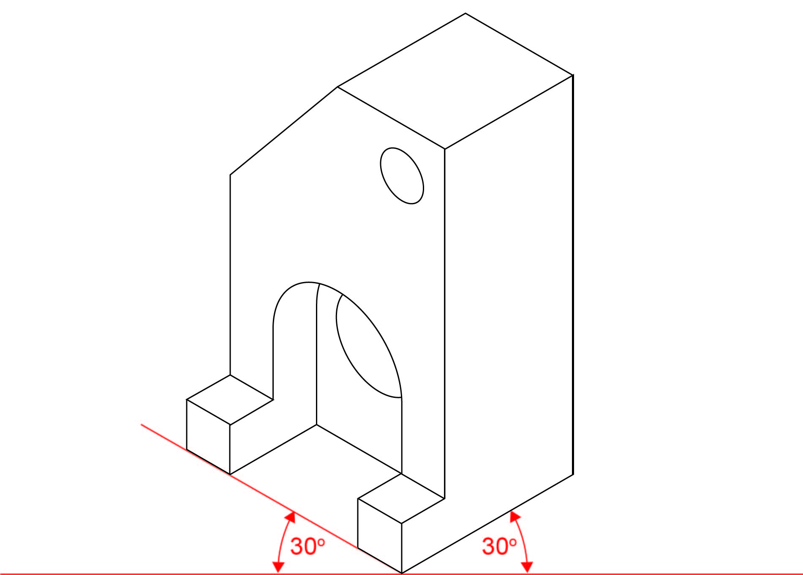

Figure 1
Isometric drawing.
Planometric drawings have a similar purpose to isometric drawings, and the receding planes are drawn in parallel. However, the base (or plan) of the object retains its shape. The angle between the base and the perpendicular sides is 90 degrees. Planometric drawings can be constructed with the receding planes drawn at a 45-degree angle, or one side can be set at 30 degrees and the other at 60 degrees. The angle of the drawing will depend on which aspects of the object or interior need to be viewed. Refer to Figure 2.

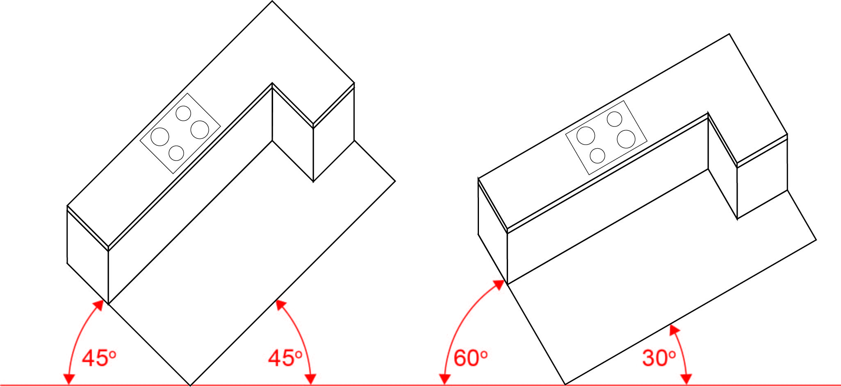

Figure 2
Planometric drawings showing receding planes at 45 degrees and 60/30 degrees.

Constructing and applying ellipses in paraline drawings
Figure 3a shows a circle drawn in a square and then the same circle at a 30-degree angle. A good method for drawing an ellipse is to use the box method known as ‘crating’.
- Note the relationship between the circle and the square. The red and green dots are the points that are used to draw the ellipse.
- Draw an isometric square and locate the centre using diagonal lines.
- Mark out the positions where the circle cuts the diagonal lines in the isometric projection.
- Take the distance from the corner to the centre and divide into thirds. Use the outer third to form your circle.
- Join all points with one flowing curved line to make the ellipse.
Refer to Figures 3a, 3b, 4 and 5.

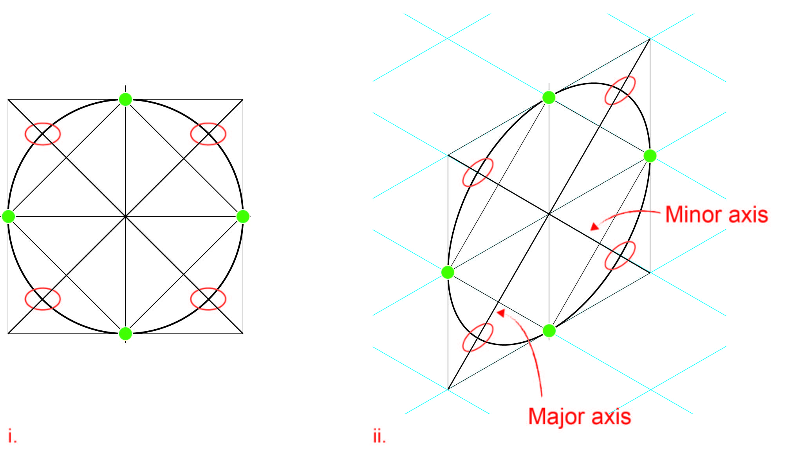
Figure 3a
Using the relationship between a square and a circle to create an ellipse.
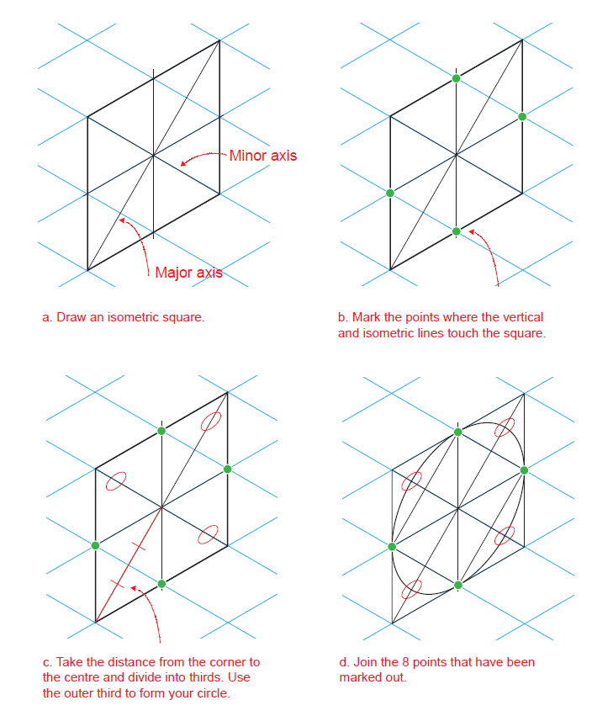
Figure 3b
An explanation of how to use a square to draft an ellipse.
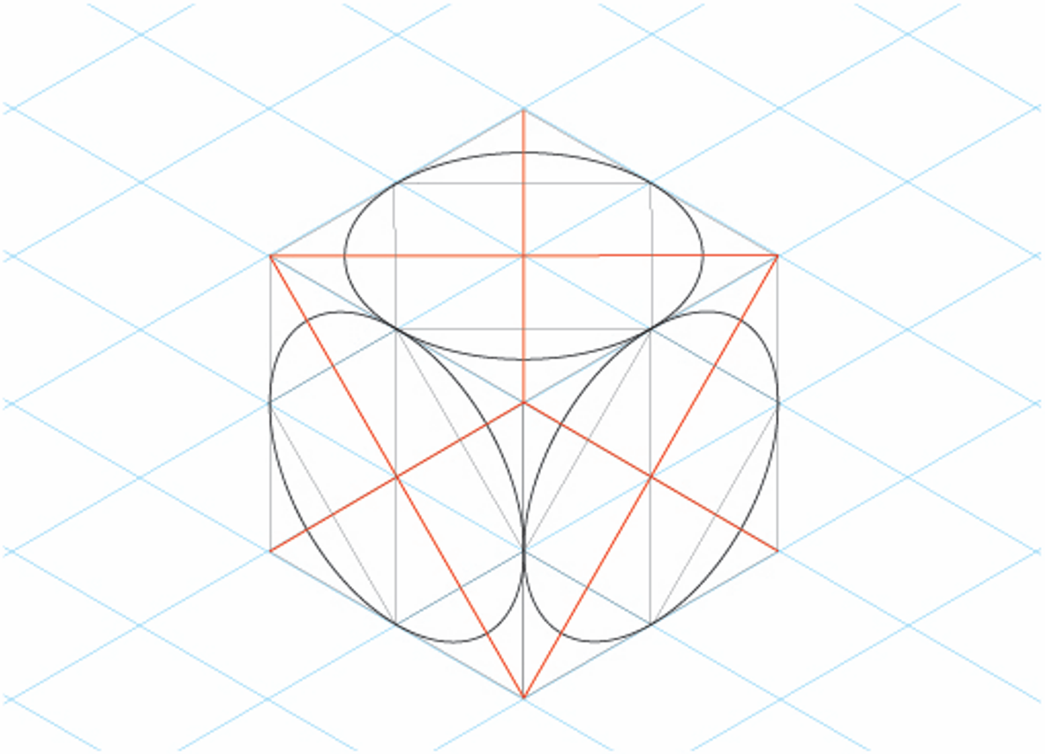
Figure 4
This figure shows how an ellipse can be applied to each face of an isometric cube.
In each case, the ellipse is the same, but the major axis is rotated.
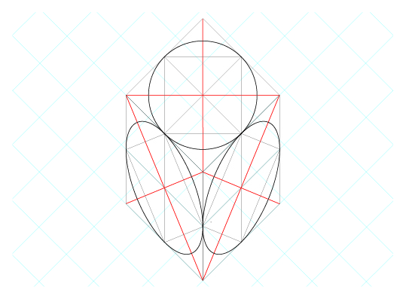
Figure 5
Ellipses can be applied to each face of a planometric cube in the same way. However, note that the ellipse angle is different to those shown in isometric drawing. Circles remain true to their shape on the top of a planometric form because a planometric drawing is based on an undistorted ‘top’ view.

Perspective drawings
Perspective drawings depict objects, structures and environments in the way humans would view them. In perspective drawings, the form is represented by using receding lines that converge towards the horizon (eye level), rather than parallel lines. The position of the object in relation to the horizon line determines the view we see of the object. Perspective drawings can include ‘one-point’, ‘two-point’ and ‘three-point’ perspective.
Figure 6 explains the key terms in perspective drawing.

The horizon line (HL) drawn across the page represents
the eye level (EL) of the viewer. The height of an object is then drawn in relation to the height of the eye level. Objects in perspective may be situated below, above
or across the horizon line.

Vanishing points (VP) are the points on
the horizon line to which the depth of
an object or composition converge
toward. It is this diminishing effect that
creates the naturalistic representation
of form. A perspective drawing may be
set up with one or more vanishing
points.

The spectator point (SP) is the position an object is
viewed from. The height and distance of a
spectator point from an object will determine
how much of an object is visible.

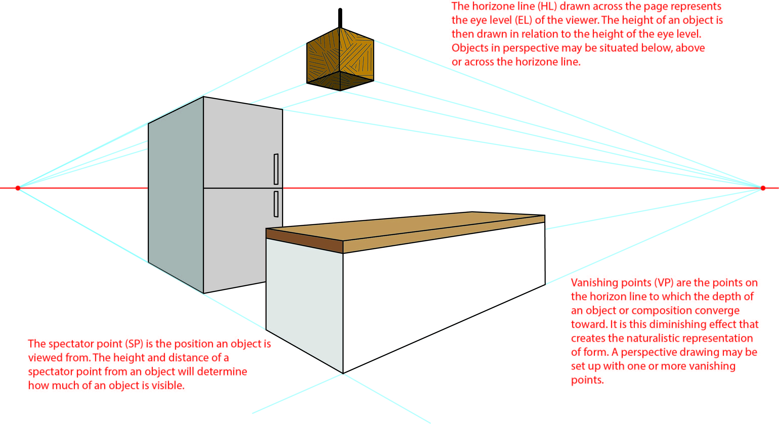

Figure 6
Illustration of terms used and position of objects relative to horizon line in a perspective drawing.

One-point perspective
In one-point perspective drawings, objects or structures are drawn ‘front on’. The sides of the object recede, with lines converging to one vanishing point on the horizon line. The vanishing point may be situated outside the object for an exterior view, or inside it for an interior view. The measurements of the object or structure may be applied to the horizontal and vertical lines (parallel to the picture plane). When drawing the receding lines, the proportions of the object are maintained depending on the position of the horizon line and the vanishing point. Refer to Figure 7.

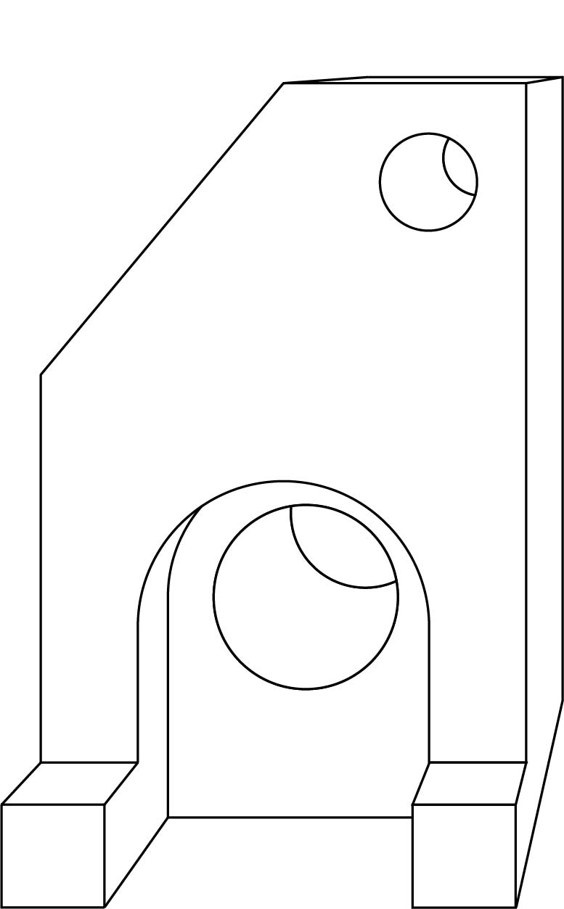
Figure 7
One-point perspective drawing.

Two-point perspective
In two-point perspective drawings, objects or structures are drawn from a corner view, with the depth of the object (sides) drawn with receding lines converging at either of the 2 vanishing points on the horizon line. Refer to Figure 8.
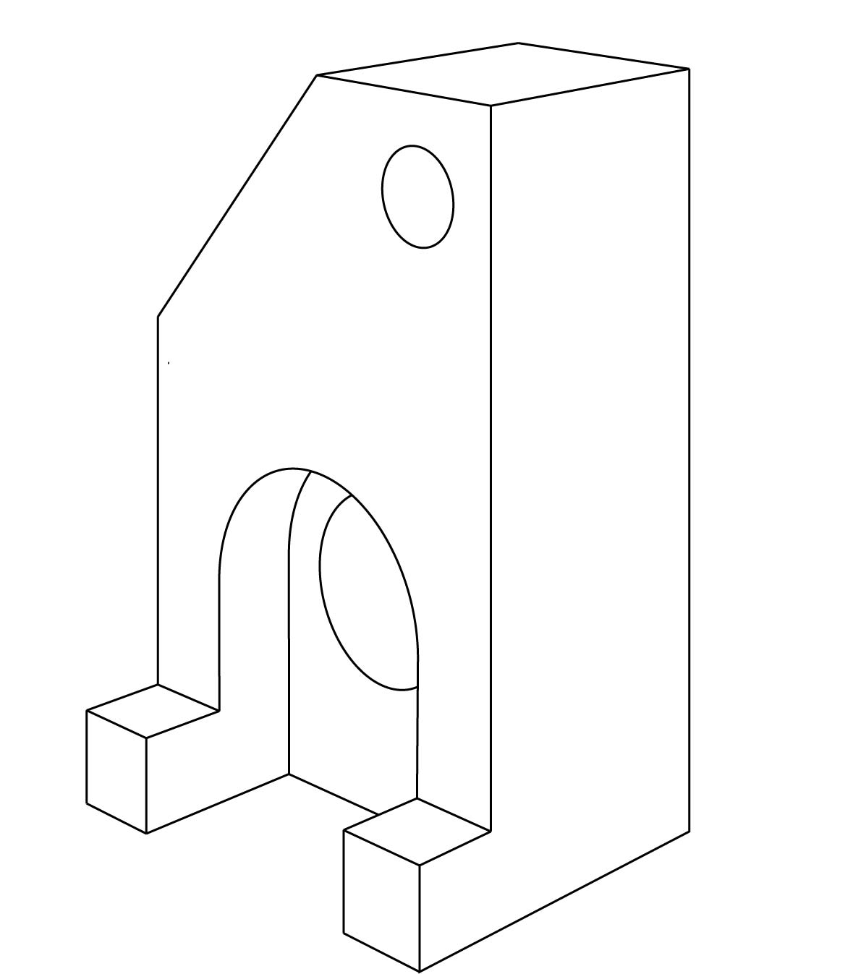
Figure 8
Two-point perspective drawing.

Constructing ellipses in perspective drawings
Ellipses are constructed in the same way for one- and two-point perspective, as both drawing methods use receding planes. However, in a one-point perspective, circles remain as circles on planes parallel to the picture plane (front).
Ellipses must be constructed within correctly proportioned squares in one- or two-point perspective. The vertical centre line of the square and ellipse shift towards the vanishing point, in keeping with the diminishing size of objects as they recede from the viewer. Refer to Figure 9.

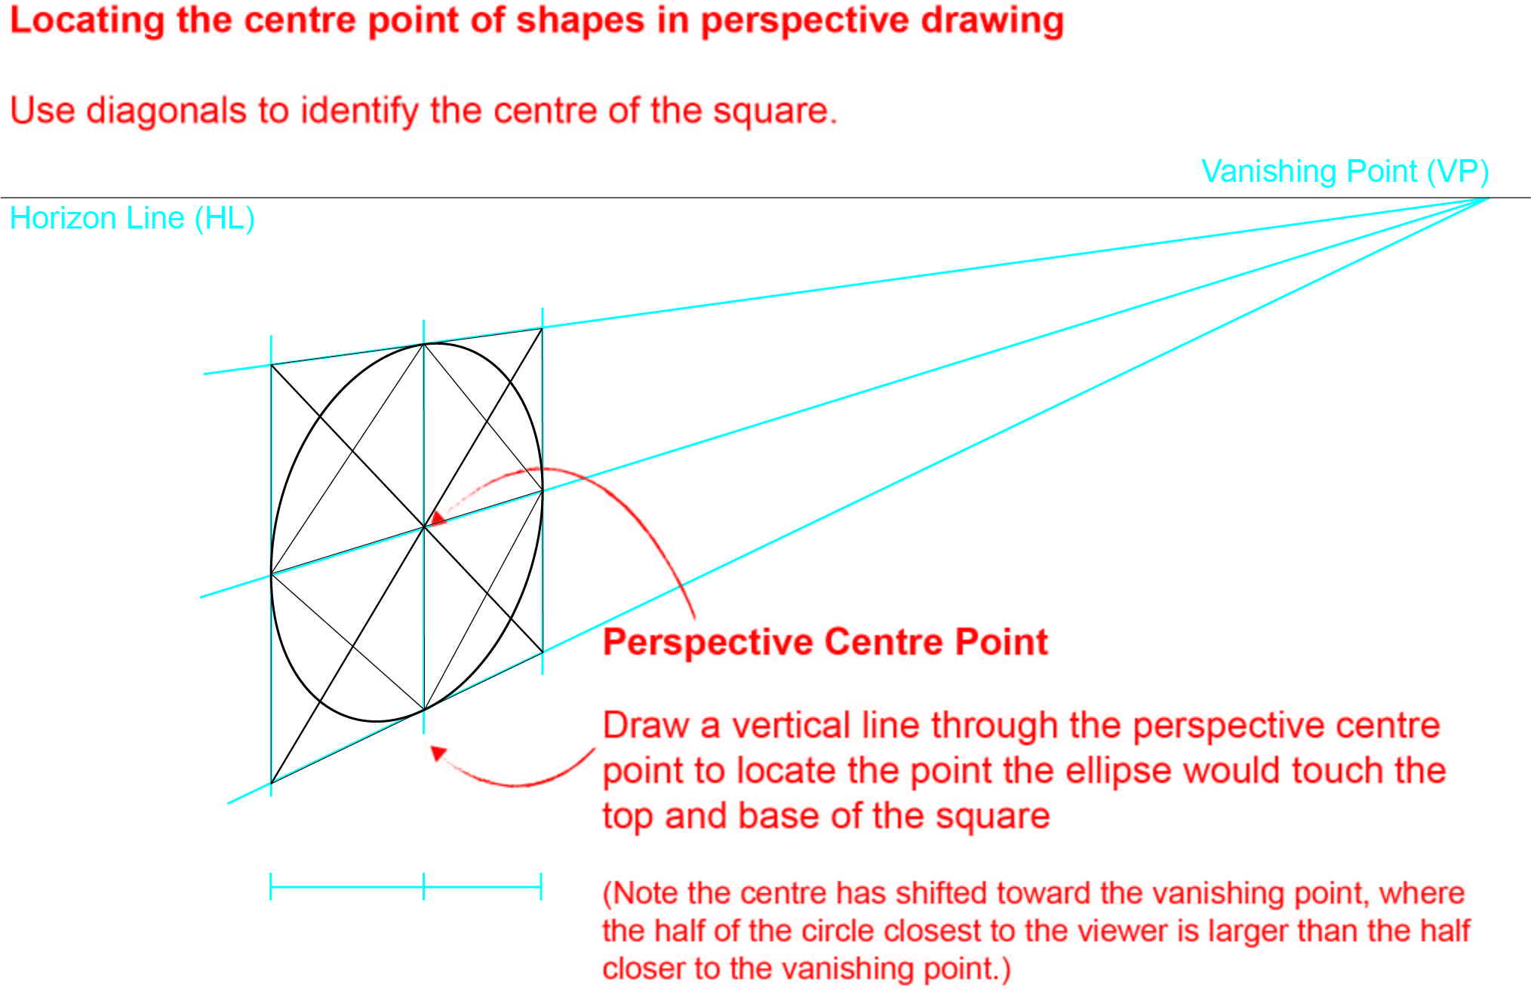

Figure 9
Constructing ellipses in perspective drawings.

Two-dimensional drawings
Two-dimensional (2D) drawings provide a simple and clear representation of objects, structures and environments, showing views of details and measurements. Unlike 3D drawings, 2D drawings represent breadth and width, but not depth. Two-dimensional drawings include packaging nets and third-angle orthogonal drawings.

Packaging nets
A packaging net is a drawing of a flat 2D shape that, when folded, becomes a 3D form. Often a packaging net will include tabs for stability and fastening. The drawings are to scale and involve the use of line conventions that indicate fold lines (broken lines) and a cutting edge (continuous, solid outline). Refer to Figure 10.

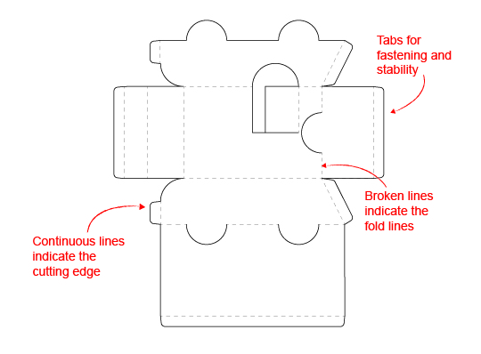

Figure 10
Packaging net that when cut out and folded will form a simplified version of a car.

Third-angle orthogonal drawings
A third-angle orthogonal drawing is a ‘flat’ representation of an object that has been drawn as a paraline or perspective drawing.
Figure 11a is an isometric drawing of a solid object. Figure 11b is the same object drawn two-dimensionally as an orthogonal drawing.
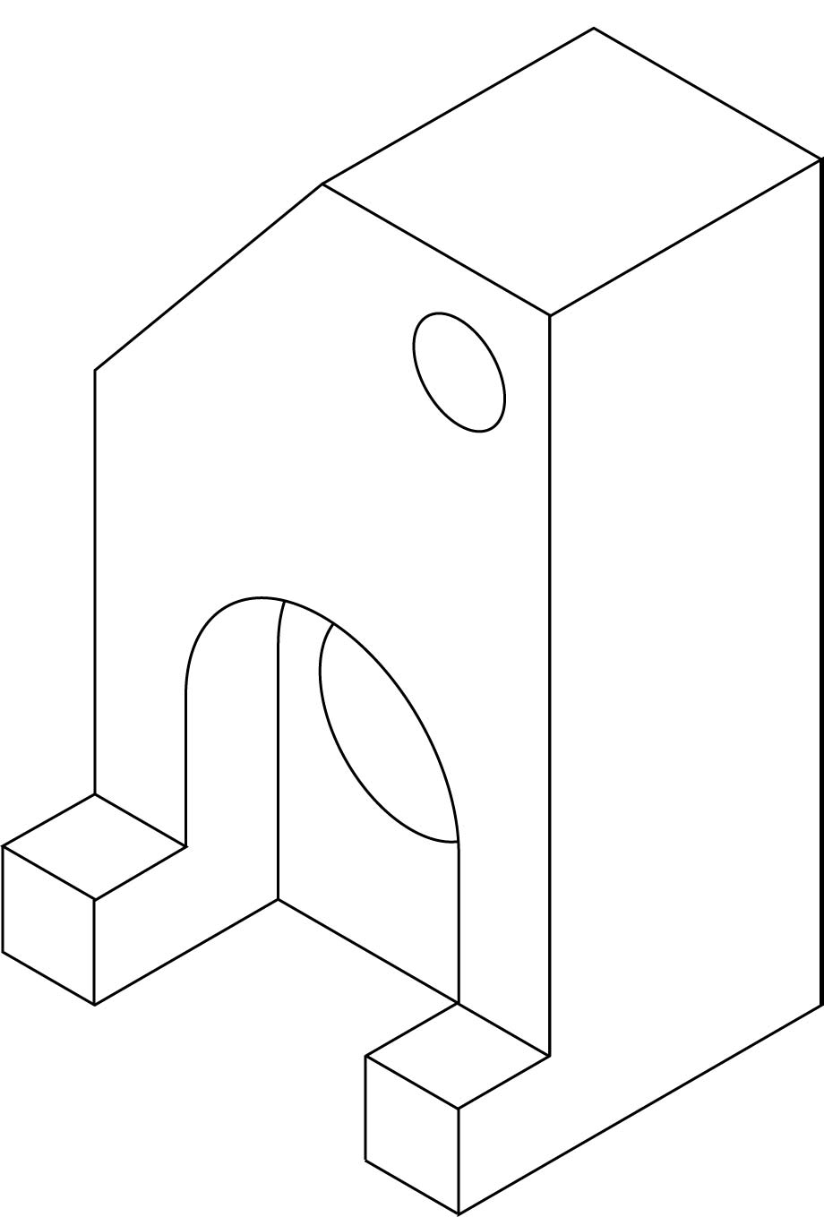
Figure 11a
Isometric drawing of a solid object.

In third-angle orthogonal drawing, each view of an object (front, top, sides and base) is drawn separately using only 2 dimensions, and the views are drawn in alignment and to the same scale. Refer to Figure 11b. Showing multiple views of an object on the one page allows all 3 dimensions to be considered and compared. ‘Third-angle projection’ refers to the layout of the views and is identified by the third-angle orthogonal projection symbol, a special symbol placed on each drawing. See ‘Third-angle orthogonal projection symbol’ and Figure 13 on page 14.
The video linked below demonstrates how to construct a third-angle orthogonal drawing.
What Make Art: Third Angle Projection with T-Square Drafting Tutorial – YouTube

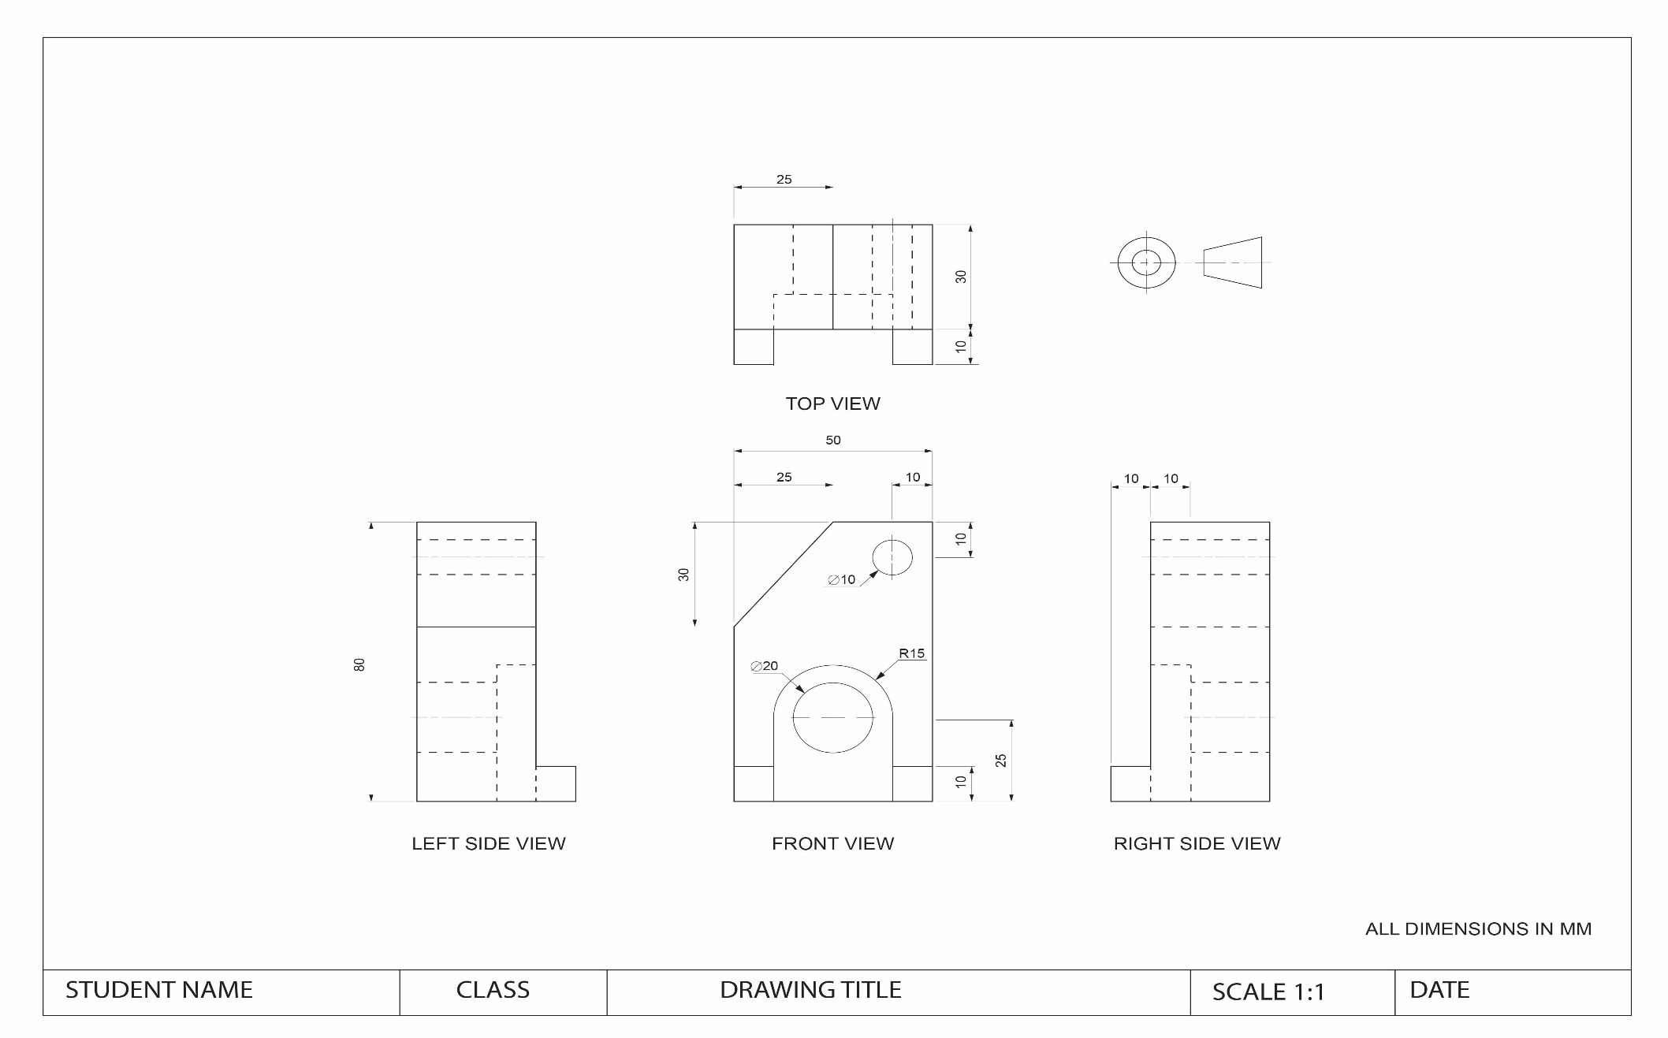
Figure 11b
Third-angle orthogonal drawing showing 3 labelled dimensions, title box and third-angle orthogonal symbol (FIGURE NOT TO SCALE).

Layout and scale
The third-angle orthogonal drawing has to be laid out carefully, so that all the views are aligned and to scale, and the dimensions (measurements) can be included. The actual size of the object and the scale of the views will determine the size of the drawing. Scale is expressed as a ratio, where the first number refers to the drawn view and the second to the actual object. For example, the scale 1:50 means the size of the drawing is 50 times smaller than the object.
The drawing should have a ‘title block’ at the base of the page. The title box identifies who owns the drawing and provides information about the drawing. A title box should include the following:
- title of the drawing
- author of the drawing
- date drawn
- scale, including a reference to the units (e.g. millimetres) used in the drawing.

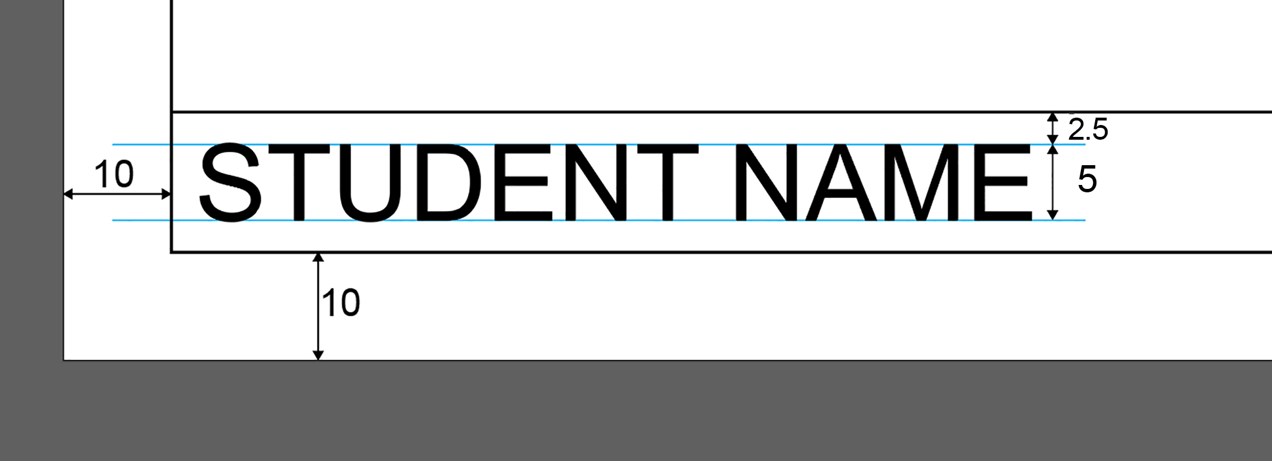

Figure 12
Size and placement of written information in the title box.

Views
An orthogonal drawing can have up to 6 views. The views that clearly describe the object are drawn. The views are known as:
- FRONT VIEW
- TOP VIEW
- LEFT-SIDE VIEW or RIGHT-SIDE VIEW
- BASE VIEW
- BACK VIEW.
The FRONT VIEW is the view that communicates the most information about the object.
The TOP VIEW is always directly above the FRONT VIEW, and the SIDE VIEWS are always ‘next to’ and ‘aligned to’ the FRONT VIEW. The measurement of the distance between views will vary depending on the dimensions and scale of the object. The distances between all views must be consistent with each other.
Each view should be labelled in capital letters in a sans-serif font. Labels should have a height of 5mm and be in a centred position 10mm below each view.

Third-angle orthogonal projection symbol
The third-angle orthogonal projection symbol identifies the drawing system used. The projection symbol is part of labelling requirements and is placed on the drawing along with the labelling of views. This symbol must be drawn using the same proportions and conventions as in the example below.

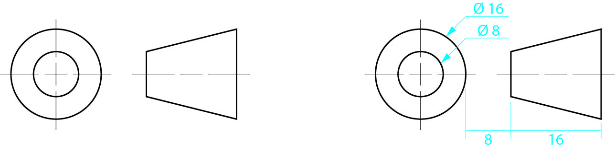

Figure 13
Third-angle orthogonal projection symbol and suggested construction method.

Line styles and weights
The use of different line styles and weights is important in orthogonal drawings, as they are used to describe details and features of objects. It is recommended that a minimum of 2 different line weights are used to meet line style conventions:
- a heavier line to draw the views that represent the object being drawn
- a thinner ‘half-weight’ line to provide additional information such as centre, projection and dimension lines.
The length and spacing of dashes in broken lines should be consistent within the drawing. The following table provides information about line styles and conventions.
Line styles and conventions
Thick continuous | 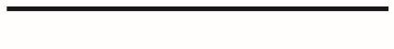 | Thick continuous lines represent visible lines used on each view, including arcs, circles, curves, title box and border.
Thick dashed | 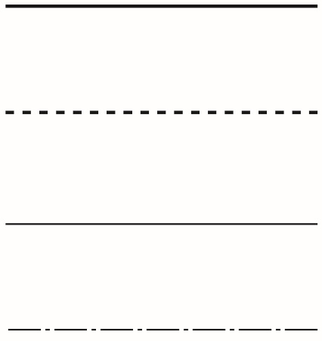 | Thick dashed lines represent hidden lines used on each view. Dashes start and end where they connect to a visible or hidden line.
Thin continuous | 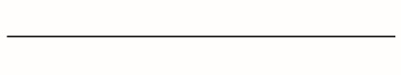 | Thin continuous lines are used for dimension lines, projection lines and leaders, and used in the title box.
Thin chain | 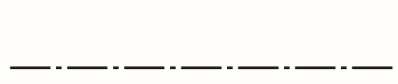 | Thin chain lines represent centre lines, for axes of solid forms.

Dimensioning orthogonal drawings
Dimensions provide the measurements of the views of the drawing. They are placed outside the outline of the object, in a position where they can be easily viewed.
The following dimensioning guidelines and styles can apply:
- All measurements of the drawing are shown in millimetres (mm). ‘ALL DIMENSIONS IN MM’ should be placed in an appropriate place on the drawing, such as:
  - directly below the third-angle orthogonal projection symbol
  - above the title box
  - within the title box.
- Dimension figures are written on top of the dimension lines. When placing dimension figures on vertical dimension lines, rotate the page or drawing once to the right. Then continue to place dimension figures.
- Ensure that there are dimensions for the height, width and depth.
- Never repeat a dimension. Always check that dimensions are not repeated on another view. Place dimensions on the view that shows a detail most clearly.
- Projection lines are thin lines that are placed 1mm from the drawing and extend beyond the last dimension line by 2mm. They define the area being dimensioned, and never touch the actual object.
- Dimension lines are thin continuous lines with arrowheads placed at each end, touching the projection line. Each dimension line starts 10mm from the object and is then 10mm apart from the next projection line. Smaller dimensions are placed inside larger dimensions, closer to the object. Longer dimension lines are further away from a view (for example, total height).
- Arrowheads are drawn 3mm long by 1mm wide. They can be open or solid, and always touch (but do not cross) projection lines.
- The term ‘stand off’ is used in drawings to refer to the height or position of an object relative to a reference point.
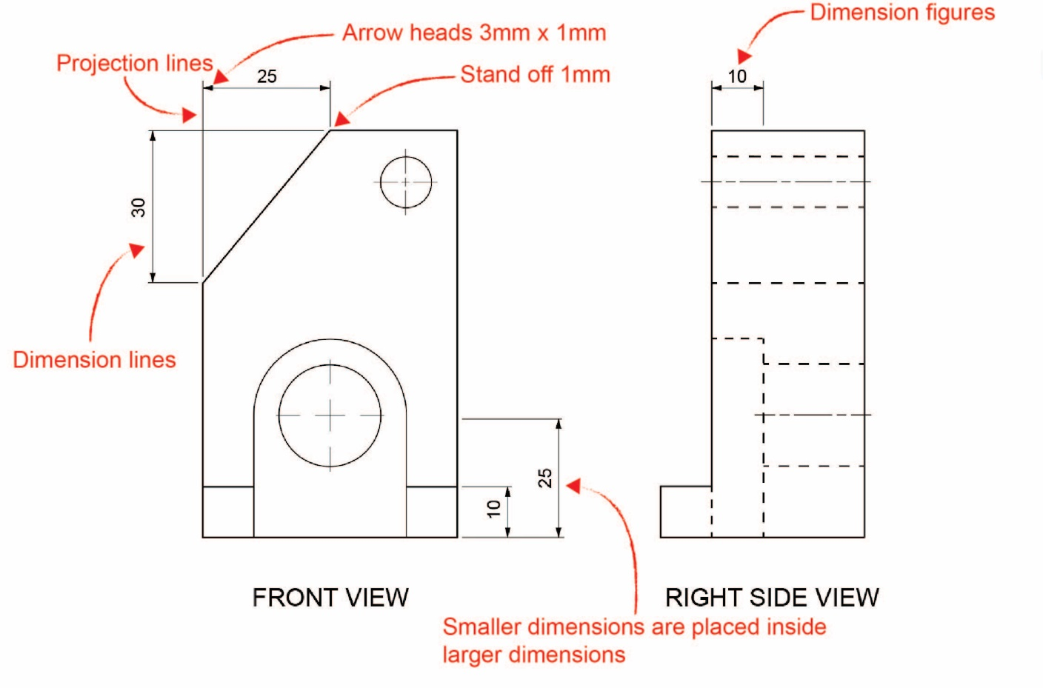
Figure 14
Style and placement of dimension lines, projection lines and arrowheads.

