Example teaching and learning unit: 1.2 Rethink rubbish! Where could it go?

Science, Foundation to Level 2
Use this teaching and learning unit template to plan a teaching and learning unit for a specific curriculum area or multiple disciplines.
Hint: Use your completed curriculum area map(s) and your completed curriculum area plan to help populate this teaching and learning unit.

Overview
Description of the teaching and learning unit | Cohort considerations (in relation to this teaching and learning unit)
What happens to rubbish after it is thrown away? Is rubbish really rubbish? These questions challenge students to rethink what happens to discarded materials (generally called ‘rubbish’) after they are thrown away. Example teaching and learning unit 1.2: Rethink rubbish! Where could it go? explores the connection between the physical changes materials can undergo and the importance of reducing, re-using and recycling. Students will investigate which common everyday materials can or cannot be physically changed, developing key scientific inquiry skills such as recording observations, organising data into provided tables and sharing ideas with peers. They will also be introduced to the concepts of linear and circular economies – in terms of where materials go after use – by considering whether discarded items are truly waste or if they can be repurposed in meaningful ways. Through hands-on activities and discussions, students will deepen their understanding of sustainable resource management and responsible waste practices. The unit concludes with students applying their knowledge by advocating for simple sustainability initiatives within their school community.  Duration:  The unit is planned as 9 lessons of 60 minutes duration over approximately 9 weeks. | This Science unit is taught within the F–2 band, so it could be delivered across Prep, Year 1 or Year 2. However, it has been specifically designed for Year 1, as evident in the curriculum area plan.  As outlined in the curriculum area plan, students enter this unit with prior knowledge of types of materials and basic scientific inquiry skills from Foundation. While these concepts are briefly revisited to reinforce understanding, the unit primarily focuses on extending student knowledge and applying it in new contexts. Additionally, some students may bring relevant knowledge from personal experiences, especially if their families are passionate about sustainability. For example, students may already have worm farms or compost bins at home. Teachers should recognise and build on this experience, offering extension opportunities where appropriate.  When offering opportunities for scaffolding and/or extension for learners, it is important to consider both cognitive and emotional needs. This will be especially relevant for students with individual education plans and the associated goals they specify.  A common student misconception relates to classifying composting as reducing, re-using or recycling. This unit clarifies that composting may be classified as both reducing and recycling.  This unit can be taught within a classroom or a specialist setting.

Continuum of learning – Victorian Curriculum F–10 links

Achievement standards
Level D (level before focus) | Foundation to Level 2 (focus band) | Levels 3 and 4 (band after focus)
 | They describe the observable properties of the materials that make up objects.  They provide examples of objects and mixtures that are made from a combination of materials, and distinguish between the properties of objects or mixtures and those of the materials from which they are made. | They relate the use and re-use of materials to the materials’ properties.
 | They identify ways to change materials without changing their material composition. | They classify solids, liquids and gases based on observable properties, and describe how heating and cooling can cause a change of state.
 | They suggest ways that the use of common materials can be reduced, re-used and recycled, and explain the importance of these actions for sustainability. | They explain how Earth’s resources can be used in a variety of ways.
 | Students pose questions about observed patterns or relationships and make predictions related to familiar objects and events. | Students pose questions to identify patterns and relationships, and make predictions based on observations.
 | They use provided tables and organisers to sort and order data, and represent simple patterns in data. | They construct representations to organise data and information, and identify patterns and simple relationships.
 | With guidance, they compare their own observations and predictions with those of others, and identify further questions for investigation. | They compare their findings with those of others, assess the fairness of their investigations, propose further questions for investigation and draw conclusions.
 | They use everyday and some scientific vocabulary to communicate observations, findings and ideas. | They communicate observations, findings and ideas for an identified purpose and audience, using scientific vocabulary and digital tools where appropriate.

Content descriptions
Level D (level before focus) | Foundation to Level 2 (focus band) | Levels 3 and 4 (band after focus)
Science Understanding – Chemical sciences
 | objects can be made of one or more different materials; these materials have observable properties  VC2S2U04  materials can be combined in a variety of ways for particular purposes; the properties of objects and mixtures can differ from the properties of the materials from which they are made  VC2S2U05 | the properties of natural and made materials, including fibres, metals, glass and plastics, influence their use and re-use  VC2S4U05
 | materials can be changed physically by different actions without changing their material composition, including by bending, twisting, stretching, crushing, squashing and breaking into smaller pieces  VC2S2U06 | solids, liquids and gases have observable properties; adding or removing heat energy leads to a change of state between solids, liquids and gases  VC2S4U04
Science Understanding – Earth and space sciences
 | taking care of Earth’s water, land and air involves consideration of reducing, re-using and recycling materials to conserve Earth’s resources  VC2S2U09 | rocks, minerals and soils are important Earth resources and have observable properties that enable them to be used in a variety of ways  VC2S4U06
Science Inquiry – Questioning and predicting
 | experiences can be used as a basis for posing questions to explore observed patterns and relationships, and to make predictions  VC2S2I01 | observations can be used as a basis for posing questions to identify patterns and relationships, and to predict the outcomes of investigations  VC2S4I01
Science Inquiry – Processing, modelling and analysing
 | data and information can be sorted and ordered using provided tables and organisers, and visual or physical models, to show simple patterns  VC2S2I04 | data and information can be organised and represented to identify patterns and simple relationships by constructing tables, graphs and visual or physical models  VC2S4I04
Science Inquiry – Evaluating
 | observations can be compared to predictions and the observations of others, which may lead to further questions being identified  VC2S2I05 | findings can be compared to those of others, including, as appropriate, whether a test was fair or not, to enable conclusions to be drawn, and may lead to the identification of further questions for investigation  VC2S4I05
Science Inquiry – Communicating
 | observations, findings and ideas can be shared with others by using everyday and some scientific vocabulary  VC2S2I06 | observations, findings and ideas can be communicated for an identified purpose and audience by using scientific vocabulary and digital tools as appropriate  VC2S4I06

Other curriculum content
Capability | Achievement standard link(s) and assessment notes | Content description link(s) and teaching and learning notes
Critical and Creative Thinking  (Foundation to Level 2) | They generate ideas and possibilities that are new to them and identify the strategy used.  Note for summative assessment (lessons 6–8):  See VCAA Example assessment task: Creating a game from rubbish.  Students may describe or record their ideas to justify selecting different manipulation methods when creating a game from rubbish. For example, they may explain that crumpling rather than folding a sheet of paper into a sphere makes it better suited as a bowling ball due to its round shape.  Students can be guided to see how the strategy used to generate the possibilities was to try different manipulation methods. | Content description:  modification as a strategy to generate a new idea or possibility  VC2CC2Q03  Teaching and learning note for Lesson 5:  Leading up to the assessment task, students should develop an understanding of the concept of ‘modification’ to scaffold the transfer of learning to new contexts. For example, students could transform used paper into pulp to create pot plant holders. This activity demonstrates how materials can be repurposed: the paper (a used material) is changed into pulp which is then recycled into something new and useful. Through this, students recognise that modification involves changing a material’s properties, for example ‘We modified (changed) the paper’s texture from hard to soft, allowing us to create something different’. Students could be provided with a template for making a pot plant holder, and could then be allowed to be creative about customising their design (e.g. adding texture, including handles or creating a base). Students can see the class variety, showing many feasible design possibilities from a single material. They could also explore other uses for paper pulp or think of other examples of modifications.
Critical and Creative Thinking  (Foundation to Level 2) | Students propose a solution to a problem, describing how the solution was selected.  Note for summative assessment (lessons 6–8):  See VCAA Example assessment task: Creating a game from rubbish.  Students propose a possible solution to the problem presented in an assessment task of creating a game from discarded materials (rubbish). They complete a provided table to record their selected materials and how each will be used/modified to form part of the game. They annotate a sketch of their design to show the function of each game component, describing how their solution was chosen. | Content description:  ways to make choices between alternative possibilities and propose a solution  VC2CC2M03  Teaching and learning note for Lesson 2:  Leading up to the assessment task, students look at different ways that rubbish can spread, such as how smells can travel from one corner of a room to other parts of the room and how water can carry rubbish from one place to another. They could use sticky notes to suggest and compare possible solutions for preventing wastes from spreading, considering which methods may be most effective. Critical thinking is developed when students understand that one way to make a choice is to consider which option is most ‘effective’ and exploring what is meant by ‘most effective’. For example, asking the question, ‘Will this option make the water clean?’ could be used to make decisions about effectiveness.
Ethical Capability  (Foundation to Level 2) | They use examples to show why values, rights and responsibilities, and shared expectations are considered important …  Assessment note for Lesson 9:  Students explain why taking personal responsibility for seeking opportunities to recycle, such as when creating a game from rubbish, reflects values such as care and responsibility, supports the right to a clean environment, and aligns with following agreed rules for sustainable actions. Through these examples, they demonstrate an understanding of how individual actions contribute to environmental care. | Content description:  examples of values, rights and responsibilities, and shared expectations, and reasons they are important  VC2CE2U02  Teaching and learning note for Lesson 2:  Leading up to the assessment task, students look at different ways that rubbish can spread. Discussions could include why it is important to prevent rubbish from spreading, referencing ethical concepts such as sharing (e.g. of the environment with others, so that rubbish does not pollute an animal’s or plant’s home), whether everyone should or can be responsible for reducing waste, and the shared expectations for responsible behaviour in the classroom and in the school ground, such as keeping areas clean and disposing of litter properly. As a reflection, students could explore the question, ‘Is rubbish really rubbish?’ by giving examples of the values people associate with used materials, the rights and responsibilities involved in their disposal, and the shared expectations within communities for managing waste sustainably. They could also consider reasons that these aspects are important in making ethical and environmental decisions.
Personal and Social Capability  (Foundation to Level 2) | Students begin to distinguish between appropriate and inappropriate behaviours and attitudes in personal, collaborative and other social contexts.  Assessment note throughout the unit:  Teachers may use a checklist to record observations of appropriate student collaborative behaviours such as listening to others, sharing ideas, asking questions and giving feedback. | Content description:  broader skills required for collaboration with peers and ways to monitor contributions to group tasks  VC2CP2O04  Teaching and learning note throughout the unit:  Many opportunities exist in the unit for teachers to encourage collaborative behaviours. For example, sharing ideas in response to questions such as ‘What happens to objects when we are finished with them?’ provides the chance to discuss why it is important for one person at a time to speak, and why listening to other students’ ideas often shows different ways of thinking. These skills need to be explicitly taught and assessed using agreed school practices. If not previously taught, this unit can be used to introduce collaboration, self-awareness and management, and social awareness and management knowledge and skills based on student needs.

Cross-curriculum priorities
Cross-curriculum priority | Teaching and learning notes
Sustainability | Focus organising idea:  Sustainable patterns of living require the responsible use of resources; circular economies; maintenance of clean air, water and soils; and the restoration of healthy environments and habitats with ecological integrity.  VC2CCPSIS2  Teaching note throughout the unit:  The study of rubbish links to the Sustainability cross-curriculum priority. For example, by re-using or recycling rubbish into a usable game, students increase their awareness of the responsible use of resources. This also connects to the concept of a circular economy, where materials are re-used rather than simply thrown away, and encourages awareness of maintaining clean environments, contributing to ecological integrity and sustainability.

Essential questions
Essential questions to foster inquiry, understanding and transfer of learning | 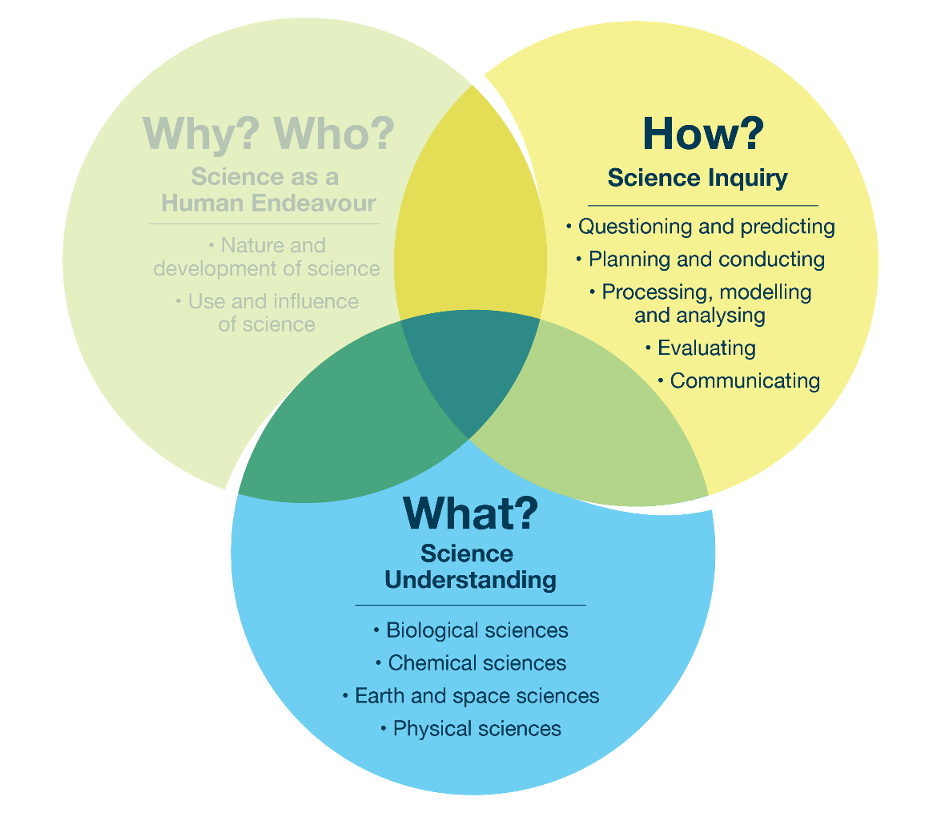  The Venn diagram above shows how teachers might use the interconnected strands to design a teaching and learning unit. For more information about how the Science strands meaningfully intersect, see VCAA Planning for teaching and learning across the Science strands in the Science Resources section of the Victorian Curriculum F–10 Version 2.0 website.
- What is rubbish?
- How do materials change over time?
- How do discarded materials affect land, water and air?
- How do my actions impact the environment?
- What actions can change materials?
- In how many ways can I change materials?
- How do different materials contribute to pollution?
- Where do things go when I have finished with them?
- How can I reduce landfill?
- What is the difference between reducing, re-using and recycling, and why is each important?
- How can materials be sorted?
- How can we re-use materials to make something new?
- What can we make out of rubbish?
- How do my predictions compare with my observations and others’ predictions and observations?
- What other questions do I have?
- How can we help our school community become more sustainable?

Assessment and learning sequence details
Assessment task(s) and type(s) | Linked achievement standard sentence(s) | Moderation
Predicting how materials change (lesson 1)  Type: Diagnostic | They describe the observable properties of the materials that make up objects.  They suggest ways that the use of common materials can be reduced, re-used and recycled, and explain the importance of these actions for sustainability.  Students pose questions about observed patterns or relationships and make predictions related to familiar objects and events. | This task may be moderated by professional learning communities with respect to the Foundation to Level 2 achievement standard, using a representative selection of student work samples. Together the communities can discuss how they will plan to address common misconceptions. This can also be used to inform scaffolding and/or extension opportunities and track student growth throughout the unit.
Sorting rubbish (lesson 3)  Type: Formative | They describe the observable properties of the materials that make up objects.  They use provided tables and organisers to sort and order data, and represent simple patterns in data. | Not applicable
Changing materials (lesson 4)  Type: Formative | They identify ways to change materials without changing their material composition.  They use provided tables and organisers to sort and order data, and represent simple patterns in data. | Not applicable
Creating a game from rubbish (lessons 6–8)  Type: Summative | They provide examples of objects and mixtures that are made from a combination of materials, and distinguish between the properties of objects or mixtures and those of the materials from which they are made.  They identify ways to change materials without changing their material composition.  They suggest ways that the use of common materials can be reduced, re-used and recycled, and explain the importance of these actions for sustainability.  They use provided tables and organisers to sort and order data, and represent simple patterns in data.  They use everyday and some scientific vocabulary to communicate observations, findings and ideas. | This task can be moderated by the professional learning community by using a range of student learning samples and by using a teacher-generated rubric to identify the level of student understanding and skills: either developing, at band (F–2) or above (Levels 3 and 4).
Taking action on sustainability (lesson 9)  Type: Summative | They suggest ways that the use of common materials can be reduced, re-used and recycled, and explain the importance of these actions for sustainability.  With guidance, they compare their own observations and predictions with those of others, and identify further questions for investigation. | Not applicable

Week | Lesson | Learning goal  (e.g. learning intention and success criteria) | Lesson elements | Scaffold towards and/or extend | Assessment | Resources
1 | 1 | Learning intention:  We are exploring our ideas about what ‘rubbish’ is and how it might change over time.  Success criteria:  - I can describe what I think rubbish is.  - I can discuss how the properties of materials might affect how the materials will change over time. | Lesson title: What is rubbish? How do materials change over time?  Overview:  Determine students’ prior understanding of the term ‘rubbish’ and their knowledge of the properties of materials, including how they change over time.  Warm-up activity:  Each student completes the ‘What I think I know’ and ‘What I want to know’ columns of the KWL chart (see ‘Appendix 1’). Students share their knowledge and thinking about what rubbish is, what materials rubbish is made of, where rubbish goes and how the materials can be changed. Students will fill in the ‘What I learned’ column in Lesson 9.  Write all ideas down, including misconceptions, so that students can reflect on how their understanding has changed throughout the unit; teachers can use these to guide future planning.  Explicit teaching:  Discuss students’ ideas about the word ‘rubbish’ by providing suitable scenarios. Here are 2 examples:  - Mark is preparing vegetables to make a soup and he plans to throw out all the food scraps such as carrot peelings, onion skins and turnip tops into the bin. Ask students, ‘Are the food scraps “rubbish”?’  - Sarah is retiling her bathroom and she cuts out tiles to fit around the taps. She plans to throw all the broken tiles, cut-offs and extra tiles into the bin. Monica, her next-door neighbour, is an artist and she asks Sarah for all the cut-offs and broken tiles to make a mosaic garden sculpture. Ask students, ‘What does Sarah think is “rubbish”?’ and ‘What does Monica think is “rubbish”?’  Consider the old saying, ‘One man’s trash is another man’s treasure’. How does this relate to ‘rubbish’?  Show students a variety of rubbish that is made from familiar materials (see ‘Resources’ column for suggested materials) and inform them that they will be burying these and digging them up 8 weeks later.  Students identify the materials and predict how these will change over time.  Use gloves to line the bottom of a plastic container with moist soil, spread the materials over the soil, add more moist soil to cover the materials, and put the lid on the container. Keep the container in a safe, sunny place.  Reflection:  Students share predictions and discuss how the properties of materials might affect how these will change over time. | Enable:  Predictions can be verbal, drawn or written.  Extend:  Grow plants from kitchen scraps (e.g. regrow lettuce, celery, or carrot tops) and document the process through drawings or photos.  Explore online resources such as sustainable farming, community recycling initiatives and recycling facilities.  Read and respond to books with a theme of sustainability (see ‘Resources’ column) and write or draw students’ favourite ideas from the books.  Provide students with a journal to record drawings or ideas on what they can do daily to protect the environment. | Predicting how materials change (diagnostic):  Students will explain why they think certain materials will change in specific ways. This will indicate their understanding of the observable properties of materials and material decomposition. See ‘Assessment and learning sequence details’. | For warm-up activity:  ‘Appendix 1 − KWL chart’  - butcher’s paper for the KWL chart  For explicit teaching:  Resources for predicting how materials change could include:  - materials for burying (e.g. banana peel, plastic chip packet, paper, apple, metal, modelling dough)  - plastic containers with lids  - moist soil  - gloves.  For extension:  Book suggestions:  - The Lorax  Author and illustrator: Dr. Seuss  Publisher: HarperCollins  - Compost Stew  Author: Mary McKenna Siddals  Publisher: Penguin Books Australia
2 | 2 | Learning intention:  We are learning how discarded materials can make pollution and how they can affect Earth’s water, land and air.  Success criteria:  - I can identify how rubbish can travel.  - I can explain how different materials contribute to pollution of water, land and air.  - I can discuss why we don’t like pollution. | Lesson title: How do discarded materials affect land, water and air? How do my actions impact the environment?  Warm-up activity:  Read Ducks Overboard!: A True Story of Plastic in Our Oceans (see ‘Resources’ column).  Introduce the vocabulary term ‘pollution’.  Students identify the pollution described in the text and discuss where the ducks travel (land and water).  Explicit teaching:  Put on gloves and pick up a piece of clean plastic rubbish from the bin. Ask students where rubbish goes after it leaves the bin. Students share their thoughts and ideas. Discuss that rubbish not disposed of correctly can contribute to pollution.  Rotate through 3 stations where students can investigate how pollution affects Earth’s water, land and air.  Model to students how the stations will work:  - Demonstrating air pollution: How do small pollutants travel through the air?  - Spray a scent in the corner of the classroom and ask students to raise their hands when they smell it.  - Students communicate their observations and ideas through drawings that show how the smell travelled through the air.  - Station 1: Landfill model (to observe what happens to rubbish in landfills and why reducing waste is important).  - Layer soil, rubbish items and more soil in a transparent container. Observe how waste stays in the ground and what happens when there is too much rubbish.  - Students communicate their observations and ideas through drawings that show how rubbish affects the land.  - Station 2: Water pollution experiment (to investigate how waste spreads in water and how hard it is to clean up).  - Fill a transparent bowl with water and add safe items like food colouring, glitter and oil to represent pollutants. Students try to remove the pollutants with tools such as spoons and paper towels.  - Students communicate their observations and ideas through drawings that show how rubbish affects the water.  - Station 3: Rubbish travelling in the air demonstration (to demonstrate how easily rubbish can be carried away by wind).  - Place a range of materials on the floor and ask students to use a fan to blow these items.  - Students communicate their observations and ideas through drawings that show how rubbish can travel through the air.  Reflection:  Students share their work and create a class summary together. Students discuss why we don’t like pollution (e.g. due to its negative impact on living things). | Extend:  Students add annotations to their drawings to show their thinking while rotating through stations.  Role-play:  Students act out the journey a piece of rubbish may take (e.g. from being used to being thrown away, recycled or littered). | Communicating (formative):  See ‘Assessment and learning sequence details’. | For warm-up activity:  Ducks Overboard!: A True Story of Plastic in Our Oceans  Author and Illustrator: Markus Motum  Publisher: Walker Books  For explicit teaching:  - Demonstration: a safe and allergy-aware scent that can be sprayed, such as perfume or deodoriser spray. Teachers should demonstrate how to safely waft a scent toward their nose, rather than inhaling directly, to model safe practices and prevent students from breathing in too much of the scent.  - Station 1: transparent container, soil, rubbish, gloves, tongs  - Station 2: transparent bowl, water, food dye, glitter, oil, spoons, paper towel  - Station 3: fan, a range of materials, including some that travel easily through the air (e.g. tissue, plastic bag, balloon, plastic chip packet) and some that don’t
3 | 3 | Learning intention:  We are learning to understand why reducing, re-using and recycling are important.  Success criteria:  - I can explain what ‘reduce, re-use and recycle’ means.  - I can sort rubbish into categories by identifying materials.  - I can discuss what materials can be reduced, re-used and recycled. | Lesson title: What is the difference between reducing, re-using and recycling, and why is each important? How can materials be sorted?  Warm-up activity:  Place a range of clean and safe rubbish materials in a box and ask students to feel inside without looking. Students use their sense of touch to predict what rubbish is in the box by identifying the properties of the materials.  Explicit teaching:  Create an anchor chart and explain how our rubbish can be:  - reduced: Cut back on the amount of rubbish we produce, for example by choosing products with less packaging.  - re-used: Use something again for the same purpose or a different purpose without breaking it down; for example, plastic bags can be re-used to carry something or could be used to line a rubbish bin.  - recycled: Break something down and use the pieces to make something new, for example melting plastic from bottles and turning it into playground equipment, or putting fruit scraps into a compost bin to produce fertiliser for a garden.  Students discuss the importance of each action and together categorise the materials from the warm-up activity as either being reduced, re-used or recycled based on the properties of the materials.  Before revealing the rubbish you have collected, ask students to predict what type of materials they would expect to find in the school grounds (e.g. plastic, paper, metal), what there would be most of, and where it would be (e.g. plastic rubbish near the canteen).  Show students the rubbish you have collected, and ask them to sort and organise descriptions and/or drawings of the items in a table according to the material (see ‘Appendix 2’).  Reflection:  Ask students to explain what they noticed about their table, and what surprised them.  Together, analyse the table and discuss which materials can be reduced, re-used or recycled. For example, plastic food packets can be reduced; clean cardboard or clean plastic bags can be re-used; paper can be recycled; fruit and vegetable scraps can also be recycled by composting. | Enable:  Draw the rubbish that was collected.  Extend:  Add labels to show whether the material could be reduced, re-used or recycled. | Sorting rubbish (formative):  Review whether students were effectively able to sort data into tables. See ‘Assessment and learning sequence details’. | For warm-up activity:  Box, clean safe rubbish materials (e.g. plastic chip packet, magazine, newspaper, plastic bottle, foil ball)  For lesson preparation:  Disposable or garden gloves, tongs, bucket  ‘Appendix 2 – Sorting rubbish’
4 | 4 | Learning intention:  We are learning to understand how different actions change materials.  Success criteria:  - I can identify how materials change.  - I can predict how materials might change when I perform different actions.  - I can use a table to show my observations.  - I can ask questions to further investigate how actions might change materials. | Lesson title: Changing materials  Warm-up activity:  Challenge students to make as many changes to modelling dough as they can in one minute. Write these actions on the board; these may include tearing, twisting, bending, squashing and rolling.  Explicit teaching:  Squash, twist, cut and bend the modelling dough used in the warm-up activity, and ask students to follow and discuss what they notice about each action.  Use a material such as chalk to demonstrate that crushing is different to squashing, as these terms are often misunderstood.  Set up stations or trays with various material samples for students to view and record their predictions for how actions could physically change each material. After recording their predictions, students physically touch each material and record their observations (see ‘Appendix 3’).  Reflection:  After testing, students ask questions for further investigation, for example, ‘What other materials can be crushed? Can all fabrics be cut?’ | Enable:  Students write ‘Y’ or ‘N’ to denote whether or not a material can be changed by each action.  Extend:  Write justifications to explain thinking or use diagrams and symbols such as arrows to show changes. | Can actions change these materials? (formative)  Note whether students can:  - make a prediction  - identify the correct action  - sort data in a prepared table  - ask questions for further investigation. | For warm-up activity:  A small ball of modelling dough per student  For explicit teaching:  ‘Appendix 3 – Can actions change these materials?’  Materials for performing actions: fabric, elastic band, paper, chalk, icy pole stick, modelling clay and scissors
5 | 5 | Learning intention:  We are learning to understand how to use actions to recycle materials.  Success criteria:  - I can explain what recycling means.  - I can identify actions that can recycle materials.  - I can discuss why recycling is important for sustainability. | Lesson title: What actions are needed to recycle materials? Why is this important?  Warm-up activity:  Revise Lesson 4 by asking students to predict what actions could change paper. When they list ‘tear’, inform them that today they will be breaking down paper to recycle it into something new. Set a 2-minute timer and have the class work as a team to tear up the paper into small pieces. Half-fill a small bowl or plastic ice-cream container with the torn paper and cover with water to soak. When the paper has softened, use a stick blender to change the mixture into pulp. Students observe changes.  Explicit teaching:  Revise what recycling means from Lesson 3, for example melting plastic from bottles and turning into something new such as playground equipment, or putting fruit scraps in a compost bin to produce fertiliser for the garden.  Students use pulp and place it into yoghurt containers or silicone muffin trays to make paper-pulp cups in which to plant seeds. Place to the side and dry, then students can take these home.  Reflection:  Students discuss why recycling is important for sustainability and identify other things that could be made with paper pulp. Examples include handmade paper, simple masks (shape pulp on a flat surface or over a balloon to create a mask; add cut-out eye holes once dried; decorate for pretend play or for cultural celebrations), picture frames (mould pulp into a frame shape or press it around a sturdy cardboard base), hanging ornaments (stars, hearts or circles), pulp beads, pulp flowers (shape petals and leaves from pulp, and then assemble to make flowers and/or bouquets), 3D collages and piggy banks (use a balloon as the body, add cardboard body parts, paper mâché over the construction, and add a slot for the money).  Inform students they will need to collect materials they can re-use the following week. | Extend:  Draw and label the changes made to paper. |  | For explicit teaching:  Instructions for creating seed starters out of paper pulp: Christine Wallace, 365 days of DIY  Materials: shredded paper, water, stick blender, silicone muffin trays/recycled yoghurt containers  Optional: seeds and soil for students to take home and plant in the cup
6 | 6 | Learning intention:  We are learning to change materials to reduce, re-use and recycle.  Success criteria:  - I can describe how changing materials can help us reduce, re-use and recycle.  - I can describe how reducing, re-using and recycling help the environment.  - I can identify the actions I have performed to change material. | Lesson title: How can I change materials to reduce, re-use and recycle?  Warm-up activity:  Read a picture storybook about re-using and recycling (see ‘Resources’ column). Students discuss how these stories inspire people to reduce, re-use and recycle, or inspire people to take responsibility for reducing, re-using and recycling.  Explicit teaching:  Brainstorm fun games students like to play such as hoop toss, bowling, marble run, basketball and checkers.  Discuss the questions, ‘What materials are usually used to make these games? Can we re-use or recycle materials to make similar games?’.  See VCAA Example assessment task: Creating a game from rubbish.  Students follow the steps across lessons 6–8 to design and build a game, drawing and recording in the spaces provided in the example assessment task.  Lesson 6:  - Sort clean rubbish provided by the teacher into different categories (e.g. bottles, caps, boxes, paper, plastic).  - Look at the collected rubbish and think of a game that you could make.  - Draw an annotated diagram of your design in the space provided under ‘My game design’, including the names of the materials and how you will make your game.  Reflection:  Asking questions about how physically changing materials helps people to re-use them in a variety of ways, and to decrease waste. For example, ‘When I have finished with my game, can I recycle the materials?’. | Enable:  Display terminology of materials on the board to assist students with labelling. | Creating a game from rubbish (summative):  See VCAA Example assessment task: Creating a game from rubbish and ‘Assessment and learning sequence details’. | For warm-up activity:  Book suggestions:  - Title: The Most Magnificent Thing  Author and illustrator: Ashley Spires  Publisher: Kids Can Press  - Title: Don’t Throw That Away!  Author: Lara Bergen  Illustrator: Betsy Snyder  Publisher: Simon & Schuster  - Title: Made by Maxine  Author: Ruth Spiro  Illustrator: Holly Hatam  Publisher: Penguin Random House  - Title: One Little Bag: An Amazing Journey  Author and Illustrator: Henry Cole  Publisher: Scholastic
7 | 7 | Learning intention:  We are learning to understand how changing materials helps to reduce, re-use and recycle.  Success criteria:  - I can identify the actions I performed to change materials and use a table to display them.  - I can describe how materials can be reduced, re-used or recycled.  - I can test and make changes to my game. | Lesson title: How can I change materials to re-use, reduce and recycle?  Warm-up activity:  Ask students to share their thoughts about what they will be doing with materials as they make their games. Will they be reducing materials going to landfill, re-using materials for a new purpose or recycling materials by breaking them down and rebuilding them?  Explicit teaching:  See VCAA Example assessment task: Creating a game from rubbish.  Students follow the steps across lessons 6–8 to design and build a game, drawing and recording in the spaces provided in the example assessment task.  Students complete the following steps:  - Make your game.  - Complete the ‘Changing materials data table’, describing at least 3 changes you made to materials. Below the table, describe how making your game has helped the environment.  - Complete the ‘Rating my game’ worksheet.  Reflection:  Students read the feedback from other students and make changes. | Extend:  If students finish early, they can play another student’s game. They then provide feedback (see ‘Assessment’ column). | Creating a game from rubbish (summative):  See VCAA Example assessment task: Creating a game from rubbish and ‘Assessment and learning sequence details’. | For explicit teaching:  Students will bring in clean recycled materials.  The teacher could provide extra recycled materials as well as scissors, tape, glue, etc.  The teacher could set up a ‘helping station’ with a hot glue gun and utility knife.
8 | 8 | Learning intention:  We are learning to evaluate our games by comparing observations.  Success criteria:  - I can explain how making my game helped reduce, re-use or recycle materials and explain the importance of this for sustainability.  - I can explain how we can all contribute to reducing, re-using and recycling. | Lesson title: How can I provide feedback and evaluate my game?  Warm-up activity:  Show students a cup and ask them to brainstorm as many ways to re-use it as possible, for example as a hat, a pen holder or a bird feeder. Encourage students to be creative.  Explicit teaching:  VCAA Example assessment task: Creating a game from rubbish.  Students follow the steps across lessons 6–8 to design and build a game, drawing and recording in the spaces provided in the example assessment task.  Encourage students to think creatively and to offer other students constructive feedback with specific suggestions for improvement.  Students complete the following steps:  - Place your game on display in the classroom, then play some games displayed by other students.  - Provide a short evaluation of another student’s game in the ‘Feedback to a peer’ worksheet.  - Using feedback for your game, finish building your game, test it and make changes to improve it.  Reflection:  Students reflect on their learning while creating a game and discuss other ways they can reduce, re-use and recycle materials at home and at school.  Students reflect on reconceptualising the concept of ‘rubbish’ by responding to the question, ‘Is rubbish really rubbish?’ |  | Creating a game from rubbish (summative):  See VCAA Example assessment task: Creating a game from rubbish and ‘Assessment and learning sequence details’.
9 | 9 | Learning intention:  We are learning to reflect on ways we can reduce, re-use and recycle to take action and help our school community become more sustainable.  Success criteria:  - I can compare my predictions and observations with other students.  - I can identify new questions based on what I learned.  - I can discuss what I know about reducing, re-using and recycling and identify an action we could take at school to be more sustainable.  - I can explain to others why it is important for everyone to take action for more sustainable practices at school. | Lesson title: How can we help our school community become more sustainable?  Warm-up activity:  Students share their predictions about buried materials from Lesson 1 with another student. Dig up the buried materials and observe the changes that have happened. Students compare these observations with another student and discuss further questions they have, for example ‘Will the apple eventually turn into a tree? How long will it take for the plastic to break down? Would the banana peel break down more if it was in a worm farm?’  Explicit teaching:  Re-read the ‘What I think I know’ column of the KWL chart completed in Lesson 1, and discuss how some thinking may have changed, then fill in the ‘What I learned’ column of the chart.  Students think about personal responsibility and identify an action they can take to reduce, re-use and recycle waste at our school. This could include:  - writing letters to create a ‘nude food’ competition, a worm farm or a compost bin  - designing and creating a ‘stop and think’ poster to encourage mindful waste disposal. For example, it could be placed next to the classroom bin with a message such as ‘Before you toss me in ... stop and think! Can I be re-used?’  - creating mini-information posters.  Reflection:  Students share their chosen action with their class and reflect on the unit’s focus question, ‘Rethink rubbish! Where could it go?’ Students should make connections between rubbish that could accidentally go to environments such as the ocean, if not disposed of correctly, and rubbish that could become something new and useful. | Extend:  Students action their plans. | Taking action on sustainability (summative):  Note whether students can:  - compare predictions and observations  - identify further questions to be investigated  - discuss reducing, re-using and recycling materials and how this is important for sustainability  - identify an action they can take to change materials to be more sustainable at school. | For warm-up activity:  KWL chart from Lesson 1 (see ‘Appendix 1’)  For reflection:  Soil, paper cups from Lesson 1, seeds, water, gloves

Unit reflection
Throughout and at the end of the unit, evaluate the teaching and learning unit and refine and adjust as necessary.
Reflection questions:
- How does the teaching and learning unit provide evidence of student learning and progress?
- Does the teaching and learning unit:
- specify the achievement standard sentences addressed in the unit
- specify the content descriptions addressed in the unit
- include the resources and learning activities used to develop knowledge and skills
- provide for a range of student abilities
- specify the assessments used to monitor and progress student learning
- provide the approximate time required for the unit?
- Considering your responses to the questions above and other relevant reflections, how can the teaching and learning unit be improved?
- How will the evidence of student learning from this teaching and learning unit influence subsequent teaching and learning units?
Responses:
- Pre-assessment in the first lesson of the teaching and learning unit through discussion and observation enables teachers to determine student understanding of science terminology related to materials and their use, re-use and recycling. This serves as a starting point for the teacher to modify/adapt further lessons. The unit has a balance of formative and summative assessment throughout, so that student learning can be monitored across the unit and early intervention/extension/reinforcement can be implemented as needed for each student.
- The unit specifies the 8 content descriptions and their associated achievement standard sentences that relate to the Science Understanding and Science Inquiry strands. Future modifications may include incorporating Science as a Human Endeavour content and/or linking explicitly to other learning areas.
- The unit describes the learning activities used to develop scientific concepts, knowledge, skills and processes, and provides links to related resources. The mix of short, snappy warm-up activities and the more extended challenges keep students engaged and motivated. This reflects the investigative nature of this learning area, and it is anticipated that this will be a feature of future units, too.
- The activities and assessments provide multiple entry points for students and support diverse learners.
- The unit caters well for a range of student abilities. Suggestions for extension are useful and the intent is to continue to develop activities that extend and enable students as needed.
- The range of diagnostic, formative and summative assessments enable determination of whether each student had met the achievement standard being assessed. There are multiple opportunities for students to develop and reinforce their understanding and skills.
- A games day tournament could be organised so that families are more directly involved in their children’s learning, and so that students have the opportunity to present their games to a wider audience.
- This unit provides opportunities to link with other learning areas, particularly Design and Technologies. The unit could also incorporate Science as a Human Endeavour more explicitly by including a visit to a recycling facility or an invitation to a guest speaker to talk about sustainable recycling practices (Use and influence of science), and by exploring with students how people discovered new ways to recycle materials and invent machines that sort rubbish (Nature and development of science).
- In this unit, students learn about the physical properties of materials through hands-on manipulation of a variety of familiar material samples. This prepares students for future units where they learn that materials can also be chemically changed to form new substances, and that materials can be classified as solids, liquids and gases (each of which have their own characteristic properties). Their skills in making predictions are further developed in future units where they base their predictions on observations, rather than rely on their own experiences. They move from completing provided tables in this unit to constructing their own simple tables to record results in future units. In comparing findings with others, students begin to recognise that people may observe or interpret things differently, laying the groundwork for respectful scientific discussion and collaboration in future units.
- This unit can be extended to allow time for students to complete their actions, for example presenting their letters to the principal or placing their posters around the school.

Appendix 1 – KWL chart (lessons 1 and 9)
A KWL chart helps students guide their learning by tracking what they think they know (K), what they want to know (W) and what they have learned (L) about a topic.
It can be used before, during and/or after learning to guide curiosity, monitor progress and reinforce understanding.
Question | What I think I know | What I want to know | What I learned
What is rubbish?

What materials is rubbish made of?

Where does rubbish go?

How do these materials change?

Appendix 2 – Sorting rubbish (Lesson 3)
Use this table to count and write how many pieces of each material you found in the rubbish.
Material | Count | Total
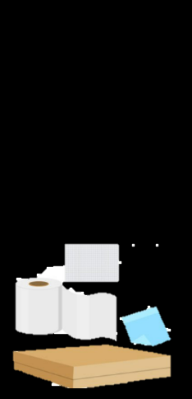
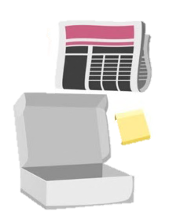
Paper or cardboard

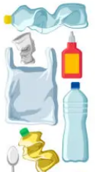
Plastic

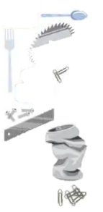
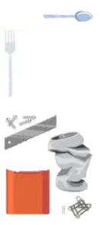
Metal

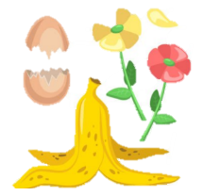
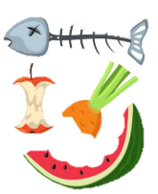
Organic (e.g. food, plants)


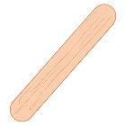
Wood

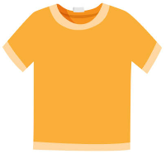
Fabric

Image sources:
(1–4) iStock.com/bestsale
(5–6) iStock.com/designer29 and iStock.com/LAUDISENO
Next page: iStock.com/Chi-tan

Appendix 3 – Can actions change these materials? (Lesson 4)
- Predict if each material can be changed by each action, writing ‘Y’ or ‘N’ for each material.
- Test your predictions and record your observations.
Action | Material
Action | Fabric |  | Paper |  | Icy pole stick |  | Chalk |  | Elastic band |  | Modelling dough
Action | Prediction  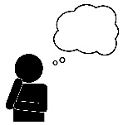 | Observation   | Prediction  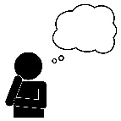 | Observation | 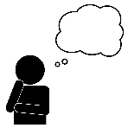  Prediction | Observation | Prediction | Observation | Prediction  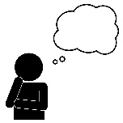 | Observation | Prediction  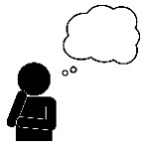 | Observation
Break
Squash
Twist
Cut
Tear
Bend
Crush
Stretch

