Example assessment task
Level 8 – Pythagoras’ theorem

Overview
Pythagoras’ theorem is used to find the length of a side of a right-angled triangle given the lengths of the other 2 sides.
It can also be used to calculate the distance between 2 points in the Cartesian plane, given their coordinates or positions on a graph.
This example assessment task requires students to apply the theorem to determine lengths in situations that can be represented using right-angled triangles. This includes:
- determining the length of the hypotenuse given the lengths of the other 2 shorter sides
- determining the length of one of the shorter sides given the length of the hypotenuse and the length of the other shorter side
- modelling situations using right-angled triangles, solving related problems involving the length of a side and interpreting the solution in context
- identifying Pythagorean triples, that is, positive integers {a, b, c} that satisfy the equation
a² + b² = c²
- generating Pythagorean triples using the formulas a = m² − n², b = 2mn, c = m² + n² where m and n are positive integers and m > n.

Curriculum connection (Victorian Curriculum Mathematics Version 2.0)
Level 8 achievement standard (linked sentence) | Level 8 content description
They use Pythagoras’ theorem to solve measurement problems involving unknown lengths of right-angled triangles. | use Pythagoras’ theorem to solve problems involving the side lengths of right-angled triangles  VC2M8M06

Equipment and duration
The example assessment task is designed to be completed individually and completed over 1 to 2 lessons of 50-minute duration.
Students will require a ruler and a scientific calculator to complete the task.

Assessment task, with teacher notes

Question 1
The following triangles are drawn to scale on 1 cm grid graph paper.
For each triangle:
- estimate the length of the hypotenuse to the nearest centimetre
- use a ruler to measure the length of the hypotenuse to the nearest millimetre
- use Pythagoras’ theorem to calculate the length of the hypotenuse as a square root, showing the substitution into the formula and steps of working to obtain the answer
- give a numerical approximation to this length, correct to 2 decimal places, and compare this with your answer from ii.
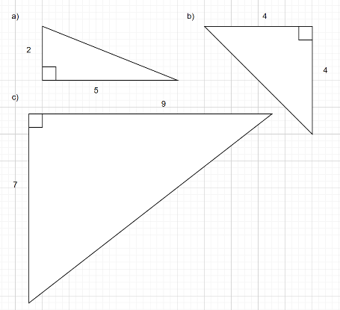

Teacher notes
This part of the task addresses the aspect of the achievement standard ‘use Pythagoras’ theorem to solve measurement problems involving unknown lengths of right-angled triangles’ with respect to the determination of the length of the hypotenuse of a right-angled triangle given the lengths of the 2 shorter sides identified from a scale diagram.
It involves:
- identifying lengths from a simple to-scale diagram on a grid
- using relevant spatial, numerical and algebraic conventions, notations and terminology
- estimating a length to a reasonable accuracy
- measuring with a ruler to a specified accuracy (rounded to the nearest mm) to form an estimate
- applying Pythagoras’ theorem (with no subtraction involved) to calculate a length as a square root of a natural number
- giving a numerical approximation to a specified accuracy using technology
- comparing the measured value with the calculated value.

Question 2
For each of the following triangles:
- use Pythagoras’ theorem to calculate the length of the missing side as a square root, showing the substitution into the formula and steps of working to obtain the solution
- give a numerical approximation to this length, correct to 3 decimal places.
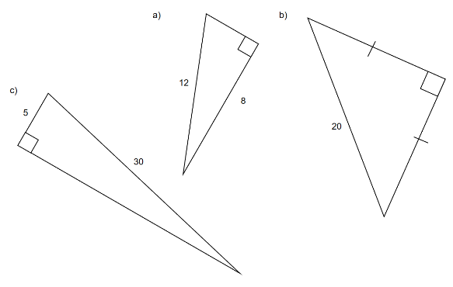

Teacher notes
This part of the task addresses the aspect of the achievement standard ‘use Pythagoras’ theorem to solve measurement problems involving unknown lengths of right-angled triangles’ with respect to the determination of the length of one of the shorter sides of a right-angled triangle given the length of the hypotenuse and the length of the other shorter side. The information is provided on not-to-scale diagrams.
It involves:
- identifying relevant information from a not-to-scale diagram
- use of relevant spatial, numerical and algebraic conventions, notations and terminology
- applying Pythagoras’ theorem with subtraction involved, to calculate the length of a shorter side as a square root of a natural number
- giving a numerical approximation to a specified accuracy using technology.

Question 3
For each of the following situations:
- use a right-angled triangle to draw a diagram that represents the situation
- solve the problem, showing all working, and state the required length as a square root
- approximate the answer to a suitable accuracy and interpret the solution for the context.

Situation 1
A thin vertical pole is 20 m high, and is supported by a set of identical cables. Each cable is anchored to the ground a distance of 8 m from the base of the pole.
What is the length of a cable from the ground to the top of the pole?

Situation 2
An advertising sign is shaped as an equilateral triangle with side lengths 100 cm.
What is the height of the sign?

Situation 3
- A right-angled triangle has all 3 sides with integer lengths. One of the sides is 8 cm.
What could be a possible length for each of the other 2 sides? Could the 8 cm side be the hypotenuse?
- Use the formulas a = m² − n², b = 2mn, c = m² + n² for m = 5 and n = 3 to find values for a, b and c and show that they form a Pythagorean triple. Use this to find a smaller Pythagorean triple.
Note: iii. does not apply as the answers are integers.

Situation 4
Consider the line segment joining the points with coordinates (−4, 8) and (10, 2).
Plot these 2 points on 1 cm grid graph paper with a 1:1 scale and draw in the line segment.
What is the length of the line segment?

Teacher notes
This part of the task addresses the aspect of the achievement standard ‘use Pythagoras’ theorem to solve measurement problems involving unknown lengths of right-angled triangles’ with respect to the formulation-solution-interpretation problem-solving process. Diagrams are not provided.
It involves:
- identifying relevant information and modelling the problem using a right-angled triangle representation
- applying Pythagoras’ theorem to calculate the required length
- interpreting the solution in context, including use of a numerical approximation to a suitable accuracy.

► A student version of the assessment task has been included in the following pages.

Assessment task: Pythagoras’ theorem

Question 1
The following triangles are drawn to scale on 1 cm grid graph paper.
For each triangle:
- estimate the length of the hypotenuse to the nearest centimetre
- use a ruler to measure the length of the hypotenuse to the nearest millimetre
- use Pythagoras’ theorem to calculate the length of the hypotenuse as a square root, showing the substitution into the formula and steps of working to obtain the answer
- give a numerical approximation to this length, correct to 2 decimal places, and compare this with your answer from ii.
Triangle a:
- Estimate of the length of the hypotenuse

- Measurement of the length of the hypotenuse

- Length of the hypotenuse using Pythagoras’ theorem

- Numerical approximation to this length, correct to 2 decimal places.
How does it compare with your answer from ii?

Triangle b:
- Estimate of the length of the hypotenuse

- Measurement of the length of the hypotenuse

- Length of the hypotenuse using Pythagoras’ theorem

- Numerical approximation to this length, correct to 2 decimal places.
How does it compare with your answer from ii?

Triangle c:
- Estimate of the length of the hypotenuse

- Measurement of the length of the hypotenuse

- Length of the hypotenuse using Pythagoras’ theorem

- Numerical approximation to this length, correct to 2 decimal places.
How does it compare with your answer from ii?

Question 2
For each of the following triangles:
- use Pythagoras’ theorem to calculate the length of the missing side as a square root, showing the substitution into the formula and steps of working to obtain the solution
- give a numerical approximation to this length, correct to 3 decimal places.
Triangle a:
- Missing side length

- Numerical approximation, correct to 3 decimal places

Triangle b:
- Missing side length

- Numerical approximation, correct to 3 decimal places

Triangle c:
- Missing side length

- Numerical approximation, correct to 3 decimal places

Question 3
For each of the following situations:
- use a right-angled triangle to draw a diagram that represents the situation
- solve the problem, showing all working, and state the required length as a square root
- approximate the answer to a suitable accuracy and interpret the solution for the context.

Situation 1
A thin vertical pole is 20 m high, and is supported by a set of identical cables. Each cable is anchored to the ground a distance of 8 m from the base of the pole.
What is the length of a cable from the ground to the top of the pole?

Situation 2
An advertising sign is shaped as an equilateral triangle with side lengths 100 cm.
What is the height of the sign?

Situation 3
- A right-angled triangle has all 3 sides with integer lengths. One of the sides is 8 cm.
What could be a possible length for each of the other 2 sides? Could the 8 cm side be the hypotenuse?

Note: iii. does not apply as the answers are integers.
- Use the formulas a = m² − n², b = 2mn, c = m² + n² for m = 5 and n = 3 to find values for a, b and c and show that they form a Pythagorean triple. Use this to find a smaller Pythagorean triple.

Situation 4
Consider the line segment joining the points with coordinates (−4, 8) and (10, 2).
Plot these 2 points on 1 cm grid graph paper with a 1:1 scale and draw in the line segment.

What is the length of the line segment?

- Answer this on the grid above.

