English Level 9 map – template

Use this curriculum area map to identify where achievement standards and content descriptions are explicitly addressed within your school’s teaching and learning units. This template will help you to both map the Victorian Curriculum F–10 Version 2.0 and audit your current teaching and learning units.

Instructions
- Enter your details in the footer on page 1.
- Look over the Curriculum Mapping tables on page 2 onwards. Read the information and important notes, below.
- Enter the title of your teaching and learning units into each part of the mapping table. Indicate each teaching and learning unit’s connections to the curriculum by checking the box of the relevant content description(s) and writing the number(s) of the connected achievement standard extract. Refer to the VCAA ‘Connections between the achievement standards and content descriptions’ support resource if necessary.
- Check that all content descriptions have been covered at least once.
- Detail any comments, notes and actions.
- Complete the Check of Achievement Standard Coverage table.
- Complete the Assessment, Analysis of Curriculum Coverage and Next Steps sections on the final page.
About the achievement standards in English:
In English, achievement standards are organised via the language modes (Speaking and Listening, Reading and Viewing, and Writing). At every level there are 5 key achievement standard extracts, each beginning ‘When …’ (see the diagram, right). The 5 achievement standard extracts can be connected to content descriptions across the 3 strands of Language, Literature and Literacy. For more information about how the achievement standards and content descriptions are connected in English Version 2.0, see Learning in English.
The VCAA has published tables that help map these connections for you; see the ‘Connections between the achievement standards and content descriptions’ support resources.
Important notes:
- Refer to the VCAA ‘Connections between the achievement standards and content descriptions’ support resource (see Learning in English) before completing the mapping table in this document.
- Some content descriptions connect to more than one language mode so, in some teaching and learning units, you might connect some content descriptions to more than one achievement standard extract.
- Make sure you use the Check of Achievement Standard Coverage table to check that you are assessing all the achievement standard extracts.
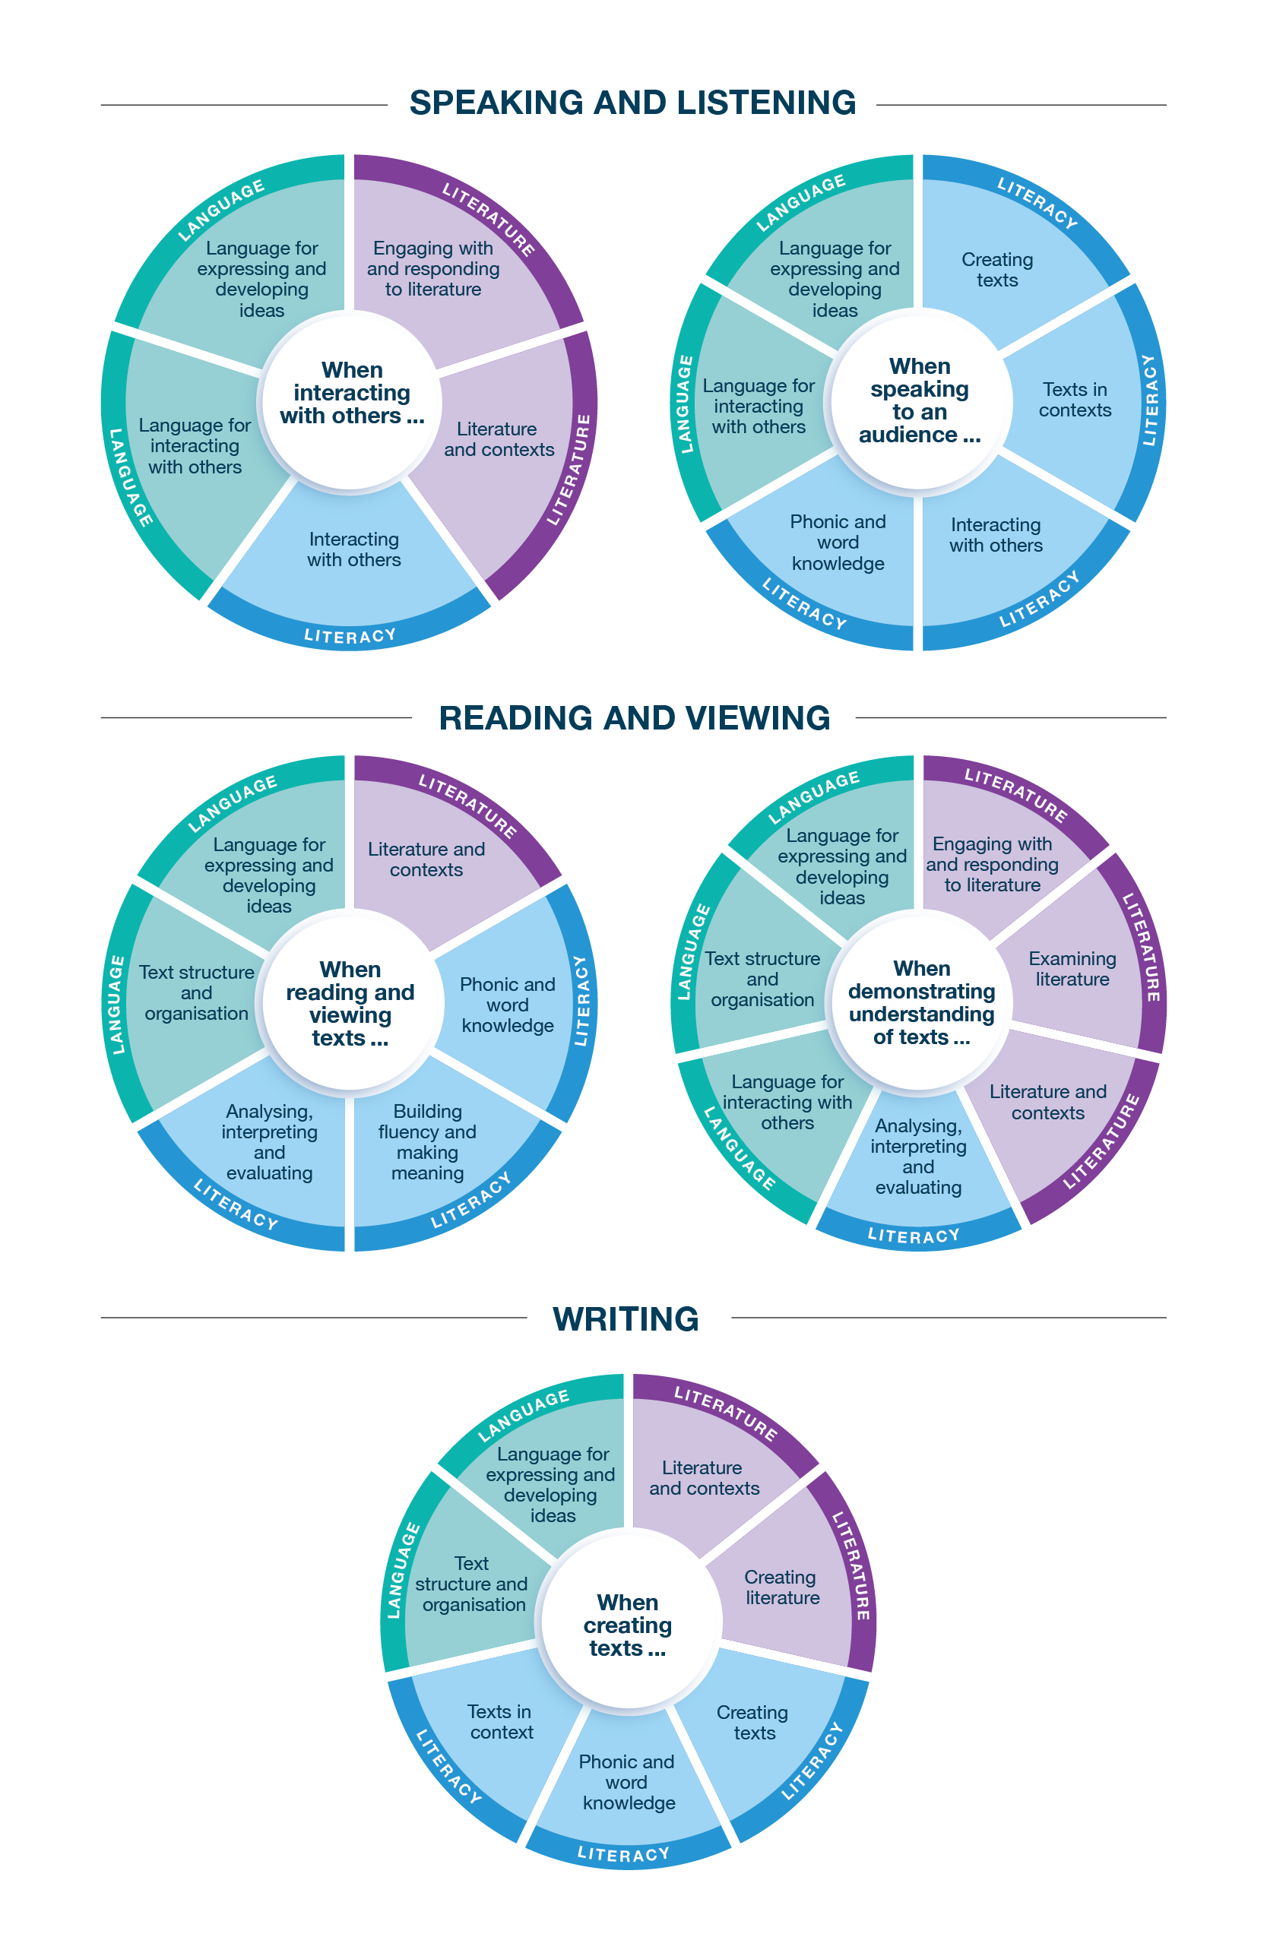
Connecting the achievement standards and sub-strands

Curriculum Mapping
Achievement standard (AS), with numbered extracts
Speaking and Listening | Reading and Viewing | Writing
1. When interacting with others, students explore vocabulary of mood and style and use language to strengthen relationships and roles.  They discuss opinions on texts. They use evaluative and substantiative language to express individual views. | 3. When reading and viewing, students engage with a range of different types of texts for meaning.  They engage with vocabulary and grammatical knowledge, including the ways that sentence structures are varied for creative effect and how punctuation supports citation and reference. | 5. When creating written and spoken texts, students present ideas through a point of view and/or a voice. They experiment with textual elements and include appropriate multimodal or digital elements. They review and edit their own and others’ texts for clarity and control and reflect on these processes.  They experiment with text structures for cohesion and sequence, vary grammar for creative effect and use punctuation to condense and link ideas.  They use vocabulary that contributes to style, mood and tone. They use language features and literary devices to create hybrid texts.  They explore standard and non-standard spelling for creative effect.
2. When speaking to an audience, students deliver structured spoken texts, selecting text types appropriate for purpose and audience, including multimodal or digital elements. They demonstrate different levels of formality in their language choice and use appropriate features of voice. | 4. When demonstrating understanding of texts, students discuss their responses to texts from diverse historical, cultural and social contexts, and they compare initial and subsequent impressions. They explore different responses, including personal impressions. They analyse how language and/or still and moving images and sound represent values, beliefs and attitudes and are used to shape audiences’ preferences. They analyse the relationship between text structures, language features, literary devices and intertextual connections.  They explore how authors adapt and experiment with texts, including print, digital and hybrid, according to purpose. They analyse how literary devices, including poetic features, create meaning and aesthetic qualities. They analyse how symbols in still and moving images, and sound effects, create meaning.

 | Strand | Language
 | Sub-strand | Language for interacting with others |  |  |  | Text structure and organisation |  |  |  | Language for expressing and developing ideas
 | Content description (CD) | understand how language strengthens relationships and roles  VC2E9LA01 |  | understand how the language of evaluation and substantiation expresses individual views and values through language features such as allusion, evocative vocabulary and metaphor  VC2E9LA02 |  | explore the ways that text structures and language features can be adapted and altered according to purpose  VC2E9LA03 |  | understand how a range of cohesive devices, including nominalisation, condense information in texts and link, expand and sequence ideas  VC2E9LA04 |  | explore how authors vary sentence structures for effect, such as using a sentence fragment, or intentionally using a dependent clause on its own  VC2E9LA05 |  | understand how abstract nouns can be used to summarise ideas in text  VC2E9LA06 |  | analyse how symbols in still and moving images and the use of sound augment meaning  VC2E9LA07
Teaching and learning unit | Semester/Year | CD | AS no. | CD | AS no. | CD | AS no. | CD | AS no. | CD | AS no. | CD | AS no. | CD | AS no.
 |  | ☐ |  | ☐ |  | ☐ |  | ☐ |  | ☐ |  | ☐ |  | ☐
 |  | ☐ |  | ☐ |  | ☐ |  | ☐ |  | ☐ |  | ☐ |  | ☐
 |  | ☐ |  | ☐ |  | ☐ |  | ☐ |  | ☐ |  | ☐ |  | ☐
 |  | ☐ |  | ☐ |  | ☐ |  | ☐ |  | ☐ |  | ☐ |  | ☐
 |  | ☐ |  | ☐ |  | ☐ |  | ☐ |  | ☐ |  | ☐ |  | ☐
 |  | ☐ |  | ☐ |  | ☐ |  | ☐ |  | ☐ |  | ☐ |  | ☐

 | Strand | Language continued
 | Sub-strand | Language for expressing and developing ideas continued
 | Content description (CD) | analyse how vocabulary choices contribute to style, mood and tone  VC2E9LA08 |  | understand and use punctuation conventions to condense information and for referencing and citing others for formal and informal purposes  VC2E9LA09
Teaching and learning unit | Semester/Year | CD | AS no. | CD | AS no.
 |  | ☐ |  | ☐
 |  | ☐ |  | ☐
 |  | ☐ |  | ☐
 |  | ☐ |  | ☐
 |  | ☐ |  | ☐
 |  | ☐ |  | ☐

 | Strand | Literature
 | Sub-strand | Literature and contexts |  | Engaging with and responding to literature |  |  |  | Examining literature |  |  |  | Creating literature
 | Content description (CD) | analyse the representations of people and places in literary texts, drawn from diverse historical, cultural and social contexts, by Aboriginal and Torres Strait Islander authors and a wide range of Australian and world authors  VC2E9LE01 |  | explore and develop responses, including personal responses, to literary texts, comparing initial and subsequent impressions  VC2E9LE02 |  | analyse how literary devices and language features, and still and moving images, shape an audience’s preference about the social, moral or ethical positions presented in literary texts  VC2E9LE03 |  | analyse the effect of text structures, language features and literary devices such as extended metaphor, metonymy, allegory, symbolism and intertextual references  VC2E9LE04 |  | analyse the ways that text structures, language features and literary devices in literary texts create aesthetic qualities  VC2E9LE05 |  | create texts, which may be hybrid, that experiment with literary text structures, language features and devices, and voice, for purposes and audiences  VC2E9LE06
Teaching and learning unit | Semester/Year | CD | AS no. | CD | AS no. | CD | AS no. | CD | AS no. | CD | AS no. | CD | AS no.
 |  | ☐ |  | ☐ |  | ☐ |  | ☐ |  | ☐ |  | ☐
 |  | ☐ |  | ☐ |  | ☐ |  | ☐ |  | ☐ |  | ☐
 |  | ☐ |  | ☐ |  | ☐ |  | ☐ |  | ☐ |  | ☐
 |  | ☐ |  | ☐ |  | ☐ |  | ☐ |  | ☐ |  | ☐
 |  | ☐ |  | ☐ |  | ☐ |  | ☐ |  | ☐ |  | ☐
 |  | ☐ |  | ☐ |  | ☐ |  | ☐ |  | ☐ |  | ☐

 | Strand | Literacy
 | Sub-strand | Interacting with others |  | Word knowledge |  |  |  | Texts in context |  | Analysing, interpreting and evaluating
 | Content description (CD) | use interaction skills to discuss opinions regarding texts that have different purposes and audiences, analysing how language features position an audience to respond in particular ways  VC2E9LY01 |  | deliver structured spoken texts for particular purposes, demonstrating different levels of formality in consideration of audience, using features of voice and multimodal or digital elements  VC2E9LY02 |  | use learnt knowledge to spell accurately and consistently, and understand that non-standard spelling is used in texts for particular effects, such as characterisation and humour, and to represent accents and distinctive speech  VC2E9LY03 |  | analyse how representations of people, places, events and concepts reflect contexts  VC2E9LY04 |  | analyse and evaluate how language features are used to explicitly represent values, beliefs and attitudes  VC2E9LY05 |  | analyse the organisation of ideas in paragraphs and extended texts, and evaluate its impact on meaning  VC2E9LY06 |  | use comprehension strategies such as visualising, predicting, connecting, summarising, monitoring, questioning and inferring to compare and contrast ideas and opinions in and between texts  VC2E9LY07
Teaching and learning unit | Semester/Year | CD | AS no. | CD | AS no. | CD | AS no. | CD | AS no. | CD | AS no. | CD | AS no. | CD | AS no.
 |  | ☐ |  | ☐ |  | ☐ |  | ☐ |  | ☐ |  | ☐ |  | ☐
 |  | ☐ |  | ☐ |  | ☐ |  | ☐ |  | ☐ |  | ☐ |  | ☐
 |  | ☐ |  | ☐ |  | ☐ |  | ☐ |  | ☐ |  | ☐ |  | ☐
 |  | ☐ |  | ☐ |  | ☐ |  | ☐ |  | ☐ |  | ☐ |  | ☐
 |  | ☐ |  | ☐ |  | ☐ |  | ☐ |  | ☐ |  | ☐ |  | ☐
 |  | ☐ |  | ☐ |  | ☐ |  | ☐ |  | ☐ |  | ☐ |  | ☐

 | Strand | Literacy continued
 | Sub-strand | Creating texts
 | Content description (CD) | create different types of texts, written and spoken, that present a point of view and advance, illustrate or expand ideas, including texts that integrate print, multimodal and/or digital elements in deliberate consideration of an audience  VC2E9LY08 |  | review and edit their own texts and the texts of others to improve clarity, coherence and control over content, organisation, paragraphing, sentence structure, vocabulary and multimodal elements, and reflect on these processes  VC2E9LY09
Teaching and learning unit | Semester/Year | CD | AS no. | CD | AS no.
 |  | ☐ |  | ☐
 |  | ☐ |  | ☐
 |  | ☐ |  | ☐
 |  | ☐ |  | ☐
 |  | ☐ |  | ☐
 |  | ☐ |  | ☐

Check of Achievement Standard Coverage
Achievement standard (AS), with numbered extracts
Speaking and Listening | Y/N | Reading and Viewing | Y/N | Writing | Y/N
1. When interacting with others, students explore vocabulary of mood and style and use language to strengthen relationships and roles.  They discuss opinions on texts. They use evaluative and substantiative language to express individual views. | ☐ | 3. When reading and viewing, students engage with a range of different types of texts for meaning.  They engage with vocabulary and grammatical knowledge, including the ways that sentence structures are varied for creative effect and how punctuation supports citation and reference. | ☐ | 5. When creating written and spoken texts, students present ideas through a point of view and/or a voice. They experiment with textual elements and include appropriate multimodal or digital elements. They review and edit their own and others’ texts for clarity and control and reflect on these processes.  They experiment with text structures for cohesion and sequence, vary grammar for creative effect and use punctuation to condense and link ideas.  They use vocabulary that contributes to style, mood and tone. They use language features and literary devices to create hybrid texts.  They explore standard and non-standard spelling for creative effect. | ☐
2. When speaking to an audience, students deliver structured spoken texts, selecting text types appropriate for purpose and audience, including multimodal or digital elements. They demonstrate different levels of formality in their language choice and use appropriate features of voice. | ☐ | 4. When demonstrating understanding of texts, students discuss their responses to texts from diverse historical, cultural and social contexts, and they compare initial and subsequent impressions. They explore different responses, including personal impressions. They analyse how language and/or still and moving images and sound represent values, beliefs and attitudes and are used to shape audiences’ preferences. They analyse the relationship between text structures, language features, literary devices and intertextual connections.  They explore how authors adapt and experiment with texts, including print, digital and hybrid, according to purpose. They analyse how literary devices, including poetic features, create meaning and aesthetic qualities. They analyse how symbols in still and moving images, and sound effects, create meaning. | ☐ |  | ☐

Assessment
Teaching and learning unit | Assessment task name(s) and type(s) | AS no.

Analysis of Curriculum Coverage
<The following questions could be used as prompts for the analysis process:
Refer to the Curriculum Mapping table:
- Have you addressed all the achievement standard extracts?
- Have you addressed all the content descriptions?
- Where are there gaps in the content description coverage?
Refer to the Assessment table:
- Has each achievement standard extract been addressed appropriately? Where are there gaps in the achievement standard coverage?
- Have students had the opportunity to show evidence that they are progressing towards the achievement standard?
Consider:
- Are all content descriptions equal? Do you think they all take the same amount of time to teach?
- Is anything being over-taught?
- Is anything being missed completely or given insufficient attention?>

Next Steps
<The following questions could be used as prompts for next steps:
- What implications would gaps in achievement standard coverage have on assessment?
- What implications would gaps in content description coverage have on your teaching and learning units?
- How will you address any gaps?
- Use your completed curriculum area map to start populating or updating your curriculum area plan.>

