English Level 8 map – template

Use this curriculum area map to identify where achievement standards and content descriptions are explicitly addressed within your school’s teaching and learning units. This template will help you to both map the Victorian Curriculum F–10 Version 2.0 and audit your current teaching and learning units.

Instructions
- Enter your details in the footer on page 1.
- Look over the Curriculum Mapping tables on page 2 onwards. Read the information and important notes, below.
- Enter the title of your teaching and learning units into each part of the mapping table. Indicate each teaching and learning unit’s connections to the curriculum by checking the box of the relevant content description(s) and writing the number(s) of the connected achievement standard extract. Refer to the VCAA ‘Connections between the achievement standards and content descriptions’ support resource if necessary.
- Check that all content descriptions have been covered at least once.
- Detail any comments, notes and actions.
- Complete the Check of Achievement Standard Coverage table.
- Complete the Assessment, Analysis of Curriculum Coverage and Next Steps sections on the final page.
About the achievement standards in English:
In English, achievement standards are organised via the language modes (Speaking and Listening, Reading and Viewing, and Writing). At every level there are 5 key achievement standard extracts, each beginning ‘When …’ (see the diagram, right). The 5 achievement standard extracts can be connected to content descriptions across the 3 strands of Language, Literature and Literacy. For more information about how the achievement standards and content descriptions are connected in English Version 2.0, see Learning in English.
The VCAA has published tables that help map these connections for you; see the ‘Connections between the achievement standards and content descriptions’ support resources.
Important notes:
- Refer to the VCAA ‘Connections between the achievement standards and content descriptions’ support resource (see Learning in English) before completing the mapping table in this document.
- Some content descriptions connect to more than one language mode so, in some teaching and learning units, you might connect some content descriptions to more than one achievement standard extract.
- Make sure you use the Check of Achievement Standard Coverage table to check that you are assessing all the achievement standard extracts.
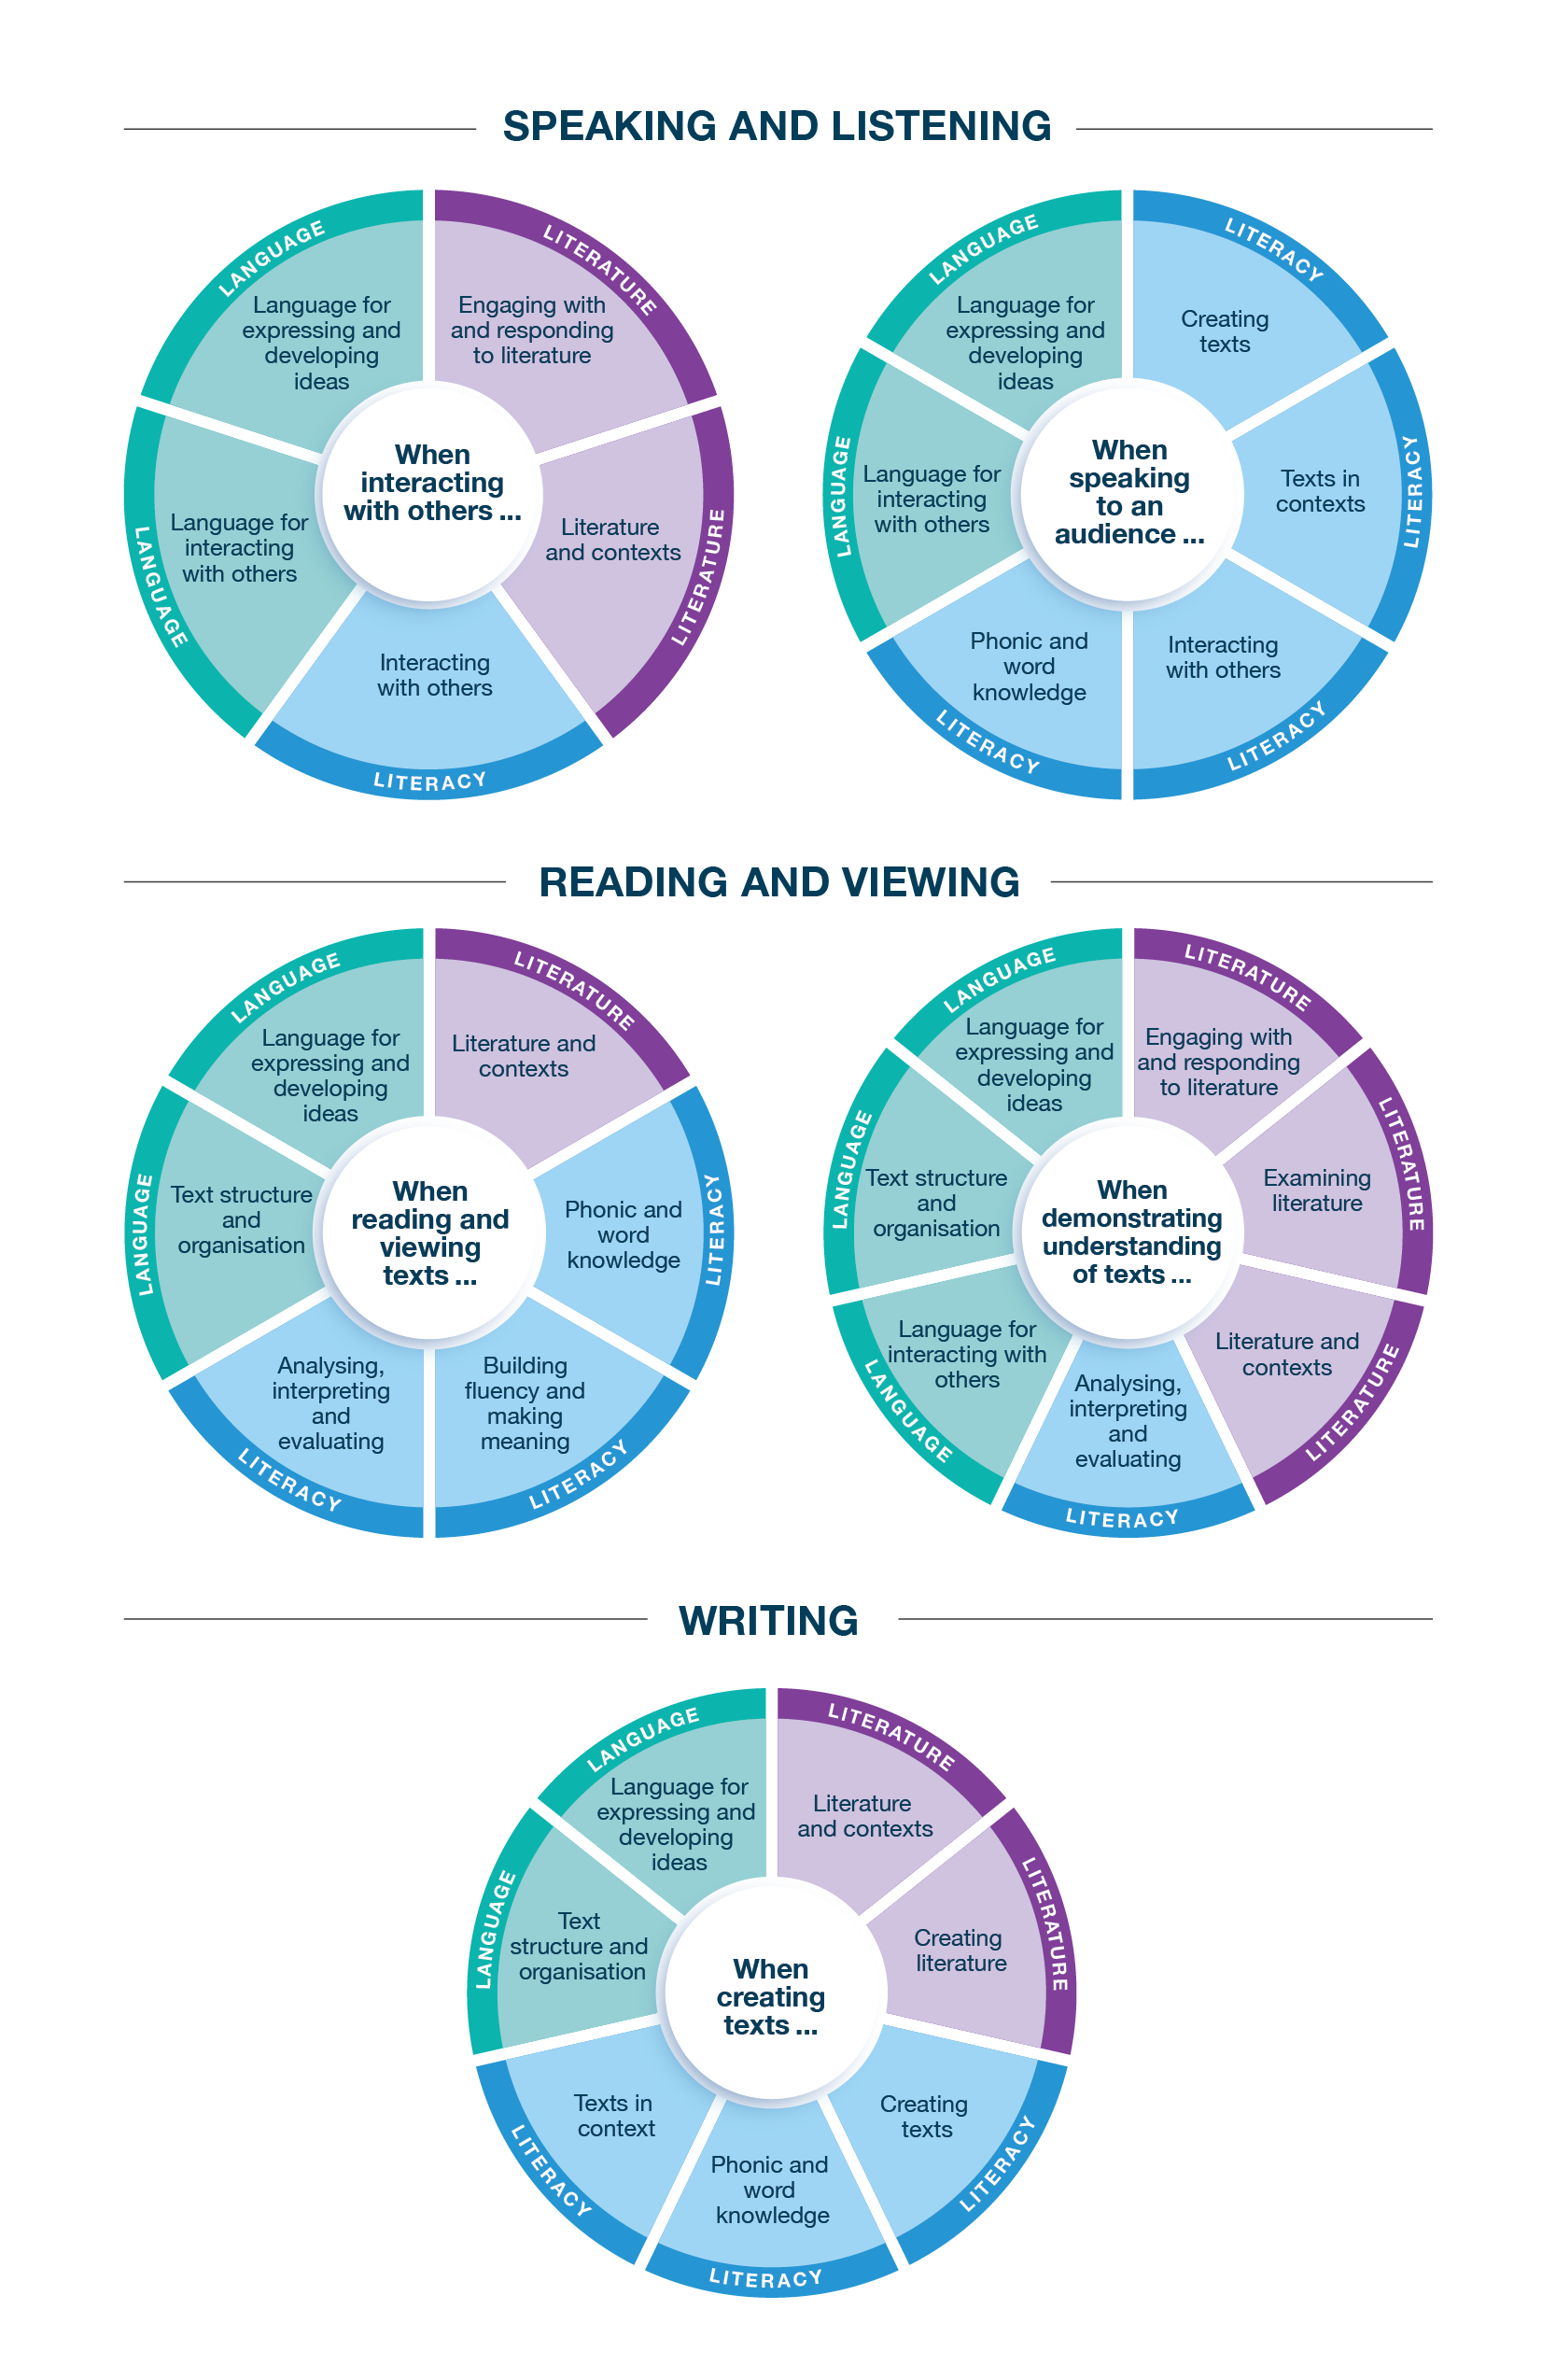
Connecting the achievement standards and sub-strands

Curriculum Mapping
Achievement standard (AS), with numbered extracts
Speaking and Listening | Reading and Viewing | Writing
1. When interacting with others, students explore academic vocabulary and use language to support relationships and roles.  They explore and challenge the various meanings in text through discussions with others. They explore rhetorical and literary devices when evaluating and substantiating. | 3. When reading and viewing, students engage with a range of different types of texts for meaning.  They engage with vocabulary and grammatical knowledge, and the ways that different clause structures add information, the effects of nominalisation and how punctuation supports meaning. | 5. When creating written and spoken texts, students select and expand on ideas and experiment with language features and literary devices for purpose and effect, and include appropriate multimodal or digital elements. They review and edit their own and others’ texts and reflect on these processes.  They use evidence and substantiation to create cohesion; structure to create sequence; grammar to add information and expand ideas; and punctuation to support meaning.  They use vocabulary typical of academic texts, including nominalisation. They experiment with language features and literary devices for effect.  They use spelling rules and word origins to learn and accurately spell new words.
2. When speaking to an audience, students deliver structured spoken texts, selecting text types appropriate for purpose and audience, including multimodal or digital elements. They use language to suit formal and informal contexts, and appropriate features of voice. | 4. When demonstrating understanding of texts, students identify and explain intertextual references, issues and points of view from diverse historical, cultural and social contexts. They explore opinions about texts through explorations of how literary devices and language features, and still and moving images and sound, influence the reader’s response to represented values. They analyse and evaluate the ways that ideas are organised in texts.  They explain how texts, including print, digital and hybrid, are structured for different purposes. They explore how literary devices, including imagery, create meaning and aesthetic qualities. They explore how still images, moving images and sound use intertextual references to create meaning.

 | Strand | Language
 | Sub-strand | Language for interacting with others |  |  |  | Text structure and organisation |  |  |  | Language for expressing and developing ideas
 | Content description (CD) | understand how language shapes relationships and roles  VC2E8LA01 |  | understand how language features such as simile and metaphor can add layers of meaning to the language of evaluation and substantiation  VC2E8LA02 |  | explain how texts are structured depending on their purpose and how language features vary, recognising that some texts are hybrids  VC2E8LA03 |  | understand how cohesion in texts is improved by strengthening internal structures and sequence, with evidence, quotations and substantiation of claims  VC2E8LA04 |  | examine a variety of clause structures, including embedded clauses, that add information and expand ideas in sentences  VC2E8LA05 |  | understand the effect of nominalisation in texts  VC2E8LA06 |  | explore how still images, moving images and sound use intertextual references to enhance and layer meaning  VC2E8LA07
Teaching and learning unit | Semester/Year | CD | AS no. | CD | AS no. | CD | AS no. | CD | AS no. | CD | AS no. | CD | AS no. | CD | AS no.
 |  | ☐ |  | ☐ |  | ☐ |  | ☐ |  | ☐ |  | ☐ |  | ☐
 |  | ☐ |  | ☐ |  | ☐ |  | ☐ |  | ☐ |  | ☐ |  | ☐
 |  | ☐ |  | ☐ |  | ☐ |  | ☐ |  | ☐ |  | ☐ |  | ☐
 |  | ☐ |  | ☐ |  | ☐ |  | ☐ |  | ☐ |  | ☐ |  | ☐
 |  | ☐ |  | ☐ |  | ☐ |  | ☐ |  | ☐ |  | ☐ |  | ☐
 |  | ☐ |  | ☐ |  | ☐ |  | ☐ |  | ☐ |  | ☐ |  | ☐

 | Strand | Language continued
 | Sub-strand | Language for expressing and developing ideas continued
 | Content description (CD) | examine the role and use of academic vocabulary  VC2E8LA08 |  | understand and use punctuation conventions, including semicolons and dashes, to extend ideas and support meaning  VC2E8LA09
Teaching and learning unit | Semester/Year | CD | AS no. | CD | AS no.
 |  | ☐ |  | ☐
 |  | ☐ |  | ☐
 |  | ☐ |  | ☐
 |  | ☐ |  | ☐
 |  | ☐ |  | ☐
 |  | ☐ |  | ☐

 | Strand | Literature
 | Sub-strand | Literature and contexts |  | Engaging with and responding to literature |  |  |  | Examining literature |  |  |  | Creating literature
 | Content description (CD) | explain the ways that ideas, issues and points of view in literary texts drawn from diverse historical, cultural and social contexts by Aboriginal and Torres Strait Islander authors, and a wide range of Australian and world authors, may represent the values of individuals and groups  VC2E8LE01 |  | explore opinions about the language features, literary devices and text structures that contribute to the styles of literary texts  VC2E8LE02 |  | explain how language and still and moving images in a range of literary texts influence an audience’s response to and formation of social and/or ethical positions  VC2E8LE03 |  | identify intertextual references in literary texts and explain how the references enable new understandings  VC2E8LE04 |  | explore how language features such as sentence patterns create tone and voice, and how literary devices such as imagery create meaning and aesthetic qualities in literary texts  VC2E8LE05 |  | create texts that experiment with literary language features and literary devices for particular purposes and effects  VC2E8LE06
Teaching and learning unit | Semester/Year | CD | AS no. | CD | AS no. | CD | AS no. | CD | AS no. | CD | AS no. | CD | AS no.
 |  | ☐ |  | ☐ |  | ☐ |  | ☐ |  | ☐ |  | ☐
 |  | ☐ |  | ☐ |  | ☐ |  | ☐ |  | ☐ |  | ☐
 |  | ☐ |  | ☐ |  | ☐ |  | ☐ |  | ☐ |  | ☐
 |  | ☐ |  | ☐ |  | ☐ |  | ☐ |  | ☐ |  | ☐
 |  | ☐ |  | ☐ |  | ☐ |  | ☐ |  | ☐ |  | ☐
 |  | ☐ |  | ☐ |  | ☐ |  | ☐ |  | ☐ |  | ☐

 | Strand | Literacy
 | Sub-strand | Interacting with others |  |  |  | Word knowledge |  | Texts in context |  | Analysing, interpreting and evaluating
 | Content description (CD) | use interaction skills for identified purposes and contexts, including when supporting or challenging the stated or implied meanings of texts in discussion  VC2E8LY01 |  | deliver structured spoken texts for particular purposes and audiences to suit formal and informal contexts, using features of voice and multimodal or digital elements  VC2E8LY02 |  | explore and use learnt knowledge to spell technical and academic words consistently and accurately  VC2E8LY03 |  | describe how representations of people, places and events reflect the context of the text  VC2E8LY04 |  | analyse and evaluate the ways that language features represent perspectives on an issue, event, situation, individual or group, and the ways that quotations and sources are used and repurposed in a text  VC2E8LY05 |  | analyse how authors organise ideas to develop and shape meaning  VC2E8LY06 |  | use comprehension strategies such as visualising, predicting, connecting, summarising, monitoring, questioning and inferring to interpret and evaluate ideas in texts  VC2E8LY07
Teaching and learning unit | Semester/Year | CD | AS no. | CD | AS no. | CD | AS no. | CD | AS no. | CD | AS no. | CD | AS no. | CD | AS no.
 |  | ☐ |  | ☐ |  | ☐ |  | ☐ |  | ☐ |  | ☐ |  | ☐
 |  | ☐ |  | ☐ |  | ☐ |  | ☐ |  | ☐ |  | ☐ |  | ☐
 |  | ☐ |  | ☐ |  | ☐ |  | ☐ |  | ☐ |  | ☐ |  | ☐
 |  | ☐ |  | ☐ |  | ☐ |  | ☐ |  | ☐ |  | ☐ |  | ☐
 |  | ☐ |  | ☐ |  | ☐ |  | ☐ |  | ☐ |  | ☐ |  | ☐
 |  | ☐ |  | ☐ |  | ☐ |  | ☐ |  | ☐ |  | ☐ |  | ☐

 | Strand | Literacy continued
 | Sub-strand | Creating texts
 | Content description (CD) | create different types of texts, written and spoken, that raise issues, report events and advance opinions, using deliberate language and textual choices, and print, multimodal and/or digital elements as appropriate  VC2E8LY08 |  | review and edit to refine and clarify ideas to improve the effectiveness and coherence of their own texts and the texts of others, and reflect on these processes  VC2E8LY09
Teaching and learning unit | Semester/Year | CD | AS no. | CD | AS no.
 |  | ☐ |  | ☐
 |  | ☐ |  | ☐
 |  | ☐ |  | ☐
 |  | ☐ |  | ☐
 |  | ☐ |  | ☐
 |  | ☐ |  | ☐

Check of Achievement Standard Coverage
Achievement standard (AS), with numbered extracts
Speaking and Listening | Y/N | Reading and Viewing | Y/N | Writing | Y/N
1. When interacting with others, students explore academic vocabulary and use language to support relationships and roles.  They explore and challenge the various meanings in text through discussions with others. They explore rhetorical and literary devices when evaluating and substantiating. | ☐ | 3. When reading and viewing, students engage with a range of different types of texts for meaning.  They engage with vocabulary and grammatical knowledge, and the ways that different clause structures add information, the effects of nominalisation and how punctuation supports meaning. | ☐ | 5. When creating written and spoken texts, students select and expand on ideas and experiment with language features and literary devices for purpose and effect, and include appropriate multimodal or digital elements. They review and edit their own and others’ texts and reflect on these processes.  They use evidence and substantiation to create cohesion; structure to create sequence; grammar to add information and expand ideas; and punctuation to support meaning.  They use vocabulary typical of academic texts, including nominalisation. They experiment with language features and literary devices for effect.  They use spelling rules and word origins to learn and accurately spell new words. | ☐
2. When speaking to an audience, students deliver structured spoken texts, selecting text types appropriate for purpose and audience, including multimodal or digital elements. They use language to suit formal and informal contexts, and appropriate features of voice. | ☐ | 4. When demonstrating understanding of texts, students identify and explain intertextual references, issues and points of view from diverse historical, cultural and social contexts. They explore opinions about texts through explorations of how literary devices and language features, and still and moving images and sound, influence the reader’s response to represented values. They analyse and evaluate the ways that ideas are organised in texts.  They explain how texts, including print, digital and hybrid, are structured for different purposes. They explore how literary devices, including imagery, create meaning and aesthetic qualities. They explore how still images, moving images and sound use intertextual references to create meaning. | ☐ |  | ☐

Assessment
Teaching and learning unit | Assessment task name(s) and type(s) | AS no.

Analysis of Curriculum Coverage
<The following questions could be used as prompts for the analysis process:
Refer to the Curriculum Mapping table:
- Have you addressed all the achievement standard extracts?
- Have you addressed all the content descriptions?
- Where are there gaps in the content description coverage?
Refer to the Assessment table:
- Has each achievement standard extract been addressed appropriately? Where are there gaps in the achievement standard coverage?
- Have students had the opportunity to show evidence that they are progressing towards the achievement standard?
Consider:
- Are all content descriptions equal? Do you think they all take the same amount of time to teach?
- Is anything being over-taught?
- Is anything being missed completely or given insufficient attention?>

Next Steps
<The following questions could be used as prompts for next steps:
- What implications would gaps in achievement standard coverage have on assessment?
- What implications would gaps in content description coverage have on your teaching and learning units?
- How will you address any gaps?
- Use your completed curriculum area map to start populating or updating your curriculum area plan.>

