English Level 7 map – template

Use this curriculum area map to identify where achievement standards and content descriptions are explicitly addressed within your school’s teaching and learning units. This template will help you to both map the Victorian Curriculum F–10 Version 2.0 and audit your current teaching and learning units.

Instructions
- Enter your details in the footer on page 1.
- Look over the Curriculum Mapping tables on page 2 onwards. Read the information and important notes, below.
- Enter the title of your teaching and learning units into each part of the mapping table. Indicate each teaching and learning unit’s connections to the curriculum by checking the box of the relevant content description(s) and writing the number(s) of the connected achievement standard extract. Refer to the VCAA ‘Connections between the achievement standards and content descriptions’ support resource if necessary.
- Check that all content descriptions have been covered at least once.
- Detail any comments, notes and actions.
- Complete the Check of Achievement Standard Coverage table.
- Complete the Assessment, Analysis of Curriculum Coverage and Next Steps sections on the final page.
About the achievement standards in English:
In English, achievement standards are organised via the language modes (Speaking and Listening, Reading and Viewing, and Writing). At every level there are 5 key achievement standard extracts, each beginning ‘When …’ (see the diagram, right). The 5 achievement standard extracts can be connected to content descriptions across the 3 strands of Language, Literature and Literacy. For more information about how the achievement standards and content descriptions are connected in English Version 2.0, see Learning in English.
The VCAA has published tables that help map these connections for you; see the ‘Connections between the achievement standards and content descriptions’ support resources.
Important notes:
- Refer to the VCAA ‘Connections between the achievement standards and content descriptions’ support resource (see Learning in English) before completing the mapping table in this document.
- Some content descriptions connect to more than one language mode so, in some teaching and learning units, you might connect some content descriptions to more than one achievement standard extract.
- Make sure you use the Check of Achievement Standard Coverage table to check that you are assessing all the achievement standard extracts.
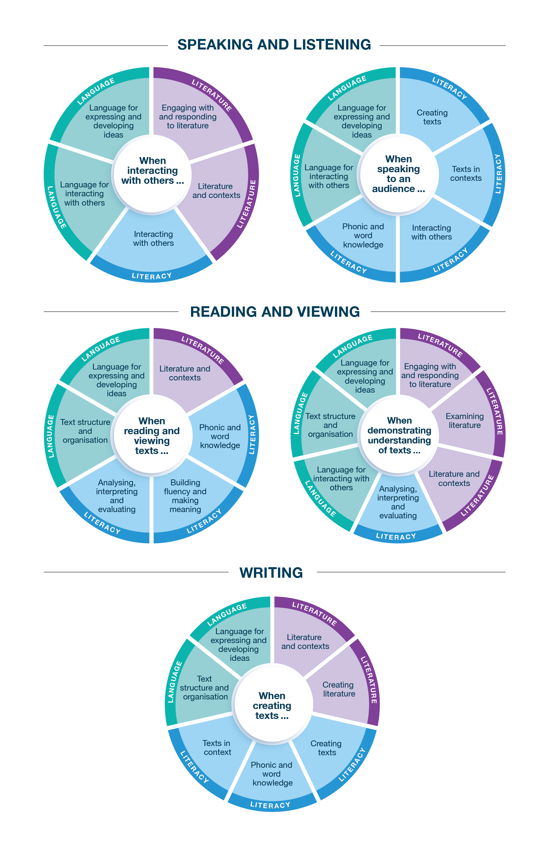
Connecting the achievement standards and sub-strands

Curriculum Mapping
Achievement standard (AS), with numbered extracts
Speaking and Listening | Reading and Viewing | Writing
1. When interacting with others, students explore specialist and technical vocabulary and use language to express social identities.  They discuss and present ideas, including about texts. They explore the language of evaluation and substantiation. | 3. When reading and viewing, students engage with a range of different types of texts for meaning.  They engage with vocabulary and grammatical knowledge, and the ways that different sentence structures extend and explain ideas, how accurate use of tense creates clarity and how punctuation supports meaning. | 5. When creating written and spoken texts, students convey ideas and information to a specific audience. They select textual details from texts appropriate for purpose, and include appropriate multimodal or digital elements. They review and edit their own and others’ texts and reflect on these processes.  They use text structures that build sequence and cohesion in a text; grammar, including sentence structures, to achieve clarity; and punctuation to support meaning.  They use vocabulary that builds specialist and technical knowledge. They experiment with language features and literary devices they have encountered in texts.  They use spelling rules and knowledge of word origins to spell unfamiliar words.
2. When speaking to an audience, students deliver structured spoken texts, selecting text types appropriate for purpose and audience, including multimodal or digital elements. They demonstrate an understanding of formal language and use appropriate features of voice. | 4. When demonstrating understanding of texts, students explain ways that characters, settings and events combine and create meaning in texts from different historical, cultural or social contexts. They develop opinions about texts through explorations of how literary devices and language features, and still and moving images and sound, create characters, settings and events. They explain and summarise ideas drawn from texts.  They describe how texts, including print and digital, are structured for different purposes. They explain how literary devices create meaning and aesthetic qualities. They explore how perspective is created through still images, moving images and sound.

 | Strand | Language
 | Sub-strand | Language for interacting with others |  |  |  | Text structure and organisation |  |  |  | Language for expressing and developing ideas
 | Content description (CD) | understand how language expresses and creates personal and social identities  VC2E7LA01 |  | understand the language of evaluation and substantiation  VC2E7LA02 |  | identify and describe how texts are structured differently depending on their purpose, and how language features vary in texts  VC2E7LA03 |  | understand that the cohesion of texts relies on devices that signal, structure and sequence, such as overviews, examples, and beginnings and endings  VC2E7LA04 |  | understand how complex and compound-complex sentences can be used to elaborate, extend and explain ideas  VC2E7LA05 |  | understand how consistency of tense through verbs and verb groups achieves clarity  VC2E7LA06 |  | explore how still images, moving images and sound can be used to create a perspective  VC2E7LA07
Teaching and learning unit | Semester/Year | CD | AS no. | CD | AS no. | CD | AS no. | CD | AS no. | CD | AS no. | CD | AS no. | CD | AS no.
 |  | ☐ |  | ☐ |  | ☐ |  | ☐ |  | ☐ |  | ☐ |  | ☐
 |  | ☐ |  | ☐ |  | ☐ |  | ☐ |  | ☐ |  | ☐ |  | ☐
 |  | ☐ |  | ☐ |  | ☐ |  | ☐ |  | ☐ |  | ☐ |  | ☐
 |  | ☐ |  | ☐ |  | ☐ |  | ☐ |  | ☐ |  | ☐ |  | ☐
 |  | ☐ |  | ☐ |  | ☐ |  | ☐ |  | ☐ |  | ☐ |  | ☐
 |  | ☐ |  | ☐ |  | ☐ |  | ☐ |  | ☐ |  | ☐ |  | ☐

 | Strand | Language continued
 | Sub-strand | Language for expressing and developing ideas continued
 | Content description (CD) | explore the role of vocabulary in building specialist and technical knowledge, including terms that have both everyday and technical meanings  VC2E7LA08 |  | understand the use of punctuation including colons and brackets to support meaning  VC2E7LA09
Teaching and learning unit | Semester/Year | CD | AS no. | CD | AS no.
 |  | ☐ |  | ☐
 |  | ☐ |  | ☐
 |  | ☐ |  | ☐
 |  | ☐ |  | ☐
 |  | ☐ |  | ☐
 |  | ☐ |  | ☐

 | Strand | Literature
 | Sub-strand | Literature and contexts |  | Engaging with and responding to literature |  |  |  | Examining literature |  |  |  | Creating literature
 | Content description (CD) | identify and explore ideas, points of view, characters, events and/or issues in literary texts, drawn from different historical, cultural and/or social contexts by Aboriginal and Torres Strait Islander authors and a wide range of Australian and world authors  VC2E7LE01 |  | develop an opinion about characters, settings and events in literary texts, identifying areas of agreement and difference with others’ opinions and justifying a response  VC2E7LE02 |  | explore the ways that literary devices and language features, such as dialogue, and still and moving images are used to create character, and to influence emotions and opinions in a range of literary texts  VC2E7LE03 |  | identify and explain the ways that characters, settings and events combine to create meaning in literary texts  VC2E7LE04 |  | identify and explain how literary devices create layers of meaning and aesthetic qualities in literary texts, including poetry  VC2E7LE05 |  | create texts that experiment with literary language features and devices encountered in texts  VC2E7LE06
Teaching and learning unit | Semester/Year | CD | AS no. | CD | AS no. | CD | AS no. | CD | AS no. | CD | AS no. | CD | AS no.
 |  | ☐ |  | ☐ |  | ☐ |  | ☐ |  | ☐ |  | ☐
 |  | ☐ |  | ☐ |  | ☐ |  | ☐ |  | ☐ |  | ☐
 |  | ☐ |  | ☐ |  | ☐ |  | ☐ |  | ☐ |  | ☐
 |  | ☐ |  | ☐ |  | ☐ |  | ☐ |  | ☐ |  | ☐
 |  | ☐ |  | ☐ |  | ☐ |  | ☐ |  | ☐ |  | ☐
 |  | ☐ |  | ☐ |  | ☐ |  | ☐ |  | ☐ |  | ☐

 | Strand | Literacy
 | Sub-strand | Interacting with others |  |  |  | Word knowledge |  | Texts in context |  | Analysing, interpreting and evaluating
 | Content description (CD) | use interaction skills when discussing ideas and information, including evaluations of the features of texts  VC2E7LY01 |  | deliver structured spoken texts for a specific purpose and audience, employing formal language and using appropriate features of voice and multimodal or digital elements  VC2E7LY02 |  | understand how to use spelling rules, base words, suffixes, prefixes, spelling patterns and word origins (etymology), including Greek and Latin roots, to learn new words and how to spell them  VC2E7LY03 |  | explain the effect of current technology on reading, creating and responding to texts, including media texts  VC2E7LY04 |  | analyse the ways in which language features shape meaning and vary according to audience and purpose  VC2E7LY05 |  | explain the structure of ideas such as the use of taxonomies, cause and effect, extended metaphors and chronology  VC2E7LY06 |  | use comprehension strategies such as visualising, predicting, connecting, summarising, monitoring, questioning and inferring to analyse and summarise information and ideas  VC2E7LY07
Teaching and learning unit | Semester/Year | CD | AS no. | CD | AS no. | CD | AS no. | CD | AS no. | CD | AS no. | CD | AS no. | CD | AS no.
 |  | ☐ |  | ☐ |  | ☐ |  | ☐ |  | ☐ |  | ☐ |  | ☐
 |  | ☐ |  | ☐ |  | ☐ |  | ☐ |  | ☐ |  | ☐ |  | ☐
 |  | ☐ |  | ☐ |  | ☐ |  | ☐ |  | ☐ |  | ☐ |  | ☐
 |  | ☐ |  | ☐ |  | ☐ |  | ☐ |  | ☐ |  | ☐ |  | ☐
 |  | ☐ |  | ☐ |  | ☐ |  | ☐ |  | ☐ |  | ☐ |  | ☐
 |  | ☐ |  | ☐ |  | ☐ |  | ☐ |  | ☐ |  | ☐ |  | ☐

 | Strand | Literacy continued
 | Sub-strand | Creating texts
 | Content description (CD) | create different types of texts, written and spoken, selecting aspects of subject matter and particular language and print, multimodal and/or digital elements to convey information and ideas to a specific audience  VC2E7LY08 |  | review and edit their own texts and the texts of others by removing repetition, refining ideas, reordering sentences and adding or substituting words for impact and coherence, and reflect on these processes  VC2E7LY09
Teaching and learning unit | Semester/Year | CD | AS no. | CD | AS no.
 |  | ☐ |  | ☐
 |  | ☐ |  | ☐
 |  | ☐ |  | ☐
 |  | ☐ |  | ☐
 |  | ☐ |  | ☐
 |  | ☐ |  | ☐

Check of Achievement Standard Coverage
Achievement standard (AS), with numbered extracts
Speaking and Listening | Y/N | Reading and Viewing | Y/N | Writing | Y/N
1. When interacting with others, students explore specialist and technical vocabulary and use language to express social identities.  They discuss and present ideas, including about texts. They explore the language of evaluation and substantiation. | ☐ | 3. When reading and viewing, students engage with a range of different types of texts for meaning.  They engage with vocabulary and grammatical knowledge, and the ways that different sentence structures extend and explain ideas, how accurate use of tense creates clarity and how punctuation supports meaning. | ☐ | 5. When creating written and spoken texts, students convey ideas and information to a specific audience. They select textual details from texts appropriate for purpose, and include appropriate multimodal or digital elements. They review and edit their own and others’ texts and reflect on these processes.  They use text structures that build sequence and cohesion in a text; grammar, including sentence structures, to achieve clarity; and punctuation to support meaning.  They use vocabulary that builds specialist and technical knowledge. They experiment with language features and literary devices they have encountered in texts.  They use spelling rules and knowledge of word origins to spell unfamiliar words. | ☐
2. When speaking to an audience, students deliver structured spoken texts, selecting text types appropriate for purpose and audience, including multimodal or digital elements. They demonstrate an understanding of formal language and use appropriate features of voice. | ☐ | 4. When demonstrating understanding of texts, students explain ways that characters, settings and events combine and create meaning in texts from different historical, cultural or social contexts. They develop opinions about texts through explorations of how literary devices and language features, and still and moving images and sound, create characters, settings and events. They explain and summarise ideas drawn from texts.  They describe how texts, including print and digital, are structured for different purposes. They explain how literary devices create meaning and aesthetic qualities. They explore how perspective is created through still images, moving images and sound. | ☐ |  | ☐

Assessment
Teaching and learning unit | Assessment task name(s) and type(s) | AS no.

Analysis of Curriculum Coverage
<The following questions could be used as prompts for the analysis process:
Refer to the Curriculum Mapping table:
- Have you addressed all the achievement standard extracts?
- Have you addressed all the content descriptions?
- Where are there gaps in the content description coverage?
Refer to the Assessment table:
- Has each achievement standard extract been addressed appropriately? Where are there gaps in the achievement standard coverage?
- Have students had the opportunity to show evidence that they are progressing towards the achievement standard?
Consider:
- Are all content descriptions equal? Do you think they all take the same amount of time to teach?
- Is anything being over-taught?
- Is anything being missed completely or given insufficient attention?>

Next Steps
<The following questions could be used as prompts for next steps:
- What implications would gaps in achievement standard coverage have on assessment?
- What implications would gaps in content description coverage have on your teaching and learning units?
- How will you address any gaps?
- Use your completed curriculum area map to start populating or updating your curriculum area plan.>

