English Level 6 map – template

Use this curriculum area map to identify where achievement standards and content descriptions are explicitly addressed within your school’s teaching and learning units. This template will help you to both map the Victorian Curriculum F–10 Version 2.0 and audit your current teaching and learning units.

Instructions
- Enter your details in the footer on page 1.
- Look over the Curriculum Mapping tables on page 2 onwards. Read the information and important notes, below.
- Enter the title of your teaching and learning units into each part of the mapping table. Indicate each teaching and learning unit’s connections to the curriculum by checking the box of the relevant content description(s) and writing the number(s) of the connected achievement standard extract. Refer to the VCAA ‘Connections between the achievement standards and content descriptions’ support resource if necessary.
- Check that all content descriptions have been covered at least once.
- Detail any comments, notes and actions.
- Complete the Check of Achievement Standard Coverage table.
- Complete the Assessment, Analysis of Curriculum Coverage and Next Steps sections on the final page.
About the achievement standards in English:
In English, achievement standards are organised via the language modes (Speaking and Listening, Reading and Viewing, and Writing). At every level there are 5 key achievement standard extracts, each beginning ‘When …’ (see the diagram, right). The 5 achievement standard extracts can be connected to content descriptions across the 3 strands of Language, Literature and Literacy. For more information about how the achievement standards and content descriptions are connected in English Version 2.0, see Learning in English.
The VCAA has published tables that help map these connections for you; see the ‘Connections between the achievement standards and content descriptions’ support resources.
Important notes:
- Refer to the VCAA ‘Connections between the achievement standards and content descriptions’ support resource (see Learning in English) before completing the mapping table in this document.
- Some content descriptions connect to more than one language mode so, in some teaching and learning units, you might connect some content descriptions to more than one achievement standard extract.
- Make sure you use the Check of Achievement Standard Coverage table to check that you are assessing all the achievement standard extracts.
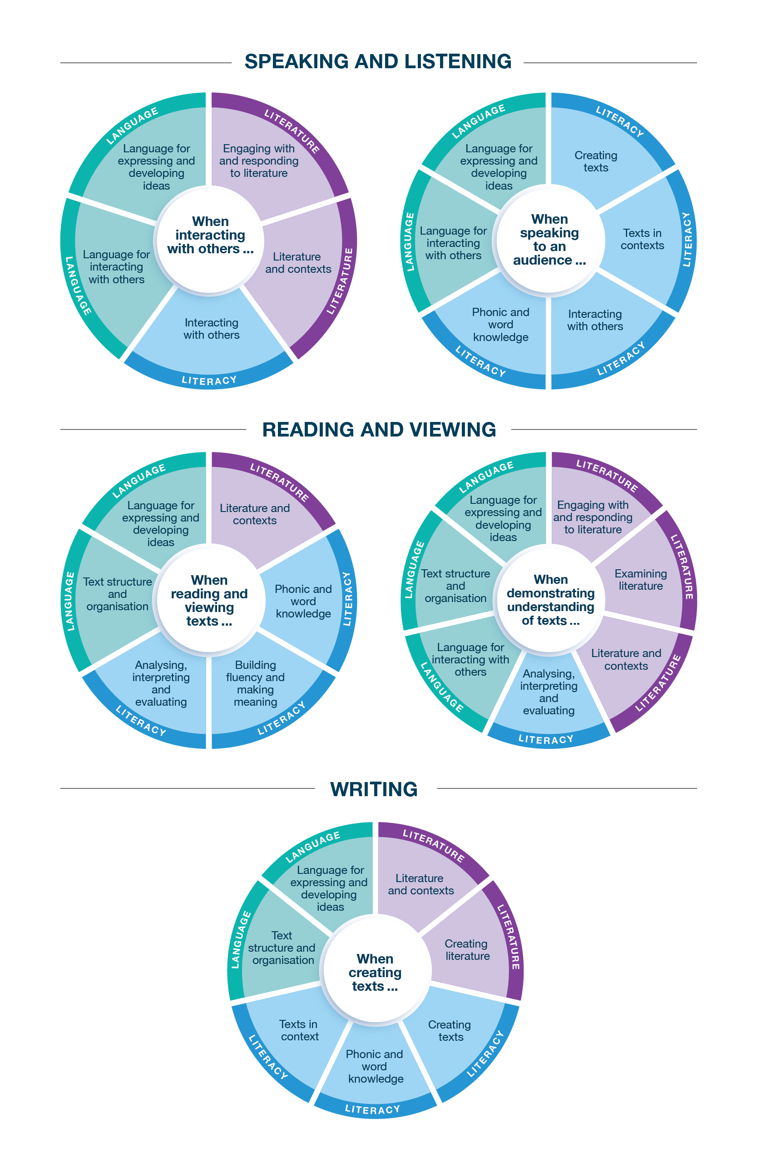
Connecting the achievement standards and sub-strands

Curriculum Mapping
Achievement standard (AS), with numbered extracts
Speaking and Listening | Reading and Viewing | Writing
1. When interacting with others, students use vivid vocabulary, select language to acknowledge formality and social distance, and use appropriate strategies such as paraphrasing and questioning.  They explore objective and subjective language and identify bias. | 3. When reading and viewing, students engage with a range of different types of texts for meaning.  They read by integrating phonic, morphemic and vocabulary knowledge; grammatical knowledge such as complex sentences and adverb groups; and knowledge of the multiple uses of commas. | 5. When creating written and spoken texts for specific purposes and audiences, students explore ideas and experiment with textual details from texts, and include appropriate multimodal elements. They edit their texts using an agreed set of criteria and explore editing choices.  They use text structures, including repetition, to create sequence and cohesion, sentence structure to expand ideas, and punctuation to create clarity.  They use vivid, emotive vocabulary. They experiment with language features and literary devices.  They write legibly and fluently for sustained periods. They spell new and technical words using phonic, morphemic and grammatical knowledge.
2. When speaking to an audience, students deliver structured spoken texts, exploring topics and text types, including multimodal or digital elements. They select language appropriate for purpose and audience and use appropriate features of voice. | 4. When demonstrating understanding of texts, students explore and compare characters and events, and information and ideas, from different historical, cultural or social contexts to build literal and inferred meanings.  They explain how different types of texts, both print and digital, adapt text structures and language features for specific purposes. They explain the effects of imagery and sound devices in texts. They explain how still images, moving images and sound create point of view.

 | Strand | Language
 | Sub-strand | Language for interacting with others |  |  |  | Text structure and organisation |  |  |  | Language for expressing and developing ideas
 | Content description (CD) | understand how language varies as levels of formality and social distance change  VC2E6LA01 |  | understand the uses of objective and subjective language, and identify bias  VC2E6LA02 |  | explain how different types of texts are typically organised into characteristic stages and phases depending on purposes, recognising how authors often adapt text structures and language features  VC2E6LA03 |  | understand that sequence and cohesion can be created by the intentional use of repetition of text structures, language features and vocabulary  VC2E6LA04 |  | understand how embedded clauses can expand the variety of complex sentences to elaborate, extend and explain ideas  VC2E6LA05 |  | understand how the choice of verb, elaborated tenses and a range of adverb groups can expand and sharpen ideas  VC2E6LA06 |  | identify the ways that still images (such as figures, tables, diagrams, maps and graphs), moving images and sound are used in texts to create point of view  VC2E6LA07
Teaching and learning unit | Semester/Year | CD | AS no. | CD | AS no. | CD | AS no. | CD | AS no. | CD | AS no. | CD | AS no. | CD | AS no.
 |  | ☐ |  | ☐ |  | ☐ |  | ☐ |  | ☐ |  | ☐ |  | ☐
 |  | ☐ |  | ☐ |  | ☐ |  | ☐ |  | ☐ |  | ☐ |  | ☐
 |  | ☐ |  | ☐ |  | ☐ |  | ☐ |  | ☐ |  | ☐ |  | ☐
 |  | ☐ |  | ☐ |  | ☐ |  | ☐ |  | ☐ |  | ☐ |  | ☐
 |  | ☐ |  | ☐ |  | ☐ |  | ☐ |  | ☐ |  | ☐ |  | ☐
 |  | ☐ |  | ☐ |  | ☐ |  | ☐ |  | ☐ |  | ☐ |  | ☐

 | Strand | Language continued
 | Sub-strand | Language for expressing and developing ideas continued
 | Content description (CD) | examine how authors use vivid vocabulary and figurative language, such as metaphors, similes, personification, idioms, imagery and hyperbole  VC2E6LA08 |  | understand how to use commas to separate a dependent clause from an independent clause  VC2E6LA09
Teaching and learning unit | Semester/Year | CD | AS no. | CD | AS no.
 |  | ☐ |  | ☐
 |  | ☐ |  | ☐
 |  | ☐ |  | ☐
 |  | ☐ |  | ☐
 |  | ☐ |  | ☐
 |  | ☐ |  | ☐

 | Strand | Literature
 | Sub-strand | Literature and contexts |  | Engaging with and responding to literature |  | Examining literature |  |  |  | Creating literature
 | Content description (CD) | explore their responses to characters and events in literary texts drawn from historical, cultural or social contexts by Aboriginal and Torres Strait Islander authors and a wide range of Australian and world authors  VC2E6LE01 |  | compare language choices, modality, emphasis, repetition and metaphor, and topics, themes or plots in a range of literary texts  VC2E6LE02 |  | describe characteristics of literary texts that define an author's individual style  VC2E6LE03 |  | explain the way authors use sound and imagery to create meaning and effect in prose and poetry  VC2E6LE04 |  | create texts that adapt plot structure, characters, settings and/or ideas from literary texts they have encountered, and experiment with vocabulary and literary devices  VC2E6LE05
Teaching and learning unit | Semester/Year | CD | AS no. | CD | AS no. | CD | AS no. | CD | AS no. | CD | AS no.
 |  | ☐ |  | ☐ |  | ☐ |  | ☐ |  | ☐
 |  | ☐ |  | ☐ |  | ☐ |  | ☐ |  | ☐
 |  | ☐ |  | ☐ |  | ☐ |  | ☐ |  | ☐
 |  | ☐ |  | ☐ |  | ☐ |  | ☐ |  | ☐
 |  | ☐ |  | ☐ |  | ☐ |  | ☐ |  | ☐
 |  | ☐ |  | ☐ |  | ☐ |  | ☐ |  | ☐

 | Strand | Literacy
 | Sub-strand | Interacting with others |  |  |  | Phonic and word knowledge |  |  |  | Building fluency and making meaning |  | Texts in context |  | Analysing, interpreting and evaluating
 | Content description (CD) | use interaction skills and awareness of formality when paraphrasing, questioning, clarifying and interrogating ideas; developing and supporting arguments; and sharing and evaluating information, experiences and opinions  VC2E6LY01 |  | deliver structured spoken and multimodal texts to an intended audience for a specific purpose, using appropriate features of voice  VC2E6LY02 |  | use combined phonological, morphological and vocabulary knowledge to read and write increasingly complex words  VC2E6LY03 |  | use their knowledge of known words, base words, prefixes, suffixes, letter patterns, spelling generalisations and word origins (etymology), including some Latin and Greek roots, to spell new words, including technical words  VC2E6LY04 |  | select and read different types of texts of varying complexity, integrating phonic, semantic and grammatical knowledge to read accurately and fluently for meaning, re-reading and self-correcting when needed  VC2E6LY05 |  | examine texts, including media texts, that represent ideas and events, and identify how they reflect the context in which they were created  VC2E6LY06 |  | analyse how text structures and language features work together to meet the purpose of a text and engage and influence audiences  VC2E6LY07 |  | use comprehension strategies, such as visualising, predicting, connecting, summarising, monitoring and questioning, and connect and compare ideas from a variety of sources to build literal and inferred meanings  VC2E6LY08
Teaching and learning unit | Semester/Year | CD | AS no. | CD | AS no. | CD | AS no. | CD | AS no. | CD | AS no. | CD | AS no. | CD | AS no. | CD | AS no.
 |  | ☐ |  | ☐ |  | ☐ |  | ☐ |  | ☐ |  | ☐ |  | ☐ |  | ☐
 |  | ☐ |  | ☐ |  | ☐ |  | ☐ |  | ☐ |  | ☐ |  | ☐ |  | ☐
 |  | ☐ |  | ☐ |  | ☐ |  | ☐ |  | ☐ |  | ☐ |  | ☐ |  | ☐
 |  | ☐ |  | ☐ |  | ☐ |  | ☐ |  | ☐ |  | ☐ |  | ☐ |  | ☐
 |  | ☐ |  | ☐ |  | ☐ |  | ☐ |  | ☐ |  | ☐ |  | ☐ |  | ☐
 |  | ☐ |  | ☐ |  | ☐ |  | ☐ |  | ☐ |  | ☐ |  | ☐ |  | ☐

 | Strand | Literacy continued
 | Sub-strand | Creating texts
 | Content description (CD) | create different types of texts, written and spoken, with developed and organised ideas for purpose and audience, and multimodal elements as appropriate  VC2E6LY09 |  | re-read and edit their own texts and the texts of others using agreed criteria and exploring editing choices  VC2E6LY10 |  | write legibly, fluently and automatically for sustained periods  VC2E6LY11
Teaching and learning unit | Semester/Year | CD | AS no. | CD | AS no. | CD | AS no.
 |  | ☐ |  | ☐ |  | ☐
 |  | ☐ |  | ☐ |  | ☐
 |  | ☐ |  | ☐ |  | ☐
 |  | ☐ |  | ☐ |  | ☐
 |  | ☐ |  | ☐ |  | ☐
 |  | ☐ |  | ☐ |  | ☐

Check of Achievement Standard Coverage
Achievement standard (AS), with numbered extracts
Speaking and Listening | Y/N | Reading and Viewing | Y/N | Writing | Y/N
1. When interacting with others, students use vivid vocabulary, select language to acknowledge formality and social distance, and use appropriate strategies such as paraphrasing and questioning.  They explore objective and subjective language and identify bias. | ☐ | 3. When reading and viewing, students engage with a range of different types of texts for meaning.  They read by integrating phonic, morphemic and vocabulary knowledge; grammatical knowledge such as complex sentences and adverb groups; and knowledge of the multiple uses of commas. | ☐ | 5. When creating written and spoken texts for specific purposes and audiences, students explore ideas and experiment with textual details from texts, and include appropriate multimodal elements. They edit their texts using an agreed set of criteria and explore editing choices.  They use text structures, including repetition, to create sequence and cohesion, sentence structure to expand ideas, and punctuation to create clarity.  They use vivid, emotive vocabulary. They experiment with language features and literary devices.  They write legibly and fluently for sustained periods. They spell new and technical words using phonic, morphemic and grammatical knowledge. | ☐
2. When speaking to an audience, students deliver structured spoken texts, exploring topics and text types, including multimodal or digital elements. They select language appropriate for purpose and audience and use appropriate features of voice. | ☐ | 4. When demonstrating understanding of texts, students explore and compare characters and events, and information and ideas, from different historical, cultural or social contexts to build literal and inferred meanings.  They explain how different types of texts, both print and digital, adapt text structures and language features for specific purposes. They explain the effects of imagery and sound devices in texts. They explain how still images, moving images and sound create point of view. | ☐ |  | ☐

Assessment
Teaching and learning unit | Assessment task name(s) and type(s) | AS no.

Analysis of Curriculum Coverage
<The following questions could be used as prompts for the analysis process:
Refer to the Curriculum Mapping table:
- Have you addressed all the achievement standard extracts?
- Have you addressed all the content descriptions?
- Where are there gaps in the content description coverage?
Refer to the Assessment table:
- Has each achievement standard extract been addressed appropriately? Where are there gaps in the achievement standard coverage?
- Have students had the opportunity to show evidence that they are progressing towards the achievement standard?
Consider:
- Are all content descriptions equal? Do you think they all take the same amount of time to teach?
- Is anything being over-taught?
- Is anything being missed completely or given insufficient attention?>

Next Steps
<The following questions could be used as prompts for next steps:
- What implications would gaps in achievement standard coverage have on assessment?
- What implications would gaps in content description coverage have on your teaching and learning units?
- How will you address any gaps?
- Use your completed curriculum area map to start populating or updating your curriculum area plan.>

