English Level 4 map – template

Use this curriculum area map to identify where achievement standards and content descriptions are explicitly addressed within your school’s teaching and learning units. This template will help you to both map the Victorian Curriculum F–10 Version 2.0 and audit your current teaching and learning units.

Instructions
- Enter your details in the footer on page 1.
- Look over the Curriculum Mapping tables on page 2 onwards. Read the information and important notes, below.
- Enter the title of your teaching and learning units into each part of the mapping table. Indicate each teaching and learning unit’s connections to the curriculum by checking the box of the relevant content description(s) and writing the number(s) of the connected achievement standard extract. Refer to the VCAA ‘Connections between the achievement standards and content descriptions’ support resource if necessary.
- Check that all content descriptions have been covered at least once.
- Detail any comments, notes and actions.
- Complete the Check of Achievement Standard Coverage table.
- Complete the Assessment, Analysis of Curriculum Coverage and Next Steps sections on the final page.
About the achievement standards in English:
In English, achievement standards are organised via the language modes (Speaking and Listening, Reading and Viewing, and Writing). At every level there are 5 key achievement standard extracts, each beginning ‘When …’ (see the diagram, right). The 5 achievement standard extracts can be connected to content descriptions across the 3 strands of Language, Literature and Literacy. For more information about how the achievement standards and content descriptions are connected in English Version 2.0, see Learning in English.
The VCAA has published tables that help map these connections for you; see the ‘Connections between the achievement standards and content descriptions’ support resources.
Important notes:
- Refer to the VCAA ‘Connections between the achievement standards and content descriptions’ support resource (see Learning in English) before completing the mapping table in this document.
- Some content descriptions connect to more than one language mode so, in some teaching and learning units, you might connect some content descriptions to more than one achievement standard extract.
- Make sure you use the Check of Achievement Standard Coverage table to check that you are assessing all the achievement standard extracts.
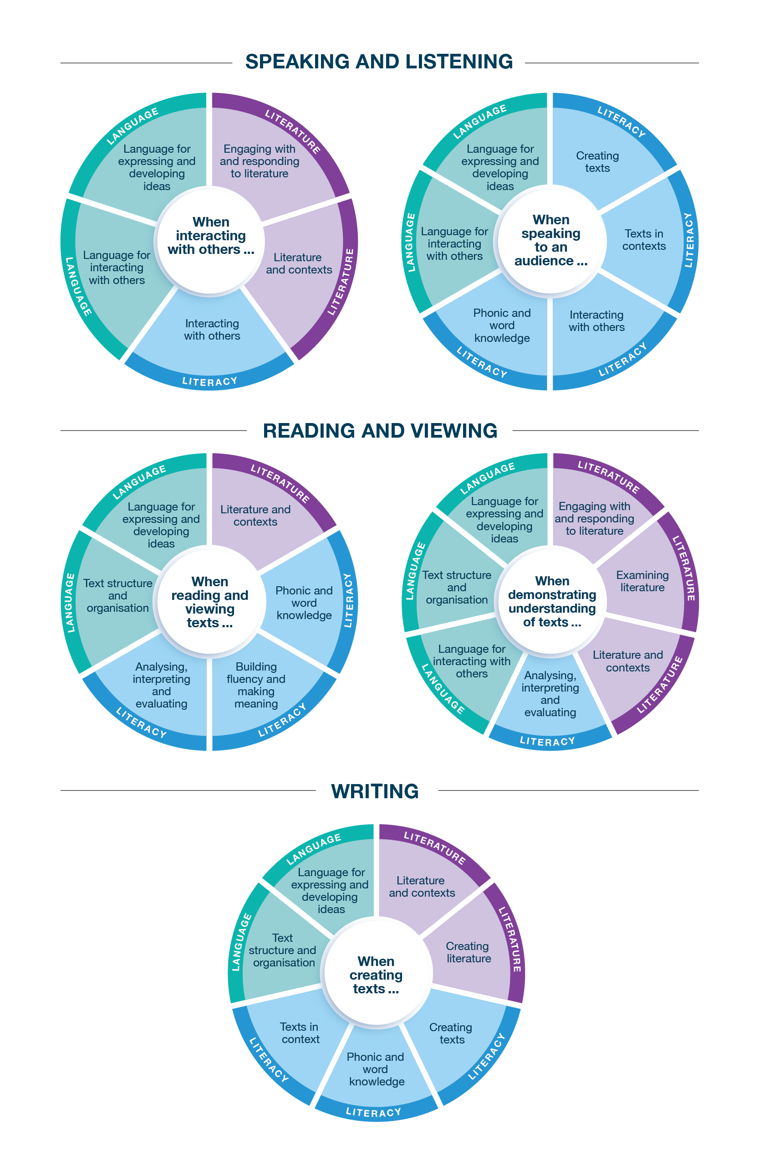
Connecting the achievement standards and sub-strands

Curriculum Mapping
Achievement standard (AS), with numbered extracts
Speaking and Listening | Reading and Viewing | Writing
1. When interacting with others, students use an expanded vocabulary and language to develop relationships in different contexts.  They share and extend ideas and information. They differentiate between the language of opinion, facts and feelings. | 3. When reading and viewing, students engage with a range of different types of texts for meaning.  They read by integrating phonic, morphemic and vocabulary knowledge; grammatical knowledge such as the use of clauses and phrases to provide details and indicate relationships; and knowledge of punctuation for dialogue. | 5. When creating written and spoken texts for a small range of purposes and audiences, students adapt ideas and details from texts, learnt topics or topics of interest, and include appropriate multimodal elements. They edit their texts to improve content and structure.  They use text structures to sequence and connect ideas and to develop paragraphs. They use grammar and punctuation to create relationships, including through the use of tense.  They expand their vocabulary, such as through using synonyms and antonyms, and they use adverbial phrases to build meaning. They explore language features, including wordplay.  They write texts using clearly formed joined letters with developing fluency. They spell words, including multisyllabic and multimorphemic words with irregular spelling patterns, using phonic, morphemic and grammatical knowledge.
2. When speaking to an audience, students deliver structured spoken texts, exploring topics and text types, including multimodal or digital elements. They use language suitable to context, and appropriate features of voice. | 4. When demonstrating understanding of texts, students consider storylines, ideas and relationships between characters to build literal and inferred meanings. They describe the effects of text structures and language features. They share opinions about texts.  They explore how different types of texts across the curriculum, both print and digital, are organised into characteristic stages for purpose and navigation. They describe how literary devices, such as wordplay, shape meaning. They explore the framing and composition of still images and moving images and the use of sound.

 | Strand | Language
 | Sub-strand | Language for interacting with others |  |  |  | Text structure and organisation |  |  |  |  |  | Language for expressing and developing ideas
 | Content description (CD) | understand how language is used to develop relationships in formal and informal situations  VC2E4LA01 |  | identify and differentiate the language of opinion, facts and feelings  VC2E4LA02 |  | describe how different types of texts across the curriculum have different language features and are typically organised into characteristic stages depending on purposes  VC2E4LA03 |  | understand how text connectives, including temporal and conditional words, and topic word associations, are used to sequence and connect ideas  VC2E4LA04 |  | identify navigation features of digital texts that enhance readability, including headlines, drop-down menus, links, graphics and layout  VC2E4LA05 |  | understand that complex sentences contain one independent clause and at least one dependent clause typically joined by a subordinating conjunction to create relationships, such as time and causality  VC2E4LA06 |  | understand how adverb groups or phrases and prepositional phrases work in different ways to provide circumstantial details about an activity  VC2E4LA07
Teaching and learning unit | Semester/Year | CD | AS no. | CD | AS no. | CD | AS no. | CD | AS no. | CD | AS no. | CD | AS no. | CD | AS no.
 |  | ☐ |  | ☐ |  | ☐ |  | ☐ |  | ☐ |  | ☐ |  | ☐
 |  | ☐ |  | ☐ |  | ☐ |  | ☐ |  | ☐ |  | ☐ |  | ☐
 |  | ☐ |  | ☐ |  | ☐ |  | ☐ |  | ☐ |  | ☐ |  | ☐
 |  | ☐ |  | ☐ |  | ☐ |  | ☐ |  | ☐ |  | ☐ |  | ☐
 |  | ☐ |  | ☐ |  | ☐ |  | ☐ |  | ☐ |  | ☐ |  | ☐
 |  | ☐ |  | ☐ |  | ☐ |  | ☐ |  | ☐ |  | ☐ |  | ☐

 | Strand | Language continued
 | Sub-strand | Language for expressing and developing ideas continued
 | Content description (CD) | understand past, present and future tenses and their impact on meaning in a sentence  VC2E4LA08 |  | explore how the use of sound and choices in the framing of an image, the placement of elements in the image, and the salience in the image affect the composition of still and moving images and enhance the meaning of a text  VC2E4LA09 |  | expand vocabulary by exploring a range of synonyms and antonyms, and using words encountered in a range of sources  VC2E4LA10 |  | understand that punctuation signals dialogue through quotation marks and that dialogue follows conventions for the use of capital letters, commas and boundary punctuation  VC2E4LA11 |  | explore how quoted (direct) and reported (indirect) speech are used  VC2E4LA12
Teaching and learning unit | Semester/Year | CD | AS no. | CD | AS no. | CD | AS no. | CD | AS no. | CD | AS no.
 |  | ☐ |  | ☐ |  | ☐ |  | ☐ |  | ☐
 |  | ☐ |  | ☐ |  | ☐ |  | ☐ |  | ☐
 |  | ☐ |  | ☐ |  | ☐ |  | ☐ |  | ☐
 |  | ☐ |  | ☐ |  | ☐ |  | ☐ |  | ☐
 |  | ☐ |  | ☐ |  | ☐ |  | ☐ |  | ☐

 | Strand | Literature
 | Sub-strand | Literature and contexts |  | Engaging with and responding to literature |  | Examining literature |  |  |  | Creating literature
 | Content description (CD) | recognise similar storylines, ideas and relationships in different contexts in literary texts by Aboriginal and Torres Strait Islander authors and a wide range of Australian and world authors  VC2E4LE01 |  | describe the effects of text structures and language features in a range of literary texts when responding to and sharing opinions  VC2E4LE02 |  | compare how authors and illustrators make literary texts exciting, moving and absorbing and hold readers’ interest by using plot tension, character and setting  VC2E4LE03 |  | explore the use of literary devices and deliberate wordplay, including grammar, in prose and poetry, and the ways that they shape meaning  VC2E4LE04 |  | create texts by developing storylines, characters and settings, and using language features from literary texts they have encountered and from their own experiences  VC2E4LE05
Teaching and learning unit | Semester/Year | CD | AS no. | CD | AS no. | CD | AS no. | CD | AS no. | CD | AS no.
 |  | ☐ |  | ☐ |  | ☐ |  | ☐ |  | ☐
 |  | ☐ |  | ☐ |  | ☐ |  | ☐ |  | ☐
 |  | ☐ |  | ☐ |  | ☐ |  | ☐ |  | ☐
 |  | ☐ |  | ☐ |  | ☐ |  | ☐ |  | ☐
 |  | ☐ |  | ☐ |  | ☐ |  | ☐ |  | ☐

 | Strand | Literacy
 | Sub-strand | Interacting with others |  |  |  | Phonic and word knowledge |  |  |  |  |  | Building fluency and making meaning |  | Texts in context
 | Content description (CD) | use interaction skills to gather information in order to carry out tasks, contribute to discussions, acknowledge another opinion, link a response to the text or topic, and share and extend ideas and information  VC2E4LY01 |  | deliver structured spoken texts to an audience using features of voice  VC2E4LY02 |  | understand how to use and apply phonological and morphological knowledge to read and write multisyllabic words with more complex letter combinations, including a variety of vowel sounds and known prefixes and suffixes  VC2E4LY03 |  | understand how to use knowledge of letter patterns, including double letters, spelling generalisations, morphological word families, word origins, and common prefixes and suffixes to spell more complex words  VC2E4LY04 |  | read and write high-frequency words including homophones and know how to use context to identify correct spelling  VC2E4LY05 |  | read different types of texts, integrating phonic, semantic and grammatical knowledge to read accurately and fluently for meaning, re-reading and self-correcting when needed  VC2E4LY06 |  | compare how texts from different times, with similar purposes and audiences, depict ideas or events  VC2E4LY07
Teaching and learning unit | Semester/Year | CD | AS no. | CD | AS no. | CD | AS no. | CD | AS no. | CD | AS no. | CD | AS no. | CD | AS no.
 |  | ☐ |  | ☐ |  | ☐ |  | ☐ |  | ☐ |  | ☐ |  | ☐
 |  | ☐ |  | ☐ |  | ☐ |  | ☐ |  | ☐ |  | ☐ |  | ☐
 |  | ☐ |  | ☐ |  | ☐ |  | ☐ |  | ☐ |  | ☐ |  | ☐
 |  | ☐ |  | ☐ |  | ☐ |  | ☐ |  | ☐ |  | ☐ |  | ☐
 |  | ☐ |  | ☐ |  | ☐ |  | ☐ |  | ☐ |  | ☐ |  | ☐

 | Strand | Literacy continued
 | Sub-strand | Analysing, interpreting and evaluating |  |  |  | Creating texts
 | Content description (CD) | identify the characteristic features used in different types of texts to meet the purpose and audience of the text  VC2E4LY08 |  | use comprehension strategies, such as visualising, predicting, connecting, summarising, monitoring and questioning, to expand topic knowledge and ideas, and begin to evaluate texts to build literal and inferred meanings  VC2E4LY09 |  | create narrative, informative and persuasive texts, written and spoken, using relevant, linked ideas for a range of audiences and using multimodal elements as appropriate  VC2E4LY10 |  | re-read and edit texts for meaning by adding, deleting or moving words or word groups to improve content and structure  VC2E4LY11 |  | write words using clearly formed joined letters, with developing fluency and automaticity  VC2E4LY12
Teaching and learning unit | Semester/Year | CD | AS no. | CD | AS no. | CD | AS no. | CD | AS no. | CD | AS no.
 |  | ☐ |  | ☐ |  | ☐ |  | ☐ |  | ☐
 |  | ☐ |  | ☐ |  | ☐ |  | ☐ |  | ☐
 |  | ☐ |  | ☐ |  | ☐ |  | ☐ |  | ☐
 |  | ☐ |  | ☐ |  | ☐ |  | ☐ |  | ☐
 |  | ☐ |  | ☐ |  | ☐ |  | ☐ |  | ☐

Check of Achievement Standard Coverage
Achievement standard (AS), with numbered extracts
Speaking and Listening | Y/N | Reading and Viewing | Y/N | Writing | Y/N
1. When interacting with others, students use an expanded vocabulary and language to develop relationships in different contexts.  They share and extend ideas and information. They differentiate between the language of opinion, facts and feelings. | ☐ | 3. When reading and viewing, students engage with a range of different types of texts for meaning.  They read by integrating phonic, morphemic and vocabulary knowledge; grammatical knowledge such as the use of clauses and phrases to provide details and indicate relationships; and knowledge of punctuation for dialogue. | ☐ | 5. When creating written and spoken texts for a small range of purposes and audiences, students adapt ideas and details from texts, learnt topics or topics of interest, and include appropriate multimodal elements. They edit their texts to improve content and structure.  They use text structures to sequence and connect ideas and to develop paragraphs. They use grammar and punctuation to create relationships, including through the use of tense.  They expand their vocabulary, such as through using synonyms and antonyms, and they use adverbial phrases to build meaning. They explore language features, including wordplay.  They write texts using clearly formed joined letters with developing fluency. They spell words, including multisyllabic and multimorphemic words with irregular spelling patterns, using phonic, morphemic and grammatical knowledge. | ☐
2. When speaking to an audience, students deliver structured spoken texts, exploring topics and text types, including multimodal or digital elements. They use language suitable to context, and appropriate features of voice. | ☐ | 4. When demonstrating understanding of texts, students consider storylines, ideas and relationships between characters to build literal and inferred meanings. They describe the effects of text structures and language features. They share opinions about texts.  They explore how different types of texts across the curriculum, both print and digital, are organised into characteristic stages for purpose and navigation. They describe how literary devices, such as wordplay, shape meaning. They explore the framing and composition of still images and moving images and the use of sound. | ☐ |  | ☐

Assessment
Teaching and learning unit | Assessment task name(s) and type(s) | AS no.

Analysis of Curriculum Coverage
<The following questions could be used as prompts for the analysis process:
Refer to the Curriculum Mapping table:
- Have you addressed all the achievement standard extracts?
- Have you addressed all the content descriptions?
- Where are there gaps in the content description coverage?
Refer to the Assessment table:
- Has each achievement standard extract been addressed appropriately? Where are there gaps in the achievement standard coverage?
- Have students had the opportunity to show evidence that they are progressing towards the achievement standard?
Consider:
- Are all content descriptions equal? Do you think they all take the same amount of time to teach?
- Is anything being over-taught?
- Is anything being missed completely or given insufficient attention?>

Next Steps
<The following questions could be used as prompts for next steps:
- What implications would gaps in achievement standard coverage have on assessment?
- What implications would gaps in content description coverage have on your teaching and learning units?
- How will you address any gaps?
- Use your completed curriculum area map to start populating or updating your curriculum area plan.>

