English Level 3 map – template

Use this curriculum area map to identify where achievement standards and content descriptions are explicitly addressed within your school’s teaching and learning units. This template will help you to both map the Victorian Curriculum F–10 Version 2.0 and audit your current teaching and learning units.

Instructions
- Enter your details in the footer on page 1.
- Look over the Curriculum Mapping tables on page 2 onwards. Read the information and important notes, below.
- Enter the title of your teaching and learning units into each part of the mapping table. Indicate each teaching and learning unit’s connections to the curriculum by checking the box of the relevant content description(s) and writing the number(s) of the connected achievement standard extract. Refer to the VCAA ‘Connections between the achievement standards and content descriptions’ support resource if necessary.
- Check that all content descriptions have been covered at least once.
- Detail any comments, notes and actions.
- Complete the Check of Achievement Standard Coverage table.
- Complete the Assessment, Analysis of Curriculum Coverage and Next Steps sections on the final page.
About the achievement standards in English:
In English, achievement standards are organised via the language modes (Speaking and Listening, Reading and Viewing, and Writing). At every level there are 5 key achievement standard extracts, each beginning ‘When …’ (see the diagram, right). The 5 achievement standard extracts can be connected to content descriptions across the 3 strands of Language, Literature and Literacy. For more information about how the achievement standards and content descriptions are connected in English Version 2.0, see Learning in English.
The VCAA has published tables that help map these connections for you; see the ‘Connections between the achievement standards and content descriptions’ support resources.
Important notes:
- Refer to the VCAA ‘Connections between the achievement standards and content descriptions’ support resource (see Learning in English) before completing the mapping table in this document.
- Some content descriptions connect to more than one language mode so, in some teaching and learning units, you might connect some content descriptions to more than one achievement standard extract.
- Make sure you use the Check of Achievement Standard Coverage table to check that you are assessing all the achievement standard extracts.
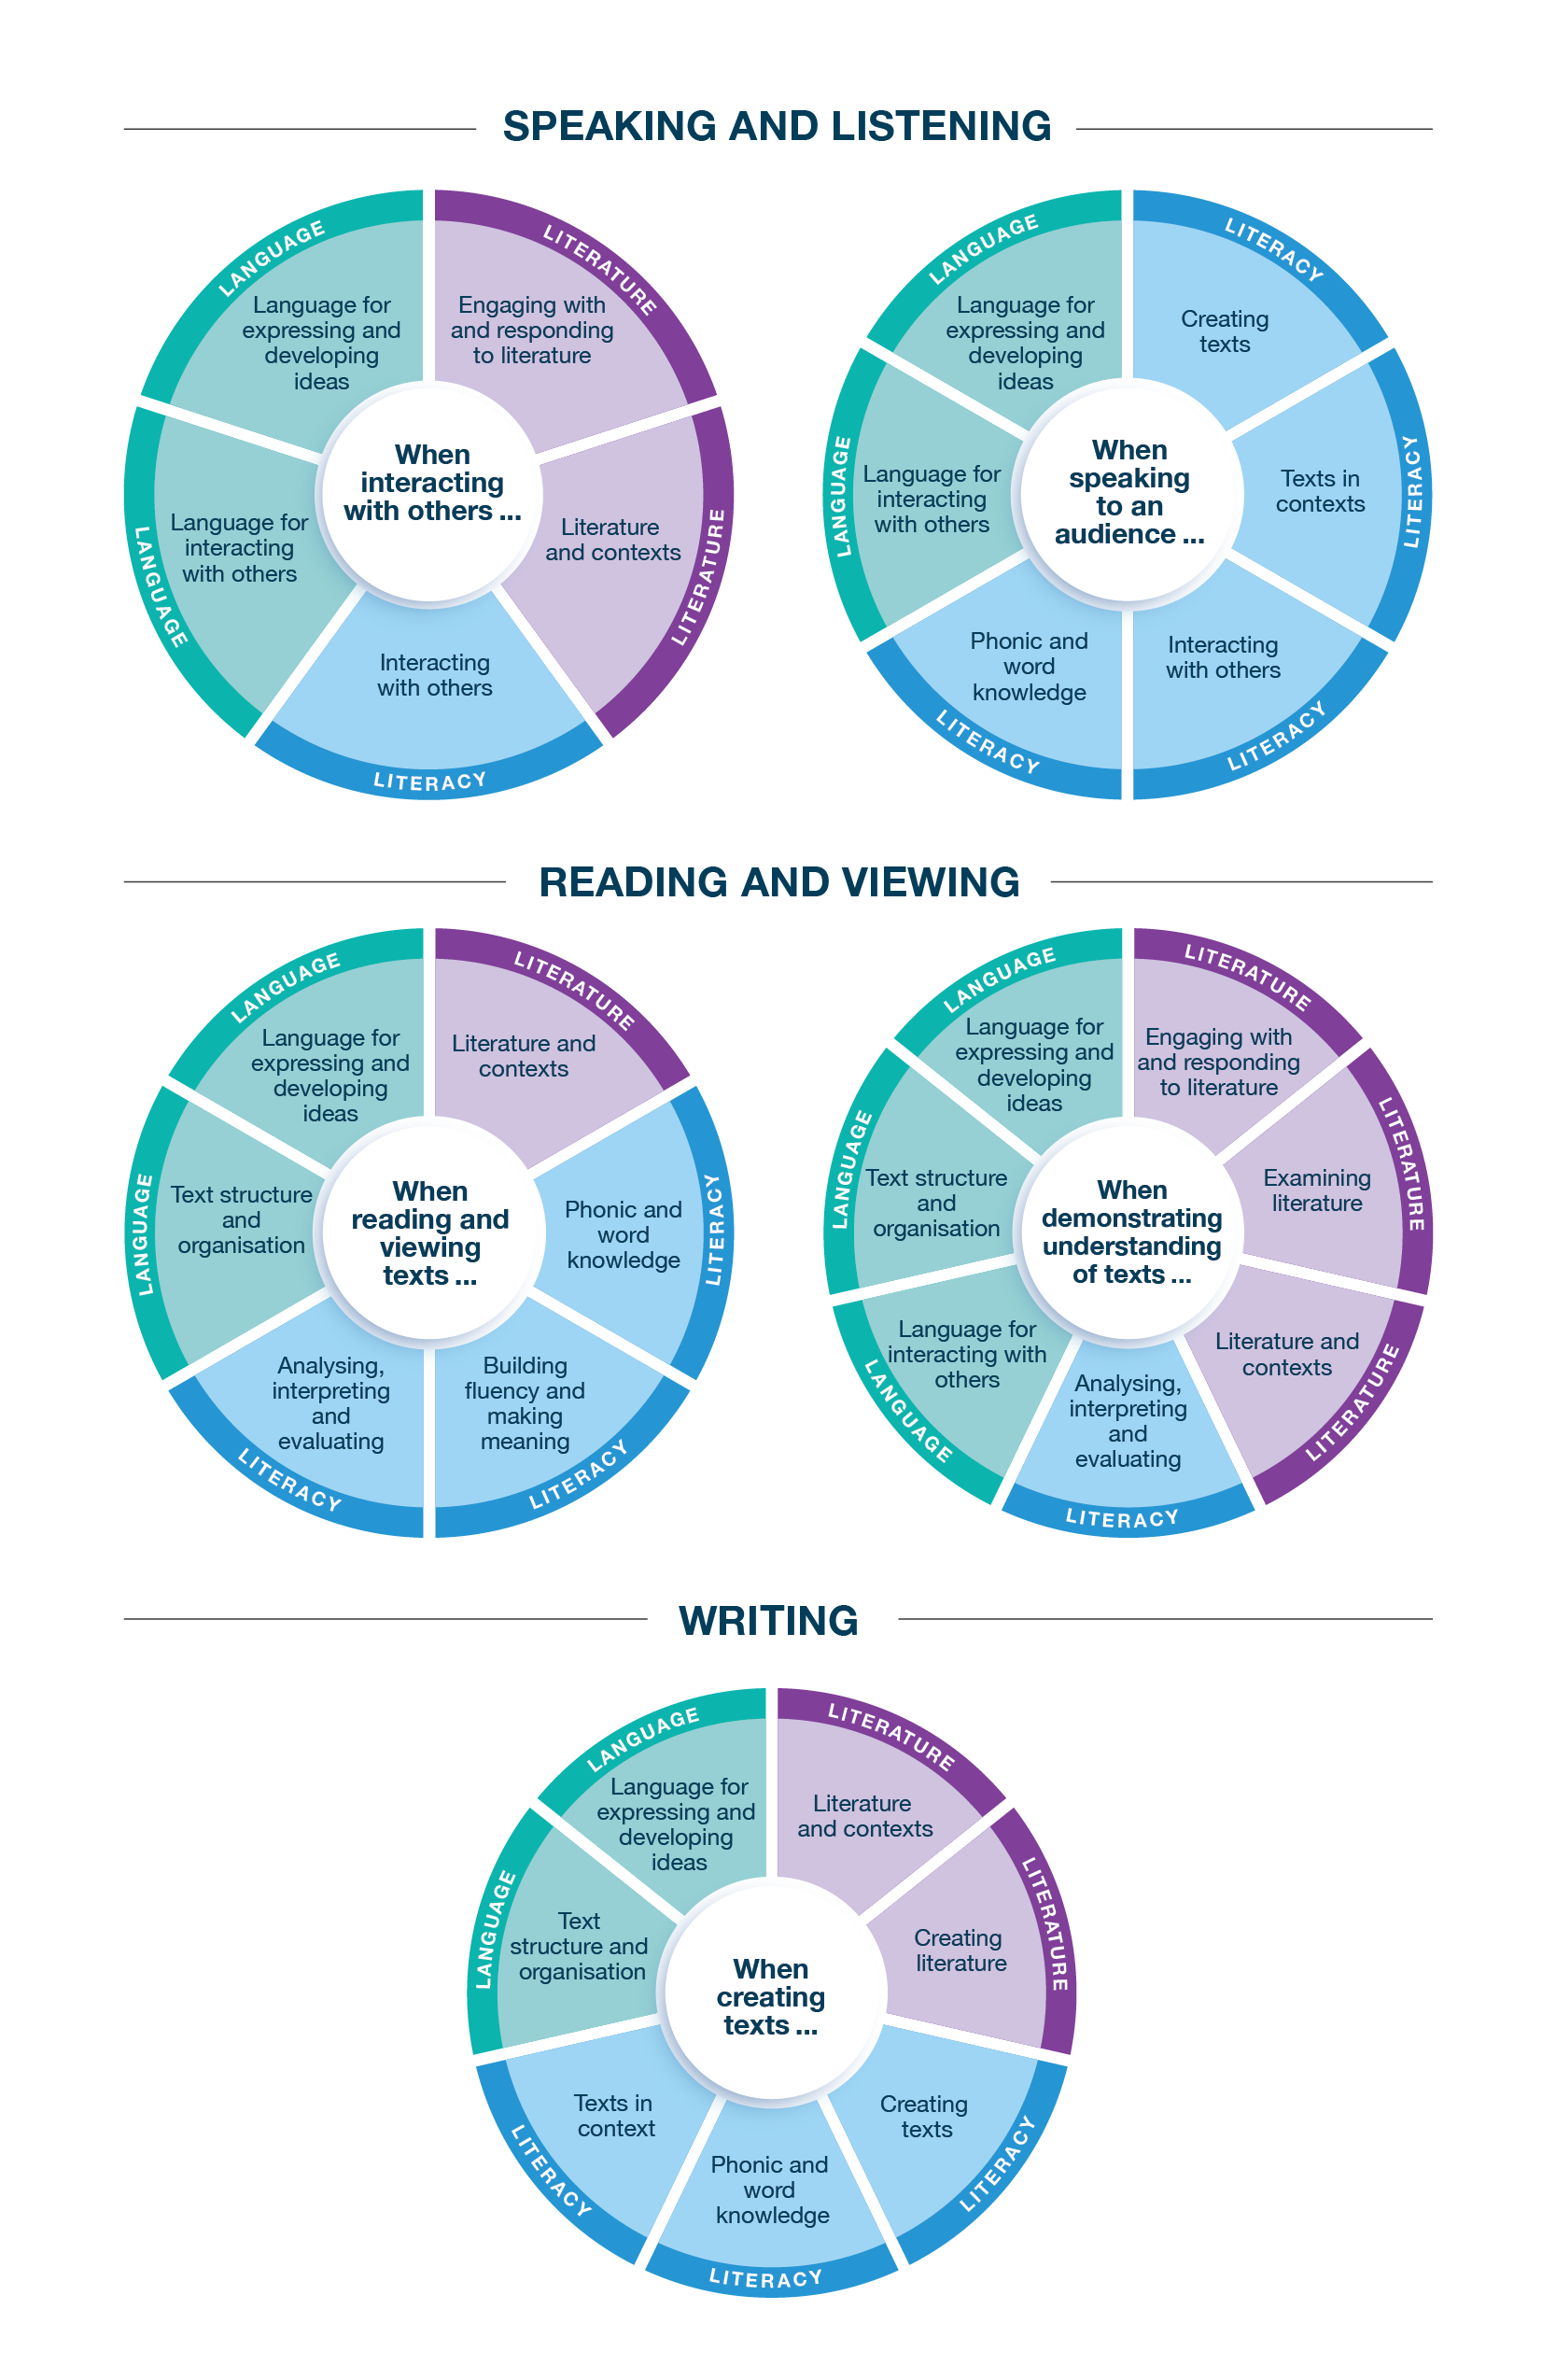
Connecting the achievement standards and sub-strands

Curriculum Mapping
Achievement standard (AS), with numbered extracts
Speaking and Listening | Reading and Viewing | Writing
1. When interacting with others, students extend topic-specific and appropriate vocabulary and use cooperation strategies and interaction skills to contribute to discussions.  They explore the language of evaluation and emotion. | 3. When reading and viewing, students engage with a range of different types of texts for meaning.  They read using phonic, morphemic and vocabulary knowledge; grammatical knowledge such as subject–verb agreement and tense; and knowledge of apostrophe use.  They read multisyllabic words with more complex letter patterns. | 5. When creating written and spoken texts to inform, narrate, explain or argue, students use ideas and details from previously encountered texts, learnt topics or topics of interest, and they include appropriate multimodal elements. They re-read their texts and edit for meaning, structure and grammatical choices.  They use text structures to begin to develop paragraphs for different purposes. They use grammar and punctuation to appropriately represent processes and connections, including using modal verbs.  They extend their use of topic-specific vocabulary, such as technical words, and adopt and adapt language features from texts.  They write texts using letters that are joined, accurately formed and consistent in size. They spell multisyllabic words using phonic and morphemic knowledge, and high-frequency words.
2. When speaking to an audience, students deliver short spoken texts, exploring topics and text types, including multimodal or digital elements, and using features of voice. | 4. When demonstrating understanding of texts, they discuss connections between the experiences of characters in texts and their own personal experiences to build literal and inferred meanings. They share personal preferences for texts.  They explore how different types of texts across the curriculum, both print and digital, use different structures for purpose and navigation. They identify literary devices, such as rhythm and onomatopoeia, and describe how images and sound can extend meaning.

 | Strand | Language
 | Sub-strand | Language for interacting with others |  |  |  | Text structure and organisation |  |  |  |  |  | Language for expressing and developing ideas
 | Content description (CD) | understand that cooperation with others depends on shared understanding of social conventions, including turn-taking language, which vary according to the degree of formality  VC2E3LA01 |  | understand how the language of evaluation and emotion can be varied to be more or less forceful  VC2E3LA02 |  | describe how different types of texts across the curriculum have different language features and structures depending on purposes  VC2E3LA03 |  | understand that paragraphs are a key organisational feature of the stages of written texts, grouping related information together  VC2E3LA04 |  | identify the purpose of layout features in print and digital texts and the words used for navigation  VC2E3LA05 |  | understand that a clause is a unit of grammar usually containing a subject and a verb that need to agree  VC2E3LA06 |  | understand how verbs represent different processes for doing, feeling, thinking, saying and relating  VC2E3LA07 |  | understand that verbs are anchored in time through tense  VC2E3LA08
Teaching and learning unit | Semester/Year | CD | AS no. | CD | AS no. | CD | AS no. | CD | AS no. | CD | AS no. | CD | AS no. | CD | AS no. | CD | AS no.
 |  | ☐ |  | ☐ |  | ☐ |  | ☐ |  | ☐ |  | ☐ |  | ☐ |  | ☐
 |  | ☐ |  | ☐ |  | ☐ |  | ☐ |  | ☐ |  | ☐ |  | ☐ |  | ☐
 |  | ☐ |  | ☐ |  | ☐ |  | ☐ |  | ☐ |  | ☐ |  | ☐ |  | ☐
 |  | ☐ |  | ☐ |  | ☐ |  | ☐ |  | ☐ |  | ☐ |  | ☐ |  | ☐
 |  | ☐ |  | ☐ |  | ☐ |  | ☐ |  | ☐ |  | ☐ |  | ☐ |  | ☐
 |  | ☐ |  | ☐ |  | ☐ |  | ☐ |  | ☐ |  | ☐ |  | ☐ |  | ☐

 | Strand | Language continued
 | Sub-strand | Language for expressing and developing ideas continued
 | Content description (CD) | understand how modal verbs indicate obligation, probability and possibility  VC2E3LA09 |  | identify how images and sound extend the meaning of a text  VC2E3LA10 |  | extend topic-specific and technical vocabulary and know that words can have different meanings in different contexts  VC2E3LA11 |  | understand that apostrophes signal missing letters in contractions, and how apostrophes are used to show singular and plural possession in regular and irregular nouns  VC2E3LA12
Teaching and learning unit | Semester/Year | CD | AS no. | CD | AS no. | CD | AS no. | CD | AS no.
 |  | ☐ |  | ☐ |  | ☐ |  | ☐
 |  | ☐ |  | ☐ |  | ☐ |  | ☐
 |  | ☐ |  | ☐ |  | ☐ |  | ☐
 |  | ☐ |  | ☐ |  | ☐ |  | ☐
 |  | ☐ |  | ☐ |  | ☐ |  | ☐
 |  | ☐ |  | ☐ |  | ☐ |  | ☐

 | Strand | Literature
 | Sub-strand | Literature and contexts |  | Engaging with and responding to literature |  | Examining literature |  |  |  | Creating literature
 | Content description (CD) | discuss characters, settings and events in different contexts in literary texts by Aboriginal and Torres Strait Islander authors and illustrators and a wide range of Australian and world authors and illustrators  VC2E3LE01 |  | discuss connections between personal experiences and character experiences in a range of literary texts and give reasons for personal preferences  VC2E3LE02 |  | discuss how an author uses language and illustrations to build plots and portray characters and settings in literary texts, and explore how mood is created through settings and events  VC2E3LE03 |  | identify and discuss some literary devices, including rhythm and onomatopoeia in poetry and prose, and discuss the ways that they shape the reader’s reaction  VC2E3LE04 |  | create texts, using or adapting language features, characters, settings, plot structures and ideas from literary texts they have encountered  VC2E3LE05
Teaching and learning unit | Semester/Year | CD | AS no. | CD | AS no. | CD | AS no. | CD | AS no. | CD | AS no.
 |  | ☐ |  | ☐ |  | ☐ |  | ☐ |  | ☐
 |  | ☐ |  | ☐ |  | ☐ |  | ☐ |  | ☐
 |  | ☐ |  | ☐ |  | ☐ |  | ☐ |  | ☐
 |  | ☐ |  | ☐ |  | ☐ |  | ☐ |  | ☐
 |  | ☐ |  | ☐ |  | ☐ |  | ☐ |  | ☐
 |  | ☐ |  | ☐ |  | ☐ |  | ☐ |  | ☐

 | Strand | Literacy
 | Sub-strand | Interacting with others |  |  |  | Phonic and word knowledge |  |  |  |  |  |  |  | Building fluency and making meaning |  | Texts in context
 | Content description (CD) | use interaction skills to contribute to conversations and discussions to share text- or topic-based information and ideas  VC2E3LY01 |  | deliver spoken texts to an audience using features of voice  VC2E3LY02 |  | understand how to apply knowledge of phoneme–grapheme correspondences, syllables, and blending and segmenting to fluently read and write multisyllabic words with more complex letter patterns  VC2E3LY03 |  | understand how to apply knowledge of common base words, prefixes, suffixes and generalisations for adding a suffix to a base word to read and comprehend new multimorphemic words  VC2E3LY04 |  | use phoneme–grapheme relationships and less common letter patterns to spell words  VC2E3LY05 |  | recognise and know how to write most high-frequency words, including some homophones  VC2E3LY06 |  | read different types of texts using phonic, semantic and grammatical knowledge to read accurately and fluently for meaning, re-reading and self-correcting when required  VC2E3LY07 |  | discuss how texts with similar purposes can be created for different audiences  VC2E3LY08
Teaching and learning unit | Semester/Year | CD | AS no. | CD | AS no. | CD | AS no. | CD | AS no. | CD | AS no. | CD | AS no. | CD | AS no. | CD | AS no.
 |  | ☐ |  | ☐ |  | ☐ |  | ☐ |  | ☐ |  | ☐ |  | ☐ |  | ☐
 |  | ☐ |  | ☐ |  | ☐ |  | ☐ |  | ☐ |  | ☐ |  | ☐ |  | ☐
 |  | ☐ |  | ☐ |  | ☐ |  | ☐ |  | ☐ |  | ☐ |  | ☐ |  | ☐
 |  | ☐ |  | ☐ |  | ☐ |  | ☐ |  | ☐ |  | ☐ |  | ☐ |  | ☐
 |  | ☐ |  | ☐ |  | ☐ |  | ☐ |  | ☐ |  | ☐ |  | ☐ |  | ☐
 |  | ☐ |  | ☐ |  | ☐ |  | ☐ |  | ☐ |  | ☐ |  | ☐ |  | ☐

 | Strand | Literacy continued
 | Sub-strand | Analysing, interpreting and evaluating |  |  |  | Creating texts
 | Content description (CD) | identify the purpose and audience of different types of texts through the use of language features and/or images in the texts  VC2E3LY09 |  | use comprehension strategies, such as visualising, predicting, connecting, summarising, monitoring and questioning, to analyse texts by drawing on a growing knowledge of context, text structures and language features to build literal and inferred meanings  VC2E3LY10 |  | create narrative, informative and persuasive texts, written and spoken, with ideas grouped in simple paragraphs, using topic-specific and precise vocabulary and multimodal elements as appropriate  VC2E3LY11 |  | re-read and edit texts for meaning, appropriate structure, grammatical choices and punctuation  VC2E3LY12 |  | write words using joined letters that are clearly formed and consistent in size  VC2E3LY13
Teaching and learning unit | Semester/Year | CD | AS no. | CD | AS no. | CD | AS no. | CD | AS no. | CD | AS no.
 |  | ☐ |  | ☐ |  | ☐ |  | ☐ |  | ☐
 |  | ☐ |  | ☐ |  | ☐ |  | ☐ |  | ☐
 |  | ☐ |  | ☐ |  | ☐ |  | ☐ |  | ☐
 |  | ☐ |  | ☐ |  | ☐ |  | ☐ |  | ☐
 |  | ☐ |  | ☐ |  | ☐ |  | ☐ |  | ☐
 |  | ☐ |  | ☐ |  | ☐ |  | ☐ |  | ☐

Check of Achievement Standard Coverage
Achievement standard (AS), with numbered extracts
Speaking and Listening | Y/N | Reading and Viewing | Y/N | Writing | Y/N
1. When interacting with others, students extend topic-specific and appropriate vocabulary and use cooperation strategies and interaction skills to contribute to discussions.  They explore the language of evaluation and emotion. | ☐ | 3. When reading and viewing, students engage with a range of different types of texts for meaning.  They read using phonic, morphemic and vocabulary knowledge; grammatical knowledge such as subject–verb agreement and tense; and knowledge of apostrophe use.  They read multisyllabic words with more complex letter patterns. | ☐ | 5. When creating written and spoken texts to inform, narrate, explain or argue, students use ideas and details from previously encountered texts, learnt topics or topics of interest, and they include appropriate multimodal elements. They re-read their texts and edit for meaning, structure and grammatical choices.  They use text structures to begin to develop paragraphs for different purposes. They use grammar and punctuation to appropriately represent processes and connections, including using modal verbs.  They extend their use of topic-specific vocabulary, such as technical words, and adopt and adapt language features from texts.  They write texts using letters that are joined, accurately formed and consistent in size. They spell multisyllabic words using phonic and morphemic knowledge, and high-frequency words. | ☐
2. When speaking to an audience, students deliver short spoken texts, exploring topics and text types, including multimodal or digital elements, and using features of voice. | ☐ | 4. When demonstrating understanding of texts, they discuss connections between the experiences of characters in texts and their own personal experiences to build literal and inferred meanings. They share personal preferences for texts.  They explore how different types of texts across the curriculum, both print and digital, use different structures for purpose and navigation. They identify literary devices, such as rhythm and onomatopoeia, and describe how images can extend meaning. | ☐ |  | ☐

Assessment
Teaching and learning unit | Assessment task name(s) and type(s) | AS no.

Analysis of Curriculum Coverage
<The following questions could be used as prompts for the analysis process:
Refer to the Curriculum Mapping table:
- Have you addressed all the achievement standard extracts?
- Have you addressed all the content descriptions?
- Where are there gaps in the content description coverage?
Refer to the Assessment table:
- Has each achievement standard extract been addressed appropriately? Where are there gaps in the achievement standard coverage?
- Have students had the opportunity to show evidence that they are progressing towards the achievement standard?
Consider:
- Are all content descriptions equal? Do you think they all take the same amount of time to teach?
- Is anything being over-taught?
- Is anything being missed completely or given insufficient attention?>

Next Steps
<The following questions could be used as prompts for next steps:
- What implications would gaps in achievement standard coverage have on assessment?
- What implications would gaps in content description coverage have on your teaching and learning units?
- How will you address any gaps?
- Use your completed curriculum area map to start populating or updating your curriculum area plan.>

