English Level 2 map – template

Use this curriculum area map to identify where achievement standards and content descriptions are explicitly addressed within your school’s teaching and learning units. This template will help you to both map the Victorian Curriculum F–10 Version 2.0 and audit your current teaching and learning units.

Instructions
- Enter your details in the footer on page 1.
- Look over the Curriculum Mapping tables on page 2 onwards. Read the information and important notes, below.
- Enter the title of your teaching and learning units into each part of the mapping table. Indicate each teaching and learning unit’s connections to the curriculum by checking the box of the relevant content description(s) and writing the number(s) of the connected achievement standard extract. Refer to the VCAA ‘Connections between the achievement standards and content descriptions’ support resource if necessary.
- Check that all content descriptions have been covered at least once.
- Detail any comments, notes and actions.
- Complete the Check of Achievement Standard Coverage table.
- Complete the Assessment, Analysis of Curriculum Coverage and Next Steps sections on the final page.
About the achievement standards in English:
In English, achievement standards are organised via the language modes (Speaking and Listening, Reading and Viewing, and Writing). At every level there are 5 key achievement standard extracts, each beginning ‘When …’ (see the diagram, right). The 5 achievement standard extracts can be connected to content descriptions across the 3 strands of Language, Literature and Literacy. For more information about how the achievement standards and content descriptions are connected in English Version 2.0, see Learning in English.
The VCAA has published tables that help map these connections for you; see the ‘Connections between the achievement standards and content descriptions’ support resources.
Important notes:
- Refer to the VCAA ‘Connections between the achievement standards and content descriptions’ support resource (see Learning in English) before completing the mapping table in this document.
- Some content descriptions connect to more than one language mode so, in some teaching and learning units, you might connect some content descriptions to more than one achievement standard extract.
- Make sure you use the Check of Achievement Standard Coverage table to check that you are assessing all the achievement standard extracts.
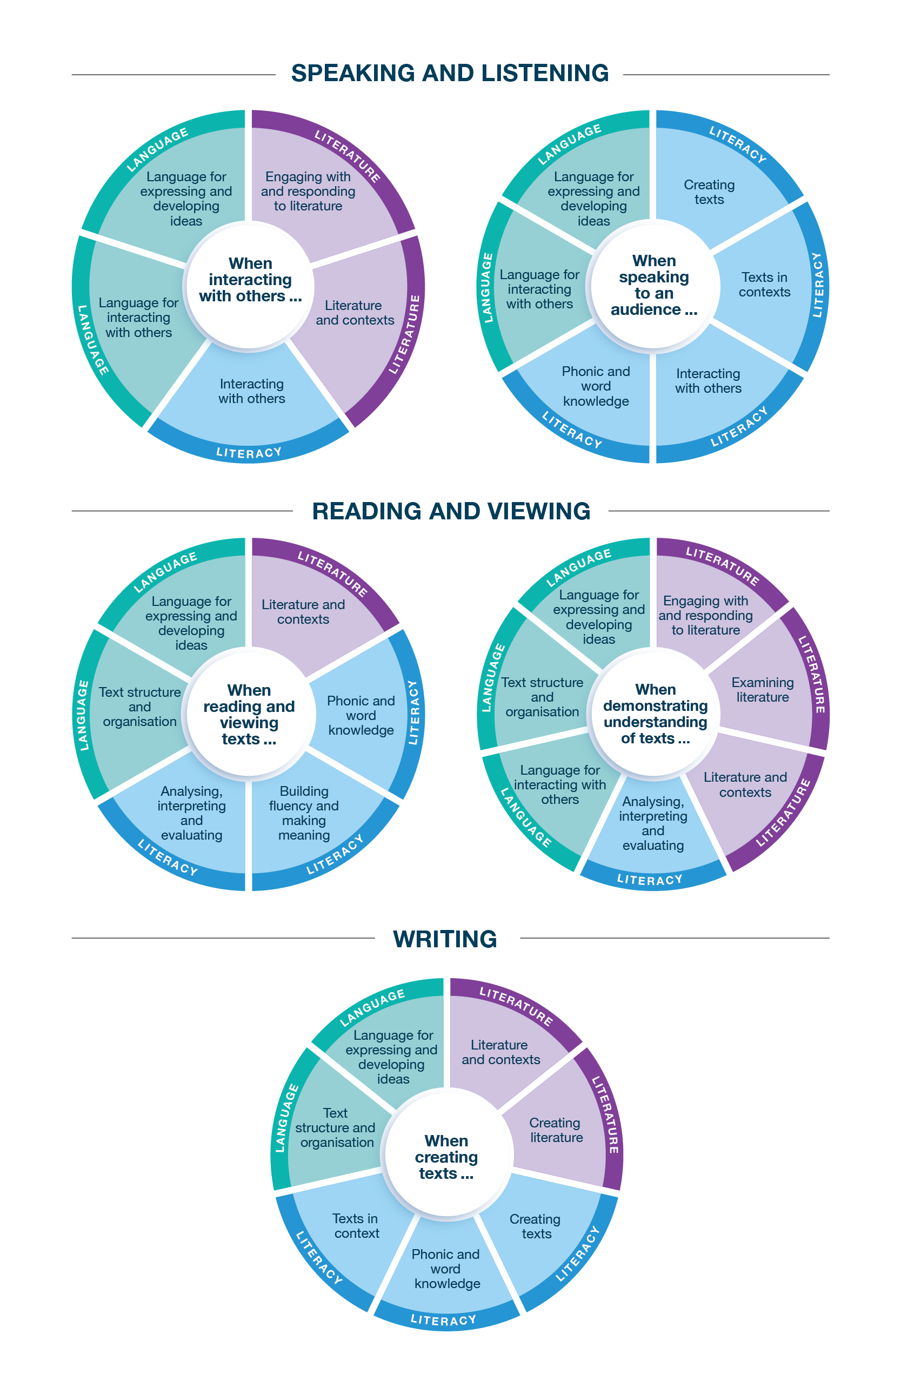
Connecting the achievement standards and sub-strands

Curriculum Mapping
Achievement standard (AS), with numbered extracts
Speaking and Listening | Reading and Viewing | Writing
1. When interacting with others, students apply learnt vocabulary and vary language choices depending on context, actively listen to others, and extend their own ideas.  They explore the language of appreciation and provide reasons for preferences. | 3. When reading and viewing, students engage with a range of different types of texts for meaning.  They read using phonic, morphemic and vocabulary knowledge; grammatical knowledge such as compound sentences, noun and verb groups; and knowledge of punctuation.  They read some unfamiliar words and most high-frequency words. | 5. When creating short written and spoken texts, including stories to inform, express an opinion, explore an idea or narrate for audiences, students use ideas and details from previously encountered texts, learnt topics or topics of interest, and include appropriate multimodal elements. They re-read their texts and edit for improvement.  They use narrative and informative text structures to organise their own texts, and they use grammar and punctuation to create links.  They begin to make deliberate choices when applying learnt vocabulary.  They write words using consistently legible unjoined lower-case and upper-case letters. They spell words with regular spelling patterns and use phonic and morphemic knowledge to attempt to spell words with less common patterns.
2. When speaking to an audience, students deliver short spoken texts, engaging with topics for a familiar audience and appropriate for purpose, using features of voice. | 4. When demonstrating understanding of texts, students discuss and compare connections between characters, settings and events, and draw on their knowledge of context to build literal and inferred meanings. They express personal preferences for particular texts.  They describe how different types of texts across the curriculum, both print and digital, are organised for purpose and navigation. They understand that elements other than language – such as images and sounds – can multiply meanings in texts.

 | Strand | Language
 | Sub-strand | Language for interacting with others |  |  |  | Text structure and organisation |  |  |  |  |  | Language for expressing and developing ideas
 | Content description (CD) | explore how interpersonal language choices vary depending on the context, including the different roles taken on in interactions  VC2E2LA01 |  | explore how language can be used for appreciating texts and providing reasons for preferences  VC2E2LA02 |  | identify how different types of texts across the curriculum are organised differently and use language features depending on purposes  VC2E2LA03 |  | understand how texts are made cohesive by using personal and possessive pronouns and by omitting words that can be inferred  VC2E2LA04 |  | navigate print and digital texts using chapters, tables of contents, indexes, sidebar menus, drop-down menus or links  VC2E2LA05 |  | understand that connections can be made between ideas by using a compound sentence with 2 or more independent clauses usually linked by a coordinating conjunction  VC2E2LA06 |  | understand that in sentences, nouns may be extended into noun groups using articles and adjectives, and verbs may be expressed as verb groups  VC2E2LA07
Teaching and learning unit | Semester/Year | CD | AS no. | CD | AS no. | CD | AS no. | CD | AS no. | CD | AS no. | CD | AS no. | CD | AS no.
 |  | ☐ |  | ☐ |  | ☐ |  | ☐ |  | ☐ |  | ☐ |  | ☐
 |  | ☐ |  | ☐ |  | ☐ |  | ☐ |  | ☐ |  | ☐ |  | ☐
 |  | ☐ |  | ☐ |  | ☐ |  | ☐ |  | ☐ |  | ☐ |  | ☐
 |  | ☐ |  | ☐ |  | ☐ |  | ☐ |  | ☐ |  | ☐ |  | ☐
 |  | ☐ |  | ☐ |  | ☐ |  | ☐ |  | ☐ |  | ☐ |  | ☐
 |  | ☐ |  | ☐ |  | ☐ |  | ☐ |  | ☐ |  | ☐ |  | ☐

 | Strand | Language continued
 | Sub-strand | Language for expressing and developing ideas continued
 | Content description (CD) | understand that images and sound add to or multiply the meanings of a text  VC2E2LA08 |  | apply learnt vocabulary and begin to make conscious choices to suit the topic  VC2E2LA09 |  | recognise that capital letters are used in titles and commas are used to separate items in lists  VC2E2LA10
Teaching and learning unit | Semester/Year | CD | AS no. | CD | AS no. | CD | AS no.
 |  | ☐ |  | ☐ |  | ☐
 |  | ☐ |  | ☐ |  | ☐
 |  | ☐ |  | ☐ |  | ☐
 |  | ☐ |  | ☐ |  | ☐
 |  | ☐ |  | ☐ |  | ☐
 |  | ☐ |  | ☐ |  | ☐

 | Strand | Literature
 | Sub-strand | Literature and contexts |  | Engaging with and responding to literature |  | Examining literature |  |  |  | Creating literature
 | Content description (CD) | discuss how characters and settings are connected in literary texts created by Aboriginal and Torres Strait Islander authors and illustrators and a wide range of Australian and world authors and illustrators  VC2E2LE01 |  | compare features of a range of literary texts, such as characters and settings, and share personal preferences  VC2E2LE02 |  | discuss the plots, characters and settings of a range of literary texts and identify how language is used to present these features in different ways  VC2E2LE03 |  | identify, reproduce and experiment with rhythmic sound and word patterns in poems, chants, rhymes and songs  VC2E2LE04 |  | create texts by adapting structures and language features of previously encountered literary texts through writing, drawing and performance  VC2E2LE05
Teaching and learning unit | Semester/Year | CD | AS no. | CD | AS no. | CD | AS no. | CD | AS no. | CD | AS no.
 |  | ☐ |  | ☐ |  | ☐ |  | ☐ |  | ☐
 |  | ☐ |  | ☐ |  | ☐ |  | ☐ |  | ☐
 |  | ☐ |  | ☐ |  | ☐ |  | ☐ |  | ☐
 |  | ☐ |  | ☐ |  | ☐ |  | ☐ |  | ☐
 |  | ☐ |  | ☐ |  | ☐ |  | ☐ |  | ☐
 |  | ☐ |  | ☐ |  | ☐ |  | ☐ |  | ☐

 | Strand | Literacy
 | Sub-strand | Interacting with others |  |  |  | Phonic and word knowledge |  |  |  |  |  |  |  | Building fluency and making meaning
 | Content description (CD) | use interaction skills when engaging with topics and texts, actively listening to others, receiving instructions and extending their own ideas, speaking appropriately, expressing and responding to opinions, making statements, and giving instructions  VC2E2LY01 |  | deliver short spoken texts to an audience using features of voice  VC2E2LY02 |  | use knowledge of blending, segmenting and manipulating to read and write increasingly complex words (phonemic awareness)  VC2E2LY03 |  | use phoneme–grapheme correspondence knowledge to read and write words of one or more syllables with vowel digraphs, less common long vowel patterns, consonant blends and silent letters (phonic knowledge)  VC2E2LY04 |  | use knowledge of spelling patterns and morphemes to read and write words whose spelling is not completely predictable from their sounds, including high-frequency words  VC2E2LY05 |  | build morphemic word families using knowledge of prefixes and suffixes  VC2E2LY06 |  | read different types of texts with phrasing and fluency, using phonic and word knowledge, and make and monitor meaning by re-reading and self-correcting  VC2E2LY07
Teaching and learning unit | Semester/Year | CD | AS no. | CD | AS no. | CD | AS no. | CD | AS no. | CD | AS no. | CD | AS no. | CD | AS no.
 |  | ☐ |  | ☐ |  | ☐ |  | ☐ |  | ☐ |  | ☐ |  | ☐
 |  | ☐ |  | ☐ |  | ☐ |  | ☐ |  | ☐ |  | ☐ |  | ☐
 |  | ☐ |  | ☐ |  | ☐ |  | ☐ |  | ☐ |  | ☐ |  | ☐
 |  | ☐ |  | ☐ |  | ☐ |  | ☐ |  | ☐ |  | ☐ |  | ☐
 |  | ☐ |  | ☐ |  | ☐ |  | ☐ |  | ☐ |  | ☐ |  | ☐

 | Strand | Literacy continued
 | Sub-strand | Texts in context |  | Analysing, interpreting and evaluating |  |  |  | Creating texts
 | Content description (CD) | discuss how similar topics and information are presented in different types of texts  VC2E2LY08 |  | identify the purpose and audience of different types of texts  VC2E2LY09 |  | use comprehension strategies, such as visualising, predicting, connecting, summarising, monitoring and questioning, and begin to analyse texts by drawing on a growing knowledge of context and text structures to build literal and inferred meanings  VC2E2LY10 |  | create short narrative, informative and persuasive texts for familiar audiences using simple text structures, topic-specific vocabulary and multimodal elements as appropriate  VC2E2LY11 |  | re-read and edit texts for spelling, sentence boundary punctuation and text structure  VC2E2LY12 |  | write words legibly and with growing fluency using unjoined lower-case and upper-case letters  VC2E2LY13
Teaching and learning unit | Semester/Year | CD | AS no. | CD | AS no. | CD | AS no. | CD | AS no. | CD | AS no. | CD | AS no.
 |  | ☐ |  | ☐ |  | ☐ |  | ☐ |  | ☐ |  | ☐
 |  | ☐ |  | ☐ |  | ☐ |  | ☐ |  | ☐ |  | ☐
 |  | ☐ |  | ☐ |  | ☐ |  | ☐ |  | ☐ |  | ☐
 |  | ☐ |  | ☐ |  | ☐ |  | ☐ |  | ☐ |  | ☐
 |  | ☐ |  | ☐ |  | ☐ |  | ☐ |  | ☐ |  | ☐

Check of Achievement Standard Coverage
Achievement standard (AS), with numbered extracts
Speaking and Listening | Y/N | Reading and Viewing | Y/N | Writing | Y/N
1. When interacting with others, students apply learnt vocabulary and vary language choices depending on context, actively listen to others, and extend their own ideas.  They explore the language of appreciation and provide reasons for preferences. | ☐ | 3. When reading and viewing, students engage with a range of different types of texts for meaning.  They read using phonic, morphemic and vocabulary knowledge; grammatical knowledge such as compound sentences, noun and verb groups; and knowledge of punctuation.  They read some unfamiliar words and most high-frequency words. | ☐ | 5. When creating short written and spoken texts, including stories to inform, express an opinion, explore an idea or narrate for audiences, students use ideas and details from previously encountered texts, learnt topics or topics of interest, and include appropriate multimodal elements. They re-read their texts and edit for improvement.  They use narrative and informative text structures to organise their own texts, and they use grammar and punctuation to create links.  They begin to make deliberate choices when applying learnt vocabulary.  They write words using consistently legible unjoined lower-case and upper-case letters. They spell words with regular spelling patterns and use phonic and morphemic knowledge to attempt to spell words with less common patterns. | ☐
2. When speaking to an audience, students deliver short spoken texts, engaging with topics for a familiar audience and appropriate for purpose, using features of voice. | ☐ | 4. When demonstrating understanding of texts, students discuss and compare connections between characters, settings and events, and draw on their knowledge of context to build literal and inferred meanings. They express personal preferences for particular texts.  They describe how different types of texts across the curriculum, both print and digital, are organised for purpose and navigation. They understand that elements other than language – such as images and sounds – can multiply meanings in texts. | ☐ |  | ☐

Assessment
Teaching and learning unit | Assessment task name(s) and type(s) | AS no.

Analysis of Curriculum Coverage
<The following questions could be used as prompts for the analysis process:
Refer to the Curriculum Mapping table:
- Have you addressed all the achievement standard extracts?
- Have you addressed all the content descriptions?
- Where are there gaps in the content description coverage?
Refer to the Assessment table:
- Has each achievement standard extract been addressed appropriately? Where are there gaps in the achievement standard coverage?
- Have students had the opportunity to show evidence that they are progressing towards the achievement standard?
Consider:
- Are all content descriptions equal? Do you think they all take the same amount of time to teach?
- Is anything being over-taught?
- Is anything being missed completely or given insufficient attention?>

Next Steps
<The following questions could be used as prompts for next steps:
- What implications would gaps in achievement standard coverage have on assessment?
- What implications would gaps in content description coverage have on your teaching and learning units?
- How will you address any gaps?
- Use your completed curriculum area map to start populating or updating your curriculum area plan.>

