English Foundation map – template

Use this curriculum area map to identify where achievement standards and content descriptions are explicitly addressed within your school’s teaching and learning units. This template will help you to both map the Victorian Curriculum F–10 Version 2.0 and audit your current teaching and learning units.

Instructions
- Enter your details in the footer on page 1.
- Look over the Curriculum Mapping tables on page 2 onwards. Read the information and important notes, below.
- Enter the title of your teaching and learning units into each part of the mapping table. Indicate each teaching and learning unit’s connections to the curriculum by checking the box of the relevant content description(s) and writing the number(s) of the connected achievement standard extract. Refer to the VCAA ‘Connections between the achievement standards and content descriptions’ support resource if necessary.
- Check that all content descriptions have been covered at least once.
- Detail any comments, notes and actions.
- Complete the Check of Achievement Standard Coverage table.
- Complete the Assessment, Analysis of Curriculum Coverage and Next Steps sections on the final page.
About the achievement standards in English:
In English, achievement standards are organised via the language modes (Speaking and Listening, Reading and Viewing, and Writing). At every level there are 5 key achievement standard extracts, each beginning ‘When …’ (see the diagram, right). The 5 achievement standard extracts can be connected to content descriptions across the 3 strands of Language, Literature and Literacy. For more information about how the achievement standards and content descriptions are connected in English Version 2.0, see Learning in English.
The VCAA has published tables that help map these connections for you; see the ‘Connections between the achievement standards and content descriptions’ support resources.
Important notes:
- Refer to the VCAA ‘Connections between the achievement standards and content descriptions’ support resource (see Learning in English) before completing the mapping table in this document.
- Some content descriptions connect to more than one language mode so, in some teaching and learning units, you might connect some content descriptions to more than one achievement standard extract.
- Make sure you use the Check of Achievement Standard Coverage table to check that you are assessing all the achievement standard extracts.
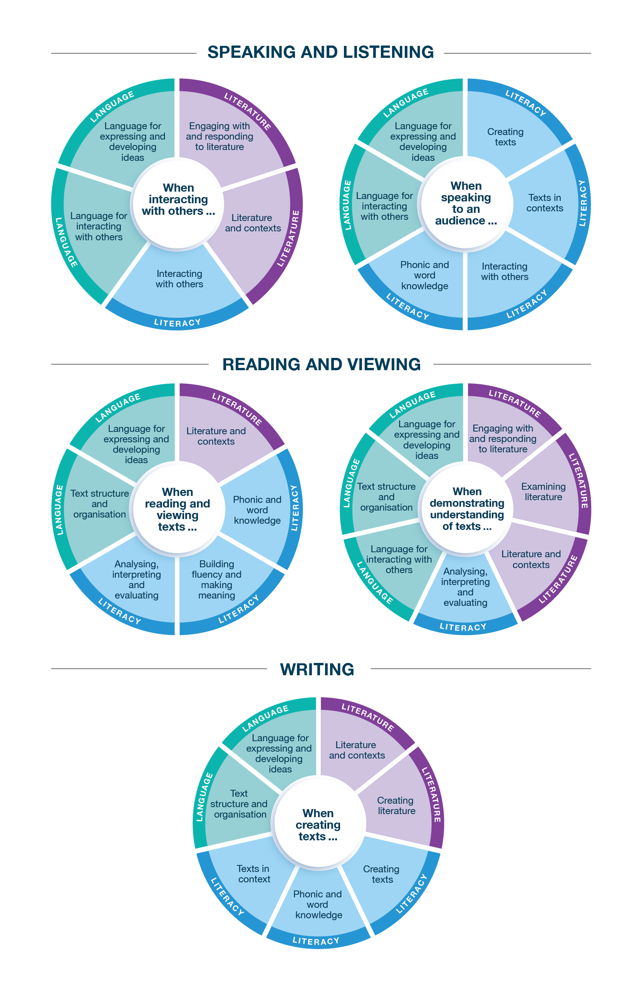
Connecting the achievement standards and sub-strands

Curriculum Mapping
Achievement standard (AS), with numbered extracts
Speaking and Listening | Reading and Viewing | Writing
1. When interacting with others, students explore vocabulary used in familiar contexts and how language changes in different contexts.  They share thoughts and preferences. | 3. When listening, reading and viewing, students engage with a range of different types of texts, including decodable and authentic texts, using developing phonic knowledge.  They blend, segment and manipulate phonemes in one-syllable words, and use knowledge of letters and sounds to read consonant-vowel-consonant (CVC) words. They read some high-frequency words and identify boundary punctuation. | 5. When creating and sharing short texts, students retell stories and report information, using familiar words and images where appropriate. They share in simple editing processes.  They use words, phrases and punctuation, including capital letters and full stops, from familiar contexts and texts, and from their learning.  They form letters and spell most consonant-vowel-consonant (CVC) words.
2. When speaking to an audience, students deliver short spoken texts, including retelling stories and reporting events, using features of voice. | 4. When demonstrating understanding of texts, students identify and make connections between characters, settings and events and their own feelings and thoughts.  They identify how types of texts, both print and digital, are organised for purpose and navigation. They compare how textual elements other than language, such as images and sounds, can contribute to meaning.

 | Strand | Language
 | Sub-strand | Language for interacting with others |  |  |  | Text structure and organisation |  |  |  | Language for expressing and developing ideas
 | Content description (CD) | explore how language is used differently at home and school depending on the relationships between people  VC2EFLA01 |  | explore different ways of using language to express preferences, likes and dislikes  VC2EFLA02 |  | understand that texts can take many forms, such as signs, books and digital texts  VC2EFLA03 |  | understand concepts about print in print and digital texts, including how books and simple digital texts are usually organised  VC2EFLA04 |  | recognise that sentences are key units for expressing ideas  VC2EFLA05 |  | recognise that sentences are made up of groups of words that work together in particular ways to make meaning  VC2EFLA06
Teaching and learning unit | Semester/Year | CD | AS no. | CD | AS no. | CD | AS no. | CD | AS no. | CD | AS no. | CD | AS no.
 |  | ☐ |  | ☐ |  | ☐ |  | ☐ |  | ☐ |  | ☐
 |  | ☐ |  | ☐ |  | ☐ |  | ☐ |  | ☐ |  | ☐
 |  | ☐ |  | ☐ |  | ☐ |  | ☐ |  | ☐ |  | ☐
 |  | ☐ |  | ☐ |  | ☐ |  | ☐ |  | ☐ |  | ☐
 |  | ☐ |  | ☐ |  | ☐ |  | ☐ |  | ☐ |  | ☐
 |  | ☐ |  | ☐ |  | ☐ |  | ☐ |  | ☐ |  | ☐

 | Strand | Language continued
 | Sub-strand | Language for expressing and developing ideas continued
 | Content description (CD) | explore the contribution of images, words and sound to meaning in stories and informative texts  VC2EFLA07 |  | recognise and develop awareness of vocabulary used in familiar contexts related to everyday experiences, personal interests and topics taught at school  VC2EFLA08 |  | identify punctuation as a feature of written text different from letters; recognise that capital letters are used for names, and that capital letters also signal the beginning of sentences while punctuation marks signal the end  VC2EFLA09
Teaching and learning unit | Semester/Year | CD | AS no. | CD | AS no. | CD | AS no.
 |  | ☐ |  | ☐ |  | ☐
 |  | ☐ |  | ☐ |  | ☐
 |  | ☐ |  | ☐ |  | ☐
 |  | ☐ |  | ☐ |  | ☐
 |  | ☐ |  | ☐ |  | ☐
 |  | ☐ |  | ☐ |  | ☐

 | Strand | Literature
 | Sub-strand | Literature and contexts |  | Engaging with and responding to literature |  | Examining literature |  |  |  | Creating literature
 | Content description (CD) | discuss experiences that are similar or different to their own by engaging with literary texts by Aboriginal and Torres Strait Islander authors and illustrators and a wide range of Australian and world authors and illustrators  VC2EFLE01 |  | respond to stories and share feelings and thoughts about the events and characters depicted  VC2EFLE02 |  | recognise a range of literary texts and identify features including events, characters, and beginnings and endings  VC2EFLE03 |  | explore and replicate the rhythms and sound patterns of poems, chants, rhymes and songs  VC2EFLE04 |  | retell and adapt a range of previously encountered literary texts through play, performance, images, drawing and writing  VC2EFLE05
Teaching and learning unit | Semester/Year | CD | AS no. | CD | AS no. | CD | AS no. | CD | AS no. | CD | AS no.
 |  | ☐ |  | ☐ |  | ☐ |  | ☐ |  | ☐
 |  | ☐ |  | ☐ |  | ☐ |  | ☐ |  | ☐
 |  | ☐ |  | ☐ |  | ☐ |  | ☐ |  | ☐
 |  | ☐ |  | ☐ |  | ☐ |  | ☐ |  | ☐
 |  | ☐ |  | ☐ |  | ☐ |  | ☐ |  | ☐
 |  | ☐ |  | ☐ |  | ☐ |  | ☐ |  | ☐

 | Strand | Literacy
 | Sub-strand | Interacting with others |  |  |  | Phonic and word knowledge
 | Content description (CD) | interact in informal and structured situations, using appropriate voice levels and listening while others read or speak  VC2EFLY01 |  | deliver short spoken texts to an audience using features of voice  VC2EFLY02 |  | recognise and generate syllables, rhyming words, alliteration patterns and phonemes in spoken words (phonological awareness)  VC2EFLY03 |  | orally blend, segment and manipulate one-syllable words (phonemic awareness)  VC2EFLY04 |  | use knowledge of letters and sounds to read and spell consonant-vowel-consonant (CVC) words (phoneme–grapheme correspondence knowledge)  VC2EFLY05 |  | recognise and name all upper- and lower-case letters and know the most common phoneme–grapheme correspondences (sound–letter relationships)  VC2EFLY06 |  | read and write some high-frequency words and other familiar words  VC2EFLY07 |  | understand that words are units of meaning and can be made of more than one meaningful part (morphemic knowledge)  VC2EFLY08
Teaching and learning unit | Semester/Year | CD | AS no. | CD | AS no. | CD | AS no. | CD | AS no. | CD | AS no. | CD | AS no. | CD | AS no. | CD | AS no.
 |  | ☐ |  | ☐ |  | ☐ |  | ☐ |  | ☐ |  | ☐ |  | ☐ |  | ☐
 |  | ☐ |  | ☐ |  | ☐ |  | ☐ |  | ☐ |  | ☐ |  | ☐ |  | ☐
 |  | ☐ |  | ☐ |  | ☐ |  | ☐ |  | ☐ |  | ☐ |  | ☐ |  | ☐
 |  | ☐ |  | ☐ |  | ☐ |  | ☐ |  | ☐ |  | ☐ |  | ☐ |  | ☐
 |  | ☐ |  | ☐ |  | ☐ |  | ☐ |  | ☐ |  | ☐ |  | ☐ |  | ☐
 |  | ☐ |  | ☐ |  | ☐ |  | ☐ |  | ☐ |  | ☐ |  | ☐ |  | ☐

 | Strand | Literacy continued
 | Sub-strand | Building fluency and making meaning |  | Texts in context |  | Analysing, interpreting and evaluating |  |  |  | Creating texts
 | Content description (CD) | read decodable and authentic texts using developing phonic knowledge, and make and monitor meaning using context and emerging grammatical knowledge  VC2EFLY09 |  | identify some familiar types of texts, such as stories and informative texts, and the contexts in which they are used  VC2EFLY10 |  | identify some differences between narrative and informative texts  VC2EFLY11 |  | use comprehension strategies, such as visualising, predicting, connecting, summarising and questioning, to understand and discuss texts listened to, viewed or read independently  VC2EFLY12 |  | create short texts to explore, record and report ideas and events, using familiar words and beginning writing knowledge  VC2EFLY13 |  | participate in shared editing of students’ own texts for meaning, spelling, capital letters and full stops  VC2EFLY14 |  | form most lower-case and upper-case letters using learnt letter formations  VC2EFLY15
Teaching and learning unit | Semester/Year | CD | AS no. | CD | AS no. | CD | AS no. | CD | AS no. | CD | AS no. | CD | AS no. | CD | AS no.
 |  | ☐ |  | ☐ |  | ☐ |  | ☐ |  | ☐ |  | ☐ |  | ☐
 |  | ☐ |  | ☐ |  | ☐ |  | ☐ |  | ☐ |  | ☐ |  | ☐
 |  | ☐ |  | ☐ |  | ☐ |  | ☐ |  | ☐ |  | ☐ |  | ☐
 |  | ☐ |  | ☐ |  | ☐ |  | ☐ |  | ☐ |  | ☐ |  | ☐
 |  | ☐ |  | ☐ |  | ☐ |  | ☐ |  | ☐ |  | ☐ |  | ☐
 |  | ☐ |  | ☐ |  | ☐ |  | ☐ |  | ☐ |  | ☐ |  | ☐

Check of Achievement Standard Coverage
Achievement standard (AS), with numbered extracts
Speaking and Listening | Y/N | Reading and Viewing | Y/N | Writing | Y/N
1. When interacting with others, students explore vocabulary used in familiar contexts and how language changes in different contexts.  They share thoughts and preferences. | ☐ | 3. When listening, reading and viewing, students engage with a range of different types of texts, including decodable and authentic texts, using developing phonic knowledge.  They blend, segment and manipulate phonemes in one-syllable words, and use knowledge of letters and sounds to read consonant-vowel-consonant (CVC) words. They read some high-frequency words and identify boundary punctuation. | ☐ | 5. When creating and sharing short texts, students retell stories and report information, using familiar words and images where appropriate. They share in simple editing processes.  They use words, phrases and punctuation, including capital letters and full stops, from familiar contexts and texts, and from their learning.  They form letters and spell most consonant-vowel-consonant (CVC) words. | ☐
2. When speaking to an audience, students deliver short spoken texts, including retelling stories and reporting events, using features of voice. | ☐ | 4. When demonstrating understanding of texts, students identify and make connections between characters, settings and events and their own feelings and thoughts.  They identify how types of texts, both print and digital, are organised for purpose and navigation. They compare how textual elements other than language, such as images and sounds, can contribute to meaning. | ☐ |  | ☐

Assessment
Teaching and learning unit | Assessment task name(s) and type(s) | AS no.

Analysis of Curriculum Coverage
<The following questions could be used as prompts for the analysis process:
Refer to the Curriculum Mapping table:
- Have you addressed all the achievement standard extracts?
- Have you addressed all the content descriptions?
- Where are there gaps in the content description coverage?
Refer to the Assessment table:
- Has each achievement standard extract been addressed appropriately? Where are there gaps in the achievement standard coverage?
- Have students had the opportunity to show evidence that they are progressing towards the achievement standard?
Consider:
- Are all content descriptions equal? Do you think they all take the same amount of time to teach?
- Is anything being over-taught?
- Is anything being missed completely or given insufficient attention?>

Next Steps
<The following questions could be used as prompts for next steps:
- What implications would gaps in achievement standard coverage have on assessment?
- What implications would gaps in content description coverage have on your teaching and learning units?
- How will you address any gaps?
- Use your completed curriculum area map to start populating or updating your curriculum area plan.>

