Example assessment task: Creating a game from rubbish

Science, Foundation to Level 2

Overview
What happens to rubbish after it is thrown away? VCAA Example teaching and learning unit: 1.2 Rethink rubbish! Where could it go? explores the relationship between the physical changes in materials and the importance of waste management through reducing, re-using and recycling. Students will develop an awareness of how everyday materials can be repurposed to minimise waste and conserve Earth’s resources.
This example assessment task requires students to apply their science understanding and scientific inquiry skills by designing and creating a game using rubbish. Although the assessment targets Year 1 students, it can be adapted for Prep to Year 2, ensuring that all students can be assessed at an appropriate level against the Foundation to Level 2 achievement standard.
Teachers should encourage creativity, discussion and reflection throughout the process, supporting students in making connections between their designs and broader sustainability concepts. The assessment provides opportunities to evaluate student learning through observation, questioning and discussion about their design choices and the purpose of their game.
The assessment task requires students to:
- sort clean rubbish provided by the teacher into different categories (e.g. bottles, caps, boxes, paper and plastic)
- suggest ways that the rubbish can be reduced, re-used and recycled, and explain the importance of these actions for sustainability
- brainstorm ideas for creating a game using the rubbish (e.g. a tossing game, a rolling race or a matching game)
- design the game, including sketching a design and identifying how the rubbish will be used (e.g. using a bottle as a target or a lid as a marker)
- think of ways to physically change the materials and use tables to demonstrate the changes they will make (e.g. crumpling, cutting and twisting)
- create the game using materials and equipment such as glue, scissors and tape
- test the game and make any necessary adjustments
- share their games with their peers
- use everyday and scientific vocabulary to communicate observations and ideas for improvements.

Curriculum connections (Victorian Curriculum F–10 Version 2.0 Science)
Strand | Sub-strand | Achievement standard sentences
Science Understanding | Chemical sciences | They provide examples of objects and mixtures that are made from a combination of materials, and distinguish between the properties of objects or mixtures and those of the materials from which they are made.  They identify ways to change materials without changing their material composition.
Science Understanding | Earth and space sciences | They suggest ways that the use of common materials can be reduced, re-used and recycled, and explain the importance of these actions for sustainability.
Science Inquiry | Processing, modelling and analysing | They use provided tables and organisers to sort and order data, and represent simple patterns in data.
Science Inquiry | Communicating | They use everyday and some scientific vocabulary to communicate observations, findings and ideas.
This task also has links to the following Victorian Curriculum F–10 Version 2.0 discipline, capabilities and cross-curriculum priority:
- Discipline: Design and Technology (F–2)
- Capabilities:
- Critical and Creative Thinking (F–2)
- Personal and Social Capability (F, 1–2)
- Ethical Capability (F–2)
- Cross-curriculum priority: Sustainability.

Assessment task
Using clean collected materials, students will design and create a game. They will consider different materials in terms of being re-used as game components. They will build and document the actions they perform with each material (e.g. bend, cut, twist). They will play each other’s games and provide feedback. Students will explain how making their game reduces, re-uses or recycles rubbish and why this is important for sustainability.
This example summative assessment task is designed to be completed individually or with a partner and completed over 3 lessons, each 60 minutes in duration. This allows time for students to plan, build, test and evaluate their games.

Resources required
- Clean rubbish made of a variety of different materials (e.g. paper, cardboard boxes, plastic bottles and lids, aluminium foil). Note: Do not use glass because it may break and cause cuts.
- Construction equipment (e.g. scissors, tape and glue)
- Student task sheets (pages 4–8)
- Teacher observation table – blank template (page 9).

Teacher preparation and safety notes
Teachers should collect and clean rubbish made of different materials (see ‘Resources required’ on page 2). Gloves should be used when collecting rubbish; some items may need to be washed prior to use by the students. Glass should not be used because it may break and cause cuts. Resources to make the game, such as scissors, glue and tape, can be used at workstations. A ‘helping station’ may be set up for the supervised use of a utility knife or glue gun. The blank table on page 9 may be used when assessing students as they complete various stages of the task.

Instructions for student task sheet
- Sort clean rubbish provided by your teacher into different categories (e.g. bottles, caps, boxes, paper and plastic).
- Look at the collected rubbish and think of a game that you could create.
- Draw and label a diagram of your design.
- Include the names of the materials and how you will make your game.
Some examples are shown on page 5.
My game design

- Make your game and record on page 6 how you changed your chosen materials to make your game.
- Assess your game by completing the table on page 7.
- Assess a game made by another student by completing the table on page 8.

Examples of game designs
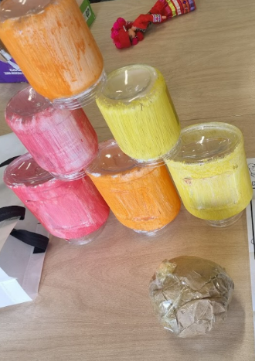  Game set-up for Knock ‘Em Down. | 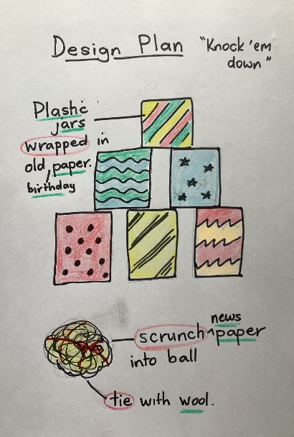  Labelled diagram for Knock ‘Em Down.  (Red circles show actions, and green  underline shows materials.)
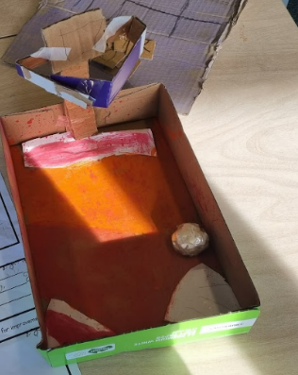  Game set-up for Basketball. | 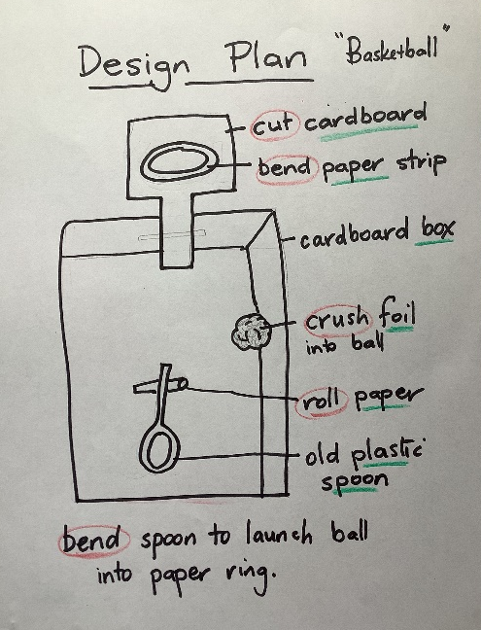  Labelled diagram for Basketball.  (Red circles show actions, and green  underline shows materials.)

Creating a game from rubbish
Student name: _____________________________________ Date: _____________
Data table: making changes
In this table, write down 3 things you used to make your game. Then write down a change you made to each of them. An example is shown in the first row.
What I used | Before | Change | After
Cardboard | Cereal box | Cut into small squares and added numbers and symbols | Cards for a matching memory card game

How is your game good for the environment?
_______________________________________________________________________________________
_______________________________________________________________________________________
_______________________________________________________________________________________

Rating my game
In this table, rate your game design by colouring in one or more stars in each row.
You may like to write extra comments at the end.
I made a game that can be played.
I used something recycled.
I recorded all changes I made.
I drew a diagram and added labels.
I explained how my game is good for the environment.

Extra comments
______________________________________________________________________________________
______________________________________________________________________________________
______________________________________________________________________________________
______________________________________________________________________________________
Feedback to a peer
Play another student’s game. Give feedback by colouring in one or more stars in each row.
You may like to write extra comments at the end.
Feedback from: _____________________________________ Date: _____________
Feedback to: _______________________________________
I can play the game.
I can see something recycled.
I can see changes they made.
I can see the rules of the game.
The student explained how their game is good for the environment.

Extra comments
_______________________________________________________________________________________
_______________________________________________________________________________________
_______________________________________________________________________________________
_______________________________________________________________________________________

Teacher observation table – blank template

Creating a game from rubbish
This teacher observation table is designed to help assess students’ understanding and communication about materials and their properties. Use this tool to observe how students identify ways to change materials, tabulate their data and discuss their ideas, including some scientific vocabulary.
Class: _____________________________________ Date: _____________

Student name | Game design  (Student has identified ways to change materials.) | Record sheet  (Student has used the table to organise data.) | Sharing  (Student has communicated observations and ideas using some scientific vocabulary.)
Mary | ✓ | ✓ | ✓

