Example assessment task: Territory game strategy plan

Health and Physical Education, Levels 9 and 10

Overview
This summative assessment relates to 9.3 ‘Adapting skills to different territory game environments’. In this task, students develop a strategy for a specific team territory game (invasion game) situation, analysing scenarios, and applying concepts of space, time and teamwork to enhance performance and address challenges.

Curriculum connection (Victorian Curriculum F–10 Version 2.0 Health and Physical Education)
The assessment focuses on the following Victorian Curriculum achievement standard sentences for Levels 9 and 10:
- They adapt and transfer movement skills and strategies to unfamiliar situations and evaluate the effectiveness to achieve successful outcomes.

Assessment task
This example assessment task is designed to be completed individually and during one lesson.

Resources required
- Marked playing area such as a field or court
- Balls and cones for set-up
- Territory game strategy plan worksheet for each student (in this document)
- Territory game strategy plan teacher observation table (blank template, in this document)
- Scenario description outlining challenges
- Team bibs for identification (optional)

Instructions
- Set-up: Students are introduced to a territory game scenario where they need to identify and address key challenges related to space, timing and tactics.
- Task requirements: Each student completes the territory game strategy plan worksheet to develop a strategic plan that includes the following:
- game analysis: Identify and describe key challenges related to space usage, timing and opponent strategies that may affect gameplay.
- strategy development: Propose a strategy to enhance movement coordination, teamwork and efficient use of space. Outline roles and specific adjustments to respond to game dynamics.
- evaluation component: Reflect on expected outcomes, potential adjustments to improve effectiveness and strategies for adapting to changing conditions during gameplay.

Using the teacher observation table
The teacher observation table at the end of this document is designed to support teachers to monitor and assess each student’s performance. It ensures students demonstrate effective coordination, positioning and teamwork while engaging in the activity. Teachers observe students during the activity and evaluate their coordination, accuracy, technique and teamwork. Notes can be added for targeted feedback and to plan future lessons.

Territory game strategy plan – completed example
Student name: <Student 1> Date: 20/4/25

1. Identify game challenges
- Describe any issues with how your team uses open spaces on the field.
Our team has difficulty spreading out across the field, so opponents can easily block our passes and movement. When we move toward the same areas, it makes it hard to keep possession.
- What challenges does your team experience with timing?
We often move too early or pass too late, giving the opposing team time to adjust. This timing problem makes it difficult to create scoring opportunities.
- How does the opposing team’s strategy impact your team?
Their defence is strong and organised, so they block our attempts at passing. This makes us hesitate and we lose momentum.

2. Develop your team strategy
- How will your team move to cover the field more effectively?
We’ll try to position ourselves in a diamond shape to give the ball carrier more passing options. This set-up will help spread the team out and reduce crowding.
- What roles will each player take on, and how will they support each other?
One player will focus on staying near the goal to receive passes, while 2 midfielders will work to create space by moving in and out of open areas. Another player will stay back for defence but move up when we’re in possession.
- How will you adjust your use of space and timing to improve gameplay?
Players will take their time to wait for a clear path or space to open before moving forward. We’ll practise making passes only when the receiver is ready, and players will spread out to make it harder for the defence to block us.

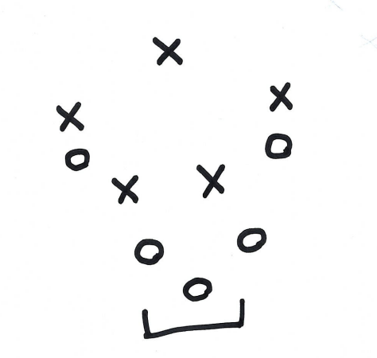
Illustrate your team strategy

3. Strategy evaluation
- What performance improvements do you expect to see if the strategy is effective?
By spreading out and using a diamond shape, we should see more passing options, which will make it easier to move the ball up the field. This set-up will also give us more chances to pass and shoot on goal.
- If the strategy isn’t working as well as expected, what changes could be made?
If the diamond shape isn’t helping enough, we may need to increase the distance between players or switch to a zigzag set-up. Also, players might need to focus on more precise passes and clearer signals to improve timing.

4. Reflection
- What was the most challenging part of creating this strategy, and why?
It was hard to figure out how to improve spacing without causing confusion. Our team needed a clear plan to avoid crowding and use the open areas effectively.
- How did considering feedback and possible adjustments improve your strategy?
Thinking about feedback helped us focus on teamwork. We realised that clear communication and positioning would be key to making this strategy work.

Territory game strategy plan – blank template
Student name: _____________________________________ Date: _____________

1. Identify game challenges
- Describe any issues with how your team uses open spaces on the field.
______________________________________________________________________________________
______________________________________________________________________________________
- What challenges does your team experience with timing?
______________________________________________________________________________________
______________________________________________________________________________________
- How does the opposing team’s strategy impact your team?
______________________________________________________________________________________
______________________________________________________________________________________

2. Develop your team strategy
- How will your team move to cover the field more effectively?
______________________________________________________________________________________
______________________________________________________________________________________
- What roles will each player take on, and how will they support each other?
______________________________________________________________________________________
______________________________________________________________________________________
- How will you adjust your use of space and timing to improve gameplay?
______________________________________________________________________________________
______________________________________________________________________________________

Illustrate your team strategy

3. Strategy evaluation
- What performance improvements do you expect to see if the strategy is effective?
______________________________________________________________________________________
______________________________________________________________________________________
- If the strategy isn’t working as well as expected, what changes could be made?
______________________________________________________________________________________
______________________________________________________________________________________

4. Reflection
- What was the most challenging part of creating this strategy, and why?
______________________________________________________________________________________
______________________________________________________________________________________
- How did considering feedback and possible adjustments improve your strategy?
______________________________________________________________________________________
______________________________________________________________________________________

Observation table – with teacher notes

Territory game strategy plan
Complete this teacher observation table to assess students’ understanding, depth of analysis and the practicality of their strategies.
Class: _____________________________________ Date: _____________
Student name | Game analysis | Strategic development | Evaluation of effectiveness | Comments
<Student 1> | Thorough analysis of space and timing needs. | Clear strategy to use space effectively with teammate roles. | Thoughtful evaluation, suggested adjustments for timing. | Demonstrated strong strategic thinking.
<Student 2> | Limited scenario analysis. | Basic strategy without clear roles or space use. | Minimal evaluation. | Needs support to deepen analysis.
<Student 3> | Identified challenges well. | Creative approach to teamwork and positioning. | Reflective evaluation with specific suggestions. | Good understanding but needs more tactical detail.

Observation table – blank template

Territory game strategy plan
Complete this teacher observation table to assess students’ understanding, depth of analysis and the practicality of their strategies.
Class: _____________________________________ Date: _____________
Student name | Game analysis | Strategic development | Evaluation of effectiveness | Comments

