Example assessment task: Fieldwork – school, local or community garden

Geography, Levels 5 and 6

Overview
This summative assessment task requires students to undertake fieldwork in a school, local or community vegetable garden, providing a hands-on experience and opportunity to demonstrate knowledge about geographical diversity, interconnections and geographical inquiry skills. Students will identify geographical diversity by mapping where different plants in the garden originate from and by comparing the climate where the plant originates to the local garden climate. Interconnections between Australia and other countries are explored by considering how and why plants from different global regions are grown locally.
Students will demonstrate their geographical inquiry skills by making observations, collecting data from primary sources (garden observations) and secondary sources (climate data, plant origins), and formulating their own questions for investigation. This assessment task demonstrates students’ understanding of growing food, environmental factors and interconnections, while assessing students’ skills in collecting data, making observations, conducting research and making connections.
Students will pose a question that they will investigate that enables them to learn about the plant they select, the geographical diversity of the place it is growing, and the interconnections between this local plant and its origins and existence both in Australia and in other countries.

Achievement standard extracts
By the end of Level 6, … They identify the major geographical divisions of the world and explain the geographical diversity of places and the impacts of interconnections between Australia and other countries.
Students develop questions, and locate, collect and organise information and data from a range of primary and secondary sources. They represent and interpret information in different formats to describe patterns, trends and relationships. They analyse information and develop evidence-based conclusions … They select and organise ideas and findings from sources, using geographical knowledge and concepts (place, interconnection, environment and sustainability) to present descriptions and explanations.

Assessment task

Materials
- Our local garden fieldwork and research booklet (see Appendix 1)
- Clipboards
- Computer, tablet or camera (for photos and research task)

Part A: Mapping (on-site)
In Part A of the booklet, students use their observation skills to draw a map of the garden, or a section of the garden, noting important features such as raised garden beds and paths. Students use the basic mapping convention BOLTSS (Border, Orientation, Legend, Title, Scale, Source) while creating their map. For ‘Source’, students record that the map was ‘drawn from observations on [date]’. Rather than drawing the map to scale, they can mark distances between important reference points.
Students respond to the following questions, recording their observations and using evidence to write their responses.
- Describe the garden and how the land is used. What do you notice about the garden’s layout, plants and surroundings? Are there any native plants here?
- What is the weather like (e.g. sunny, cloudy, windy, temperature)?
- Do you notice any features in the garden (e.g. watering system, water tanks, compost bins)?
- Who is the consumer of this produce?
- How is this place managed?
- Record a geographical inquiry question that you have. How will you investigate it?
Students conduct a detailed observation of one plant that interests them. They can sketch or photograph the plant, and should note other observations such as signs of insects, pests or diseases (e.g. 4 holes in leaves). Students observe the conditions around the plant, including the soil, mulch and weather.

Part B: Research (classroom)
In Part B of the booklet, students do additional research on their plant to learn more about the growing conditions, climate and its origins. Students record where the plant originated from on their own maps and collate this information on a class or digital map. What patterns do they notice? Can they draw any conclusions about climate zones?
At this point, students are encouraged to develop their own questions for investigation. These questions could focus on the origins of the plant and how it came to grow there, the impact of this plant on the local environment, or the benefits and costs of growing these plants locally. After developing their geographical inquiry question, students will need to locate, collect and organise information and data from a range of sources.

Part C: Reflection
The reflection questions in Part C of the booklet provide an opportunity for students to connect their local learning with global contexts, analyse and recognise patterns on a map, reflect on their fieldwork, and research and reflect on their geographical inquiry investigation. The following questions can be used to guide discussions before students record responses individually. The aim of this part of the assessment task is for students to draw meaningful conclusions based on their fieldwork and research.
- Which countries are connected to the plant that you focused on and how is Australia linked to them (e.g. climate, culture)? Why is this plant grown in our local area?
- What patterns did you notice on the class map?
- What did you find interesting about your fieldnotes and research?
- What did you learn when investigating your geographical inquiry question?

Appendix 1 – Our local garden fieldwork and research booklet

Part A: Fieldwork notes
Draw a map of the garden, applying BOLTSS (Border, Orientation arrow [North], Legend explaining all symbols, Title, Scale (approximate), Source [‘drawn from observations on insert date’]).

- Describe the garden and how the land is used. What do you notice about the garden’s layout, plants and surroundings? Are there any native plants here?

- What is the weather like (e.g. sunny, cloudy, windy, temperature)?

- Do you notice any features in the garden (e.g. watering system, water tanks, compost bins)?

- Who is the consumer of this produce?

- How is this place managed?

- Record a geographical inquiry question that you have. How will you investigate it?

Plant observations
Choose one section of the garden to examine more closely. Choose one type of plant and mark its location on your map in Part A.
Vegetable plant name: ____________________________________
How many plants of the same variety are grown here? ___________________
- Why do you think this vegetable was planted in this position (e.g. sun, shade, near water source, etc.)?
- Estimate how many hours of direct sunlight the plant receives each day (morning, midday, afternoon).
- Observe if the ground is damp or dry, or if water pools or drains quickly.
- Do you notice any nearby walls or tall plants that might provide extra shelter or shade?

- Does the plant look healthy or unhealthy? How do you know?

- What helps this plant grow in this garden (consider climate, mulch, soil, watering system)?

- How often do people need to water, weed or harvest the vegetables?

Part B: Research
- Search for your plant on the Yates website. On the following map, shade where the plant grows best using the climate guide. Compare this with other students’ plants. What do you notice?

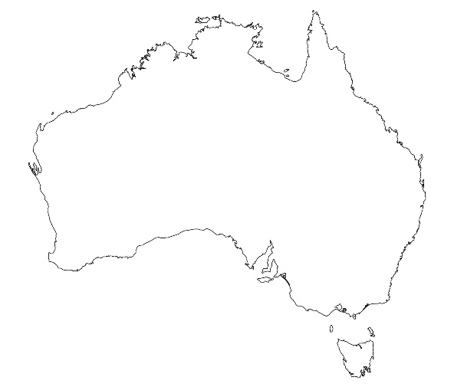

Key:
Tropical and sub-tropical
Temperate
Cool

Image source: iStock.com/Eugene B-sov

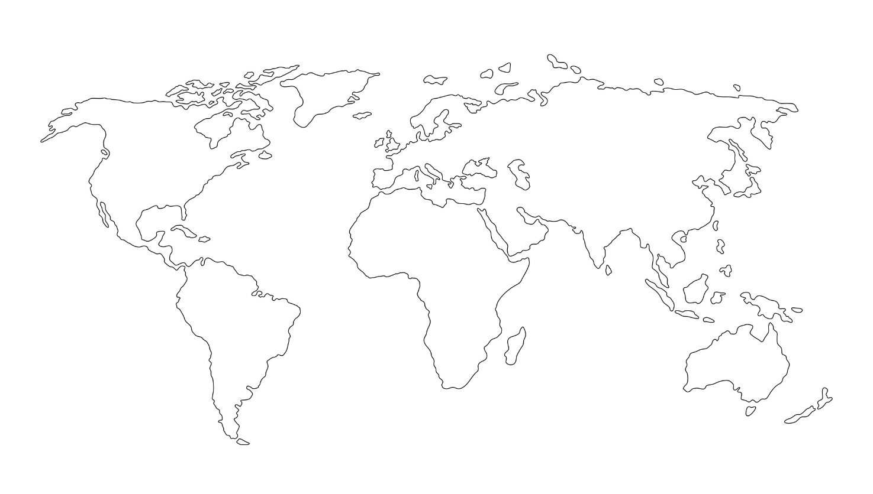
- Search online to find where your plant originated from and label it on the following map. Share the information for the class map.
Image source: iStock.com/prezent

- Investigate your question and record your findings.

Part C: Reflection
- Which countries are connected to the plant you focused on and how is Australia linked to them (e.g. climate, culture)? Why is this plant grown in our local area?

- What patterns did you notice on the class map?

- What did you find interesting about your fieldnotes and research?

- What did you learn when investigating your geographical inquiry question?

